Competition Training Guidance for WorldSkills UK National Qualifier

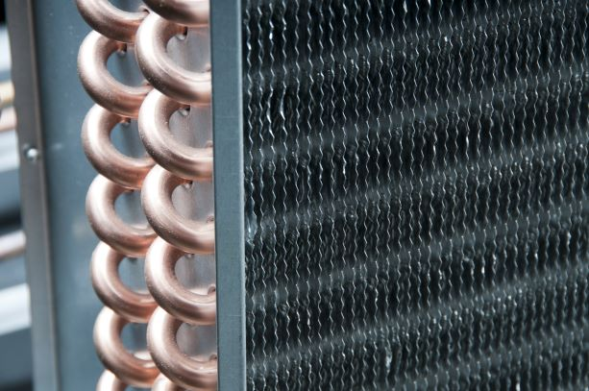

February 2024
Author: BESA Academy

TRAINING TO PRODUCE QUALITY WORK

Introduction

The purpose of this guide is to assist competitors in preparing for the RACHP WorldSkills UK National Competition highlighting their abilities to the fullest during the event. It offers technical tips and advice to help competitors reach their maximum potential. By using this guide in conjunction with the “Pre-competition Activity” you can ensure that you are fully prepared for the competition.

The guide has three sections:

Section 1: General Information

- Personal preparation
- Time management
- Competition preparation
- Marking summary
- Safe working

Section 2: Competition Outline

- Pipework fabrication
- Refrigerant handling
- Pressure testing and Evacuation
- Electrical circuit test
- Operational efficiency

Section 3: Technical Guidance

- Tolerance and standards
- Pipe bending and joint quality

Using the tips and advice in this guide should highlight the need to:

- Practice the basic skills to achieve a higher level of accuracy
- Appreciate the standards set out for each of the tasks
- Think before acting
- Check the quality of completed work against the identified standards
- Appreciate that it is not a race against fellow competitors, you are competing against standards which are achievable

1) General Information

1.1 Personal Preparation

To be effective in any competition requires preparation, encompassing the development of a resilient mindset, physical conditioning and honing technical proficiency through diligent training. Whether it is RACHP, the Olympics, or Formula 1, diligence alongside a training regime will result in an improved performance

Preparing the mind / body

Top Tips
- Keep yourself physically active as extended periods of activity may be necessary during the competition
- Approach the competition with a positive mindset, all tasks are achievable in the time limit available
- During training reflect on your own performance, what went well and what did not go so well
- Concentrate on your performance not that of others, you are competing against the standards set
- Be prepared to alter your plan, if you make an error, park the problem, re-plan and move on
- Prepare for a potential noisy and distracting environment, you need to be focussed on the task at hand not what is happening around you
- Keep hydrated to maintain mental clarity and focus, even mild dehydration can impair mood, concentration and overall cognitive performance
- Maintain a balanced diet throughout the day, as it is key for overall health and well-being
- Avoid energy drinks, the energy boost is often followed by a rapid decline in energy levels
- Eat bananas rather than an energy bar, bananas provide a slow, lasting energy release
- Arriving at the event location in plenty of time can enhance your overall experience, reduce stress and allow for preparation

Preparing your skills

Top Tips
- Practice the basic skills of measuring, bending, flame brazing, pressure testing and handling of refrigerants, as these skillsets are very important
- Practice working to manufactures tolerances and use the correct tool(s) for the task in being completed
- Make enquiries to possibly get access to additional practical training support from your college or employer
- Obtain all the tools that are required for the task and organise them in a designated place, this will prevent time wasted searching for them
- Record your training sessions, watch it back to see if you can identify where you can save time. Plan to improve as, time lost cannot be regained
- Maintain your practice regime by consistently delivering high quality work in your workplace
- Do not hesitate to revisit tasks that you completed during your initial training as, you may find that you can perform them more effectively the second time around
- Read instructions, carefully and check how components will fit together before you start
- If there is a new tool being introduced that you are not familiar with, then practice using it before the competition

1.2 Time Management
Top Tips
- Plan your time by producing a detailed plan with clear times for activities such as, setting out, positioning, bending, brazing, bracketry
- Set times which are achievable as maintaining the schedule will increase your confidence
- Be ready to adapt and revise your plans as needed. When challenges emerge, set them aside and temporarily focus on finding solutions. Swiftly developing a new plan can help shift your focus away from the problem and towards progress
- Try to ensure that you complete a task before a break, as stopping mid task can interrupt the workflow
- Plan comfort break to coincide with natural breaks
- There are no trick questions. If something doesn’t make sense, ask for clarification

The National Qualifier event will align with a typical workday
TIME | ACTIVITY
0800 - 0815  0815 - 0830  0830 - 0900  0900 - 1130  1130 - 1230  1230 - 1300  1300 - 1530  1530 - 1630  1630 - 1700 | Arrival sign in  Induction and competition introduction  Familiarisation with tools, materials and equipment  Skill Competition Part A – 2.5 hrs  Lunch and work area changeover  Familiarisation with tools, materials and equipment  Skill Competition Part B – 2.5 hrs  Marking & Feedback to competitors  Depart

1.3 Competition Preparation

This guide provides you with the competition overview. Make enquiries to possibly get access to additional practical training support from your college or employer. If you require clarification on the content of this guide, contact the competition manager in advance of the competition.

All competitions will have a test project brief presented on the day which will include the specific diagrams and instructions for your test.

Top Tips
- Always read the brief thoroughly to ensure you understand what is required
- If you are uncertain of what is required, then ask questions to clarify
- Make sure you look at and understand the marking criterion
- Use the marking criterion when planning and/or problem solving, this can help to maximise the overall marks awarded
- Use the competition website for additional competition information such as training tests and tool lists

1.4 Marking Summary

Each task undertaken is assessed by judges, the marking criterion utilised for the RACHP National Qualifiers it is as follows:

Weighting | Aspect | Criteria | Maximum marks
1 | C | Electrical Wiring & Control Fault Finding | 12
2 | D | Pressure Testing & Evacuation (refrigeration) | 14
3 | E | Charging Refrigerant (emission control) | 16
4 | F | Refrigeration System Commissioning (efficient setup) | 20
5 | B | Refrigerant Recovery (emission control) | 16
6 | A | Pipework Fabrication | 22
 | Total marks |  | 100

Each National Qualifier, in an annual cycle, will utilise the same marking criterion.

1.5 Safe Working

Safety is everyone’s responsibility.

A generic risk assessment and method statement is available in the competition manual. We have listed the required personal protective equipment to be worn for every activity.

Each location hosting a regional heat will have carried out its own risk assessment for the workplace activities.

You are responsible for using the tools and equipment in accordance with manufacturer’s instructions. This entails being informed of potential hazards receiving proper training in their usage.

The safety marks can only be revoked if you fail to adhere to health and safety regulations and guidance.

Top Tips
- No power tools are required
- No open bladed knives are to be utilised for wire stripping
- Battery screwdrivers are permitted, however impact drivers are not permitted
- Ensure all batteries are fully charged prior to arrival
- Ensure the floor area is kept free from trip hazards
- Maintain a clear workbench for optimal safety and efficiency

The risk of fire:
Flame brazing poses a high risk to property and persons, when flame brazing always use a low flame facing away from combustible materials or incorporate heat shields into the brazing process.

Practice the ignition procedures utilising a proprietary ignitor, and the shutdown procedure for the flame brazing torch. A naked flame cannot be used to ignite the fluid gas.

2) Competition Outline

2.1 Pipework Fabrication Task

Competitors are to fabricate a test piece using permanent (brazed) and non-permanent mechanical joints (flared) according to a detailed diagram.

Soft copper pipe will be supplied, that is required to be straightened without the use of mechanical tools.

Supplementary materials and components will be provided to allow fabrication of a sealed system that will require pressure testing.

It is required to maintain a safe working environment whilst apply a systematic approach to complete the installation within the specified timeframe.

It will be required to employ various methods of pipe bending and flame brazing of fittings, using both 5% & 40% silver/copper alloy.

You will need to ensure the building fabric is protected from damage during installation and the surrounding areas protected whilst carrying out hot works.

Regardless of the task, comprehensive instructions will be provided during the briefing before the competition begins, Therefore, it is essential to listen attentively and take thorough notes.

Top Tips
- Practice flame brazing copper joints in all orientations (1/2”, 3/8”, 1/4”)
- Practice flame brazing copper to brass joints in all orientations (horizontal, vertical, upside down)
Isolate cylinder valves and drain fluid lines at the end of the test

2.2 Refrigerant Handling Task

It will be required to recover refrigerant from an existing system, pressure test, evacuate, and add refrigerant back into the system.

Specific records require to be completed to document your actions using the following:

- F-Gas record (refrigerant additions, removals, leak testing)
- Pressure testing certificate (high side and low side)
- Evacuation certificate
- Operational log record

To do well in this task, the refrigerant must not be contaminated by adding any non-condensable gases during recovery and charging, best practice must be demonstrated to avoid refrigerant emissions to atmosphere.

Top Tips
- Prove the vacuum pump before starting evacuation test
- Use the vacuum pump to evacuate air from service hose lines all the way to the service valve on the system or receiver cylinder
- If the lines cannot be evacuated all the way, only purge with refrigerant vapour
- Never purge refrigerant liquid

2.3 Electrical test and Fault Finding Task

The electrical fault finding test will be carried out on the same system as used for refrigerant handling.

Competitors are to use a multi-meter to test that the electrical wiring will not trip the main power supply breaker when the system is powered up.

You will be required to demonstrate your actions to the judge during the test.

The functional tests will require testing to ensure that no voltage is present, prior to testing for earth continuity

You will be expected to check all terminations and complete a specific electrical test record for the following:

- Earth continuity test
- Neutral continuity test
- Short circuit test

Keep in mind that, simply opening a control cover to discover a loose wire will not be sufficient to score points. The judges are evaluating your ability to use a multimeter effectively in identifying faults.

Top Tips
- Use a voltage probe to test for dead (zero voltage)
- Practice using a multi meter to test for resistance of a circuit
- For resistance checks, touch the leads of the multi meter together to identify the resistance of the meter before testing begins
- Safe isolation is critical

3) Technical Guidance

3.1 Tolerances and standards

The tolerance connected to the quality of work required to gain maximum marks are:
- Measurements should be within +/- 2mm of the specification
- Angles to be within +/- 2º of the specification
- Brazed joints require to:
  - Be full and even all round
  - Have no parent metal loss
  - Have no excess alloy on exterior (blobs above 2mm)
  - Have no sharp peaks
  - Display no building fabric or component scorch marks
  - Have all flux removed (if used for silver alloy joint)
  - Be leak free

- Pressure leak and strength tests to be carried out according to BSEN 378 (2016), held for 10 minutes (time to be included within the test timeframe)
- Evacuation down to below 2000 micron, and not to rise above 2000 micron after a 10 minute rise test (time to be included within the test timeframe)
- Wiring terminations to be tight and without conductors showing when viewed at an angle of 90⁰
- Earth continuity and polarity dead resistance, no more than 5ohms
- Zero escape of refrigerant liquid, purging only allowed by using vapour
- Superheat between 5 & 10K inclusive (using dew scale)
- Sub-cooling between 3 & 8K inclusive (using bubble scale)
- High pressure switch set between 55ºC saturation pressure x 1.0 or x 0.9
- Low pressure switch cut in set at no higher than 3bg, +/- 0.5bar
- Low pressure switch differential set to cut out at no lower than 0.1bg and, no higher than 0.5bg

Top Tips
- Leak test before and after every activity, ensure the judges observe
- Ensure that you understand how the reclaim unit operates, use the purge process to transfer all the refrigerant into the cylinder, service gauges should show a vacuum on the suction
- Replace caps on all devices to prevent any refrigerant escape
- Remove service gauges after confirming only low-pressure vapour is present

3.2 Back to Basics for competition success

Pipe Bending quality

Dimensional accuracy is an opportunity for high scoring, so make sure you check and double check the accuracy of your installation.

Top Tips
- Ensure you have the means to keep your marking pencil sharp
- Make a pencil mark all around the circumference of the pipe
- Use a steel rule for measuring, not a measuring tape
- Double check angles for accuracy before moving onto your next bend
- Invest in a small angle finder to check the angle of your bend

Flattening, kinking and wrinkling during bending copper pipe can be avoided. Practice slowly with different benders if possible.
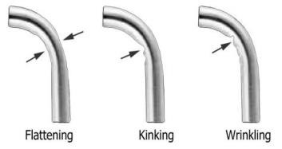

Learn how to make an offset angle by understanding the bending tool radius.
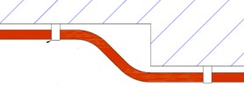
centre
centre
Offset distance

Offset bends frequently require two or three identical pipes positioned adjacent to each other, prompting consideration of the setting out requirements.

Top Tips
- For best results consider mounting the bender in a vice on a workbench. This approach can facilitate more accurate bending, as it allows for the hands to be free for marking pipe, holding squares, steel rule and the like with ease
- Check with either a square or an angle finder that the bend is accurate before removing from the bending machine

Copper Pipe Joint Quality
Top Tips  For best results, ensure both the pipe and fitting are cleaned, even if flux is being used.  Do not over apply the flux on a dissimilar metal joint as this will not improve the quality. | 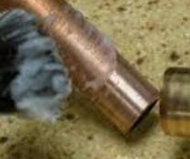
Ensure that the flame is not too fierce to burn the fitting, building fabric or adjacent components. Heat the pipe from the periphery of the fitting to raise the overall temperature, before putting heat directly onto the fitting.  Control the flame and apply heat evenly all around the male pipe first.  Move the heat onto the female pipe and apply heat evenly all around the female pipe, and then apply the alloy into the joint. | 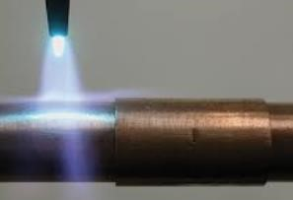  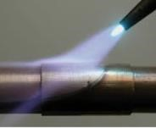
Apply the alloy behind the heat, so that the alloy flows towards the heat and into the joint.  Feed the alloy into the joint at intervals around the pipe – don’t just wipe the alloy across the joint. | 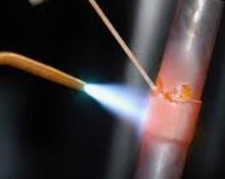

Good Quality Joint  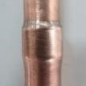 | Poor Quality Joint  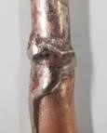
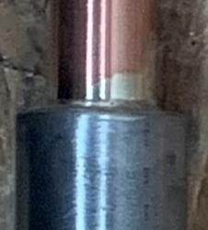  Copper to steel brazed joint | 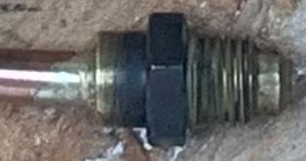  Copper to brass brazed joint
Dissimilar metal brazed joints require flux applying before assembly, remember to remove all flux after the pipe/joint has cooled down.

Use 5% Ag CuP brazing alloy for copper to copper joints and, 40% Ag silver brazing alloy and flux for copper to brass and steel joints.

Summary

The refrigeration and air conditioning industry, which now encapsulates heat pumps, boasts a rich history competing in UK and international competitions. Competitors, ever eager for new challenges, consistently rise to the occasion.

We trust that this competition training guide will elevate standards and enhance competitors’ prospects of securing a Gold Medal at WorldSkills.

College tutors and trainers can contribute by dedicating some time reinforcing the fundamental skills taught and refining the achieved standards, prior to the competition. The fundamental skills are often overlooked in the race to complete the overall task, of course time is important however, by consistently practicing the base skillset both in the workplace and at college, and allocating some extra time for refinement, increased speed will naturally follow.

The evidence from previous competitions identifies that dimensional accuracy, flame brazing quality, knowledge of pressure testing, refrigerant handling and system set up, are the areas where marks are commonly lost due to avoidable mistakes.

While reaching 100% perfection may be unattainable, aiming for scores in the high 70’s and 80’s signifies an excellent performance, reflecting positively on your contribution to the industry. Nonetheless, the essence lies in relishing the experience and giving utmost effort.

Little things make big differences, it takes a better person to make a better world.

