Competitors Digital Toolkit 2025

Automotive Body Repair

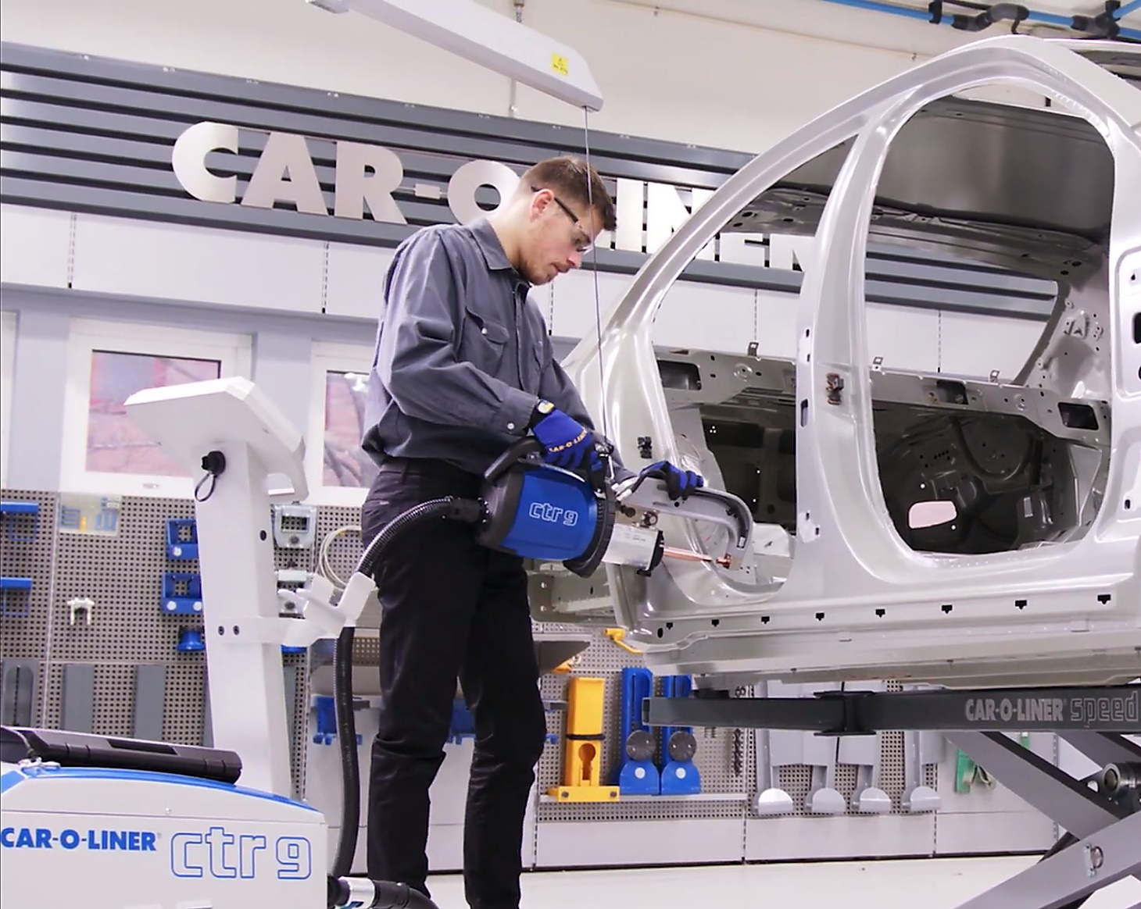

Richard Hutchins

IMI Skills Competitions Manager

RichardH@theimi.org.uk

|  |
| --- |
| **Contents** |
| IMI Skills Competitions Sponsors………………………………………………………………………………………………………….………..Page 3  Automotive Body Repair Overview……………..……………..……….……………………………………………………….………………..Page 4  Automotive Body Repair Career Pathway…………………………….………………………………………………….…….………………Page 4  WorldSkills UK Information and Resources……………………………………………………………………….……………….…….……Page 5  WorldSkills UK Registration…………………………………….…………………………………………………………………………..…………Page 5  Pre-competition Activity…………………………………………………………………………………………….……………………….…………Page 5  WorldSkills UK Automotive Body Repair Competition Structure……………………………….…….…………………..…Pages 5 & 6  Specification of the Tasks Practical and Digital…………………….…………………………………………………………………………Page 6  WorldSkills UK National Qualifiers Task Overview…….………………………………………………………………………………..….Page 7  WorldSkills UK Practical National Qualifiers Marking and Assessment………………….……………………………..…Pages 7 & 8  WorldSkills UK Digital National Qualifiers Marking and Assessment….……………………………………….……….…Pages 8 & 9  WorldSkills UK National Qualifiers (Practical) what to expect….………………………………………..………………………..…Page 9  WorldSkills UK National Qualifiers (Digital) what to expect….……………………………………………………………….…....…Page 9  WorldSkills UK National Final Task Overview……………….………………………………..……………………………….……………Page 10  WorldSkills UK National Final Marking and Assessment…………………………………..….………………….……….…Pages 10 & 11  Judges “Top Tips”…………………………………….………………………………………….…………………………………………………….…Page 12  WorldSkills UK National Final what to expect……………………………………….…………………..…………………...….Pages 12 & 13  Master Class training for WorldSkills UK National Final………………………………………….……………..……………………. Page 13  Digital Resources and “How to” Guides………………………………………………………….……………………………...….Pages 13 & 14  Competition Rules…………………………………….……………………………………………………………………………………….…………Page 14  Beyond WorldSkills UK National Finals…………………………………………….…………………………………………………. Pages 14 - 17 |

We would like to thank all of our industry leading sponsors that are passionate about finding the top talented apprentices and make this competition possible:

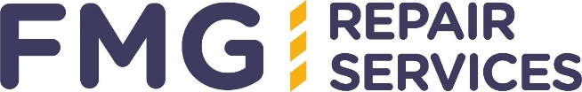

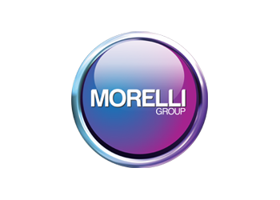

 

 

This WorldSkills UK competition is managed by the Institute of the Motor Industry 

|  |
| --- |
| **Overview:** |
| Automotive Body Repair is a significant sector within the automotive engineering industry, automotive body repairs cover the accident/crash repair and or restoration of cars, trucks, or other vehicles. Automotive body repairs include a wide range of skills, high standards and critical thinking and process applications and problem solving.  This guide will provide you with a clear path to follow, from the initial registration to the National finals and beyond. |
| **Career Pathway:** |
| **What is the job role?**  When cars, vans, motorcycles and larger vehicles are damaged in accidents, they are taken to a body repair workshop. Some repairers will complete the process from start to finish and others will have specialised roles and work on one part of the repair process. Panel technicians, also known as panel beaters or body repair technicians, specialise in repairing or replacing damaged panels. As a panel technician you will need to demonstrate: Strong communication skills, the ability to work alone and as part of a team, the ability to maintain quality under pressure an awareness of safety procedures, the ability to use specialist equipment, the ability to follow written and verbal instructions, good manual skills and a good eye for detail.  **Qualifications**  You will need to have a good understanding of vehicle body and repair operations; you will be expected to be trained in body and paint operations in refinishing at Level 2 for this level of work and then progress to body and paint operations at Level 3.  There are a range of qualifications such as N/SVQs and VRQs in vehicle body repair and paint operations in body repair.  You will need to have a good understanding of automotive systems and the specific materials required for a variety of repairs.  **Working hours and salary**  You will normally work from 8am to 5pm Monday to Friday; however, you may be able to work overtime in the evenings and at weekends. You will usually work indoors in workshops or body shops and you will be expected to wear safety clothing when using specialised equipment and carrying out tasks such as welding. As an apprentice or a trainee panel technician you may earn between £7,000-£13,000 per year.  Once you are qualified the average panel beater salary in the United Kingdom is £31,200 per year or £16 per hour. Entry level positions start at £27,030 per year while most experienced workers make up to £40,000 per year.  (Average salary’s taken from https://uk.talent.com/salary?job=panel+beater)  **Progression to:**  Senior Panel Technician, Vehicle Estimator/ Senior VDA, Bodyshop Manager.  For more Automotive career pathway information:  <https://www.autocity.org.uk/> |
| **Resources and Registration:** |
| For information and resources, including how to register, competition rules, and the steps to competing,  Visit: <https://worldskillsuk.org/champions/national-skills-competitions/tools-and-resources> |
| **Pre-competition Activity:** |
| Pre-competition competitors should try to familiarise themselves with competition style activities even if you have a fellow student to judge a completed work task during a practical session at college/training provider.  Also familiarise yourself with current industry processes and procedures for completing a range of tasks you may need to complete.  For information and resources, including a detailed Pre-Competition activity pack please click the link below.  <https://www.worldskillsuk.org/?s=Automotive+body+repair> |
| **Competition Structure:** |
| **Registration:**  Once you have completed your registration (and accepted all terms and conditions) you will be emailed a link to complete an Entry stage online test.  **Entry Stage**:  All registered competitors ***must*** complete the entry stage test to have a chance of progressing to the National Qualifiers, there will be no exemptions to this rule.  When the entry stage online test has been completed you will be notified to let you know if you have scored high enough to go through to the National Qualifiers (the practical competition rounds). You will be informed which National Qualifier you will need to attend.  **N.B**  *This is usually a practical competition and all of the relevant venue and hotel details would then be emailed to you. Alternatively, the National Qualifier maybe a digital competition, again all details would be emailed to you well in advance of any of the competitions.*  **National Qualifiers Stage one:**  Ensure you’re ready to compete in your National Qualifiers by looking at the project brief below.  This outlines the type of tasks you will be expected to carry out. Ask your lecturer/employer for help in any areas where you feel you could improve and try to gain practical experience in all the task areas of the competition.  **Digital National Qualifier Stage one:**  Ensure you’re ready to compete in your Digital National Qualifiers by looking at the project brief below.  The Digital National Qualifier consists of the tasks as the practical competition however for the digital competition  The practical task has been broken down into a series of online questions for you to answer.  The tasks outline the type of questions you will be expected to answer. Ask your lecturer/employer for help in any areas where you feel you could improve and try to use your practical experience in all the task areas to think about the different processes etc. that you could be questioned on for competition.  **National Qualifiers Stage two:**  Attend and compete in your allocated National Qualifiers.  **Digital National Qualifier Stage two:**  Remotely compete in your online/virtual Digital National Qualifier.    **WorldSkills UK National Final Stage one:**  The 6 highest scoring competitors across each National Qualifiers will be invited to compete at the finals - WorldSkills UK National Final in November.  **WorldSkills UK National Final Stage two:**  Ensure you’re ready to compete in your WorldSkills UK National Final by looking at the project brief below.  This outlines the type of tasks you will be expected to carry out. Ask your lecturer/employer for help in any areas where you feel you could improve and try to gain practical experience in all the task areas of the competition.    **Technical Master Class Training:**  Attend free pre final technical master class training arraigned by IMI Skills Competitions (budget depending) and digital, virtual online training.  **WorldSkills UK National Final Stage three:**  Attend and compete in your allocated WorldSkills UK National Final. |
| **Specification of the Practical Tasks :** |
| Tasks will be designed to test the competitor’s technical ability to:   * Read repair data sheets * Follow correct procedures * Work efficiently whilst minimising waste (time and materials) * Prepare surfaces for repair * Efficiently complete automotive welding * Set up body repair equipment (checking for any faults) * Apply body fillers materials * Identify correct welding methods for body repair * Accurately measure panels * Measure vehicle body alignment * Accurately rectify vehicle body misalignment * Accurately use bonding materials * Accurately assess any welding activity |
| **Specification of the Digital Tasks:** |
| Tasks will be designed to test the competitor’s technical ability to:  • Interpreting repair data sheets  • The importance of following correct procedures  • How to work efficiently whilst minimising waste (time and materials)  • Correct methods for prepare surfaces for repair  • The importance of efficiently complete automotive welding  • Correct set up body repair equipment (checking for any faults)  • How to apply body fillers materials  • Identify correct welding methods for body repair  • Procedures for accurately measure panels  • Methods of how to identify vehicle body alignment  • Identify how to rectify vehicle body misalignment  • Correct uses of bonding materials  • How and why we need to assess any welding activity |
| **Task Overview:** |
| **National Qualifiers- Automotive Body Repair** |
| **Task A – Part Panel Replacement:** |
| This task requires competitors to replace a section of a sill panel using a correct methods following industry standard techniques. The panel should be removed minimising any damage to the sill and a variety of welding industry standard techniques followed to replace the section. |
| **Task B – MIG Welding:** |
| Competitors will be required to check and set up the MIG welding equipment for each weld type.  This will including gun tip, nozzle shield, power settings, wire type, speed, gas type and flow and correctly prepare sheet metal provided and complete a test weld and assess for strength and defects  The competitor will then carry out the following weld types:  • Horizontal Butt weld  • Slot weld – flat position, evenly spaced  Carry out a quality check on all finished welds and correctly shut down welding equipment on completion of task. |
| **Task C – Panel Bonding:** |
| The competitors will need to fit the supplied coupons together using bonding and riveting methods as per the sample provided. |
| **Task D – Metal Finish Repair:** |
| The competitors are required to use specialist metal finishing techniques to repair the damage to a steel panel. The finished repair should be ready to accept foundation materials. |
| **Task E – Filler Repair:** |
| The competitors are required to use specialist plastic body filler techniques to repair the damage to a steel panel a using no more than 2 fills. The finished repair should be ready to accept foundation materials. |
| **Marking and Assessment (Practical National Qualifier):** |
| The WorldSkills UK/IMI Skills competitions provide an opportunity for automotive technicians to demonstrate the technical skills required to be a successful modern-day technician.  Competitors are required to work on a selection of panels carrying out various tasks, which will test the skills and abilities of a modern automotive body repair technician.  The competition consists of 5 tasks lasting between 45 minutes and 2 hours each, designed to reflect the knowledge of vehicle Body Repair technicians working towards, or at, a Level 3 vocational qualification.  The competition consists mainly of carrying out a practical activity; tasks may be from (but are not limited to) any of the following:  Welding and brazing, whole panel replacement, part panel replacement, metal finish repairs, panel fill repairs, smart repairs, bonding and riveting, body realignment, workshop, measuring and marking out techniques.  Competitors will be expected to demonstrate competence using hand tools, power tools, workshop equipment, measuring instruments, specialist tools and equipment.  Judges will also be looking for other skills expected of a successful technician such as time management, planning and problem solving skills.  All IMI Skills Competitions are judged by a panel of experts drawn from industry, colleges and training providers. The judges’ decisions will be independently moderated and quality assured before results are confirmed. The judges will be briefed on assessment procedures prior to the competition.  Judges are looking for technical competency but are also briefed to look for excellence amongst competitors. Judges will therefore take into account skills such as   * Collect, analyse and organise information * Communicate ideas and information * Plan and organise work activities * Use mathematical ideas and techniques * Solve problems * Use current technology * Comply with H&S legislation   All task marking is objective and based on agreed criteria.  **National Qualifiers**   |  |  | | --- | --- | | Welding and brazing 30% |  | | Bonding and riveting 15% |  | | Part panel replacement 30% |  | | Metal finish repairs 15% |  | | Panel fill repairs 10% |  | |
| **Marking and Assessment (Digital National Qualifier):** |
| The WorldSkills UK/IMI Skills competitions provide an opportunity for automotive technicians to demonstrate the technical knowledge and skills required to be a successful modern-day technician.  Competitors are required to answer questions on a selection of virtual panels carrying out various tasks, which will test the knowledge and abilities of a modern automotive body repair technician.  The competition consists of 5 areas lasting between 45 minutes and 2 hours each, designed to reflect the knowledge of vehicle body repair technicians working towards, or at, a Level 3 vocational qualification.  The competition consists mainly of answering questions on practical activities; tasks may be from (but are not limited to) any of the following:  Welding and brazing, whole panel replacement, part panel replacement, metal finish repairs, panel fill repairs, smart repairs, bonding and riveting, body realignment, workshop, measuring and marking out techniques.  Competitors will be expected to demonstrate competent knowledge in the using hand tools, power tools, workshop equipment, measuring instruments, specialist tools and equipment.  Judges will also be looking for other skills expected of a successful technician such as time management, planning and problem solving skills.  All task marking is objective and based on agreed criteria.  **National Qualifiers**   |  |  | | --- | --- | | Welding and brazing 30% |  | | Bonding and riveting 15% |  | | Part panel replacement 30% |  | | Metal finish repairs 15% |  | | Panel fill repairs 10% |  | |
| **National Qualifiers (Practical) What to expect:** |
| The 2025 Automotive Body Repair National Qualifiers takes place at the prestigious Eyebox training centre in Coventry, for a one-day competition between 14th to 16th of May 2025.  The competitors rotate around the five tasks below over a full day of competition.  Task duration varies according to the complexity of the task, during which time they will be required to apply industry recognised techniques and procedures to repair damaged panels and carry out body repair techniques *i.e* Various types of automotive welding and bonding techniques.  The competitors will need to show knowledge of the processes and equipment used for these operations.  At the end of the competition day there will be a presentation (and photo opportunity) for certificates and the winners for the day will be announced.  ***Please Note:***  ***Even if a competitor has the highest score on their competition day, it does not automatically guarantee them a place in the National Final.***  ***The six highest scoring competitors from all competition days will go through to the National Finals, this could be a mix of competitors from each competition day or could be all competitors from just one competition day!***  The six National Finalists will be announced (once all scores etc. have been quality assured & verified by WorldSkills UK) in an online presentation and via personal email and text message. |
| **National Qualifiers (Digital) What to expect:** |
| The Automotive Body Repair Digital National Qualifiers takes place remotely in the form of online/virtual tests.  You will be emailed a link and given a specific time to complete your digital online/virtual competition.  Task duration may vary according to the complexity of the task and the number of areas to be completed.  The competition will need to be accessed via laptop or P.C the digital competition maybe invigilated remotely by IMI staff and technical support will be available during the competition.  The competitors will need to show knowledge of the processes and equipment used for these operations.  At the end of the Digital National Qualifier certificates for attendance will be posted out to all competitors.  The six National Finalists will be announced (one all scores etc. have been verified by WorldSkills UK) in an online presentation and via personal email and text message. |
| **Task Overview:** |
| **National Final- Automotive Body Repair** |
| **Task A – Structural Panel Replacement:** |
| This task requires competitors to remove a quarter panel from a new vehicle body shell and replace with a new panel, the competitor will have 5 hours to complete this task.  The competitor will have to follow the instructions and methods provided. The task is marked in sections and you must call the judge to mark your task at the identified points shown in the instructions. |
| **Task B – Body Alignment:** |
| Competitors will be required to set up measuring systems to enable vehicle body alignment measurements to be made, accurately measure and record vehicle body measurements against manufactures specifications using mechanical measuring system and accurately measure and record vehicle body measurements against manufactures specifications using electronic measuring system. Once the misalignment of vehicle body structure has been diagnosed, carry out corrective alignment procedure and provide printed evidence of final measurements after repair. |
| **Task C – Braze, Bond and Rivet Panel:** |
| The competitors will use a sill panel on the rig provided, remove a section to an exact given measurement which will include the removal of spot welds, using the new panel provided cut a section to replace the one you have removed and braze this into position. Various MIG brazed joints should be used as indicated on instruction sheet and bonding and riveting where instructed.  Care should be taken to ensure correct measurements and alignment is achieved. |
| **Task D – Panel Pull and Filler Repair (Miracle Type System):** |
| The competitors are required to use specialist dent pulling equipment techniques to repair the damage in the panel provided. The damage to a tolerance of 2mm (on the swage lines), ready to accept filler.  Repair the remaining damage on the panel provided using no more than 2 fills (excluding stopper).  The finished repair should be ready to accept foundation materials. |
| **Task E – Metal Finish Repair:** |
| The competitors are required to use specialist metal finishing techniques to repair the damage to a steel panel. The finished repair should be ready to accept foundation materials. |
| **Task F – Plastic Weld Repair:** |
| The competitors will assess the panel provided for damage, use the plastic welding equipment provided to repair any damage identified, the competitor will carry out twist test on completion of repair. |
| **Marking and Assessment:** |
| The marking scheme is designed to fairly compare every competitor’s work.  The marking is split between specific judgement aspects throughout the task, including efficiency, health and safety and technical performance.  The IMI Skills competitions are judged by a panel of industry specialists.  The judges’ decisions will be independently moderated, and quality assured before being confirmed at the closing ceremony where the results are announced. The judges are briefed on assessment procedures prior to the competition.  Judges are looking for technical competency but are also briefed to look for excellence amongst competitors. Judges will therefore take into account skills such as time management, working under pressure and communication skills. All marking is objective and based on agreed criteria.  The competitors will be required to be competent in the set up and use of welding equipment and vehicle body misalignment equipment, specialist dent removal equipment and be competent in panel beating techniques. Judges will also be looking for other skills expected of a successful technician, such as time management, planning and problem solving skills.  Competitors are required to carry out practical activities and apply industry approved standards using equipment, techniques and materials associated with accident repairs e.g. body realignment measuring systems and jigs, welding equipment (including plastic welding), specialist air and hand tools commonly used in the repair of vehicle bodywork, filler products and smart repair equipment as well as compliance with all Health & Safety legislation.  The tasks at the UK National Final follow a similar format to those at the qualifiers but are of a more complex nature requiring an in-depth knowledge of repair procedures, techniques, materials and equipment.  You will be required to be competent in the set up and use of MIG welding equipment, MAG welding equipment and resistance spot welding equipment, vehicle measuring equipment, vehicle misalignment rectification equipment, dent pulling systems, plastic welding equipment and panel beating tools.  Judges will also be looking for other skills expected of a successful technician, such as:-   * Efficiency * Time Management * Performance when working under pressure * Communication skills * Effective Planning * Collect, analyse and organise information * Communicate ideas and information * Plan and organise work activities * Use mathematical ideas and techniques * Solve problems * Use current technology   All competitors will receive feedback after the competition on their performance. The allocation of marks is dependent on the tasks chosen and their complexity.  Below is a broad outline of how marks may be distributed:  **National final:**  Part panel replacement 40%  Vehicle body realignment 15%  Welding/Brazing/Bonding/Riveting 15%  Metal finish repair 10%  Smart/Filler repair 10%  Plastic weld repair 10% |
| **Judges Top Tips:** |
| * Preparation and Practice   A successful competitor you need to be confident, calm and self-assured when competing.  Prepare by practicing your skills and techniques to ensure you get the required standard/results you want without any surprises.   * Time Management   Learn to manage your time effectively when completing tasks by working smart not fast!  The tasks have allocated times, so practice working to time and under pressure to perfect your timing.  If you run out of time in the competition you will lose marks.   * Planning   Make your own plans for how to complete each task, work methodically and even write it down to help you prepare.   * Organised   Make sure you are organised, make sure all stages of a task are completed.  Organise all of your equipment and materials for the task.   * Health & Safety   In any automotive body repair environment Health & Safety is very important, make sure you use the appropriate PPE for the task and work safely.   * Clean and Tidy   Keep your working area tidy as you can be more efficient in a tidy work area. Make sure that when you present your work to the judges it is clean and ready for final judging.   * Understanding   Read the task brief thoroughly and make sure you understand what you need to do.  Do not be afraid to ask questions, remember there is only one silly question……the one you don’t ask!   * Don’t Worry   If a part of a task hasn’t gone as well as you might have wanted don’t worry or dwell on it, just draw a line under that and get on with the next task. Always focus on the marks you can gain not what you might have lost.   * Enjoy   To get to the WorldSkills UK National Qualifiers or the WorldSkills UK National Finals is, in itself a massive achievement that you should be extremely proud of! Make the most of the whole WorldSkills UK/IMI Skills Competitions process and enjoy it! |
| **National Final - Automotive Body Repair What to expect:** |
| The competitors rotate around the six tasks above over the two days of competition.  Task duration varies according to the complexity of the task, during which time they will be required to apply industry recognised techniques and procedures to replace a range of panels/sections and repair damaged to panels with a variety of different panel substrates.  The competitors will need to show knowledge of the equipment used in these processes and be able to follow the correct industry recognised process for each task.  The tasks are designed to assess the knowledge and skills of technicians working towards, or at, a Level 3 vehicle Body Repair vocational qualification as a minimum  A period of familiarisation and training is scheduled (Tuesday) to allow you to become acquainted with the tools, materials, and equipment you will use during the competition and the tasks to be completed.  Use this time to ensure you are confident in the use of application of all the equipment you will use. |
| **Master Classes for the National Finals:** |
| IMI Skills Competitions will invite the finalists to a Master Class training event at Car-o-liner UK’s training centre in Rugby\* and virtual training from 3M. This is an excellent opportunity for all competitors to perfect their skills and boost their confidence in using the equipment in a safe environment, while replicating the competition tasks and expectations.  The Training can cover:   * Specific product training * Latest techniques * Metal finish training * Process training * Using Car-o-liner welding equipment * Using Car-o-liner brazing equipment * Using Car-o-liner body realignment equipment * Using Car-o-liner manual measuring equipment * Using Car-o-Tronic digital measuring equipment * Using Car-o-liner dent repair system * How to use the products efficiently * How to repair aluminium panels   *\*Live training events at Car-o-liner’s training centre are dependent on funding/budget\** |
| **Digital Resources:** |
| Useful product information and “How to” guides can be gained at our sponsor suppliers websites.   * <https://car-o-liner.com/> * <https://www.youtube.com/user/CarOLinerAuto> * <https://www.youtube.com/watch?v=g3jg28x2Y6Y> * <https://www.youtube.com/playlist?list=PLe6WCqQLa3q-9fJ1JtPSem6PqfOw36Sfb> * <https://www.youtube.com/playlist?list=PLe6WCqQLa3q8FFt6lPlp7mg24dYacCgXr> * <https://www.youtube.com/playlist?list=PLe6WCqQLa3q8PYrxrP5rOQcloMCOkHeAY> * https://www.youtube.com/user/3MAutoBodyRepair * <https://www.3m.co.uk/3M/en_GB/collision-repair-uk/> * <https://www.3m.co.uk/3M/en_GB/collision-repair-uk/car-repair-and-refinish-processes/car-body-repair/> * https://www.3m.co.uk/3M/en\_GB/collision-repair-uk/ * <https://www.proworx.eu/body-filler-product/> * <https://morelli.co.uk/group> * <https://www.theimi.org.uk/landing/skillauto/> * <https://tide.theimi.org.uk/> * <https://student.theimi.org.uk/competitions> |
| **Competition Rules:** |
| Conduct for competitors during live competitions:   * It is the competitor’s responsibility to arrive on time at the event each day, late arrivals may be excluded from the competition. * The IMI will provide accommodation for the duration of the competition. * Competitors will start and finish tasks as instructed by the judges or Competition team. * Equipment, tools and specific safety equipment will be supplied; however, competitors are required to wear the WorldSkills UK Tee shirts provided. * **Please bring your own workwear and safety shoes. (Without your workwear and safety shoes you may not be able to take part in the competition due to health and safety regulations).** * Any competitor who wishes to leave the area during the competition must seek the permission of the competition organisers or lead judge. * If there is a power stoppage, breakdown of machinery or accident, the competitors must act according to the instructions of the competition organisers. * Competitors are expected to comply with the host venue rules and regulations. * Between tasks competitors will wait in the designated area until directed to their next task by a judge. |
| **Beyond the National Finals:** |
| The WorldSkills UK/IMI Skills Competitions national finals also form part of the selection process for WorldSkills International competitions and the 2025 finals will be used to identify UK squad members for the world competition in Shanghai in 2026.  WorldSkills International training managers will be onsite during the competition, monitoring the performance of those who are age eligible for Lyon and Age-eligible competitors who show the highest skills, passion, and drive to compete could be invited to train for the EuroSkills and WorldSkills international competitions.  Further details of the international competitions including eligibility criteria can be found on the WorldSkills International website [www.worldskills.org](http://www.worldskills.org) You will be notified if you are age eligible.  Those who are not eligible for international competitions may join the Champions programme, which allows continued involvement, including the opportunity to work with WorldSkills UK and visit schools, colleges, and events to inspire the next generations.  Alternatively, if training is of interest to you, you could consider supporting WorldSkills UK with organising and training, and even helping to run the National finals.  Get inspired and become a part of Team UK today!  C:\Users\richardh\Desktop\worldskills-uk-team-kazan-2019-feat.jpg  **WorldSkills Sao Paulo, Brazil 2015 Rebecca Wilson Bronze Medal**  A group of people posing for a photo  Description automatically generated with medium confidence C:\Users\richardh\Desktop\rebecca-wilson-2.jpg  **WorldSkills Abu Dhabi, United Arab Emirates 2017 Daryl Head Silver Medal**  C:\Users\richardh\Desktop\daryl-ws_logo.png  **WorldSkills Kazan, Russia 2019 Conor McKevitt Silver Medal**  A group of people holding flags  Description automatically generated with low confidence A picture containing indoor, person  Description automatically generated  **WorldSkills Special Edition Denmark 2022 Craig Kennedy Bronze Medal**  Text  Description automatically generated with medium confidence A picture containing outdoor  Description automatically generated    **WorldSkills Lyon, France 2024 David McKeown Bronze Medal**    **WorldSkills Lyon, France 2024 Miguel Harvey Medallion for Excellence** |