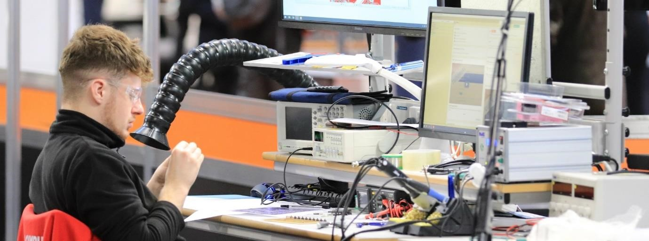

**Industrial Electronics Technical Handbook**

Steve Williams

WorldSkills UK

Steve.williams@gowercollegeswansea.ac.uk

We thank all the amazing sponsors that make this competition possible:

 

# Overview

Industrial Electronics encompasses a wide range of electronic applications. These include consumer electronics, medical electronics, industrial control electronics, and electronics in the aerospace and automotive industries, in fact, everything around us would not function without the world of electronics. Please see the following video which demonstrates the opportunities within the world of electronics. -<https://www.youtube.com/watch?v=Xy4xf3SEwvM>

# Competition Journey

## Stage 1 Pre-Competition Activity

This stage will provide some training to ensure the competitor is prepared for the entry stage. There are master class videos available for industrial electronics that will help develop core skills for the competition journey. This link will be available on the WorldSkills UK web site.

## Stage 2 Entry stage

The competition journey will begin with what is called a entry stage. This will be an online task that will ask the competitor to complete a pre-set task and then return this to WorldSkills UK. This is a really important part of the competition journey as it gives the competitor an early taste of what skills are needed to be successful on the journey. The task will come with a pre training pack that the competitor will have to study. Once this is complete the competitor will complete the task and then return to WorldSkills UK for marking. This will inform WorldSkills UK of the current suitability for the competitor to continue on the competition journey. There will be feedback provided to aid with future development if the competitor.

## Stage 3 National Qualifiers

For competitors who successfully completed the passive stage the next step is the national qualifiers. This is where the competitor will be allocated a physical local centre from where to compete.

This stage will involve the competitor completing the following tasks:

* project build (soldering and assembly of an electronics project)
* a theory paper set at level three to include analogue, digital and electronic principles.
* prototyping and measurement
* fault finding

This stage will be marked by WorldSkills UK expert judges. Each of the four disciplines attracts 25 marks giving a total of 100 marks. Competitors will be informed if they have been successful in progressing to the next stage.

## Stage 4 National Finals

The top eight (8) competitors in the UK will be invited to compete in the UK National Final which is the pinnacle of the UK national competition cycle. This is currently held in regions 2025 the region is Wales.

There is a host of pre competition training that will be offered to all finalists, this is normally a full week of electronics skill training. Further details of the competition are set out in the following information.

# Resources

For information and resources, including how to register, competition rules, and the steps to competing, visit:

[https://worldskillsuk.org/champions/national-skills-competitions/tools-andresources](https://worldskillsuk.org/champions/national-skills-competitions/tools-and-resources)

## Project specifications

Projects will be designed to test competitor’s technical ability, including:

* awareness of analogue and digital electronics
* soldering skills (through hole and surface mount)
* use of test equipment (oscilloscope, multimeters, power supply, function generator and logic probe)
* circuit design and simulation tools (Auto Desk Fusion and LT Spice)
* awareness of coding (Arduino)
* fault finding
* hardware design and prototyping

## Project example: National Qualifiers/Finals (Hardware Design)

**LT Spice:**

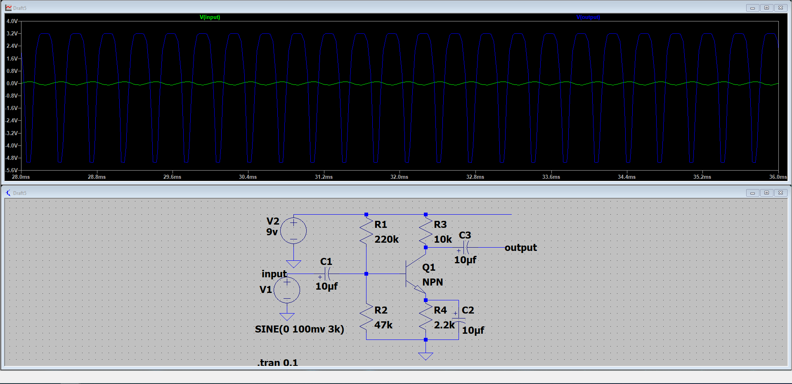

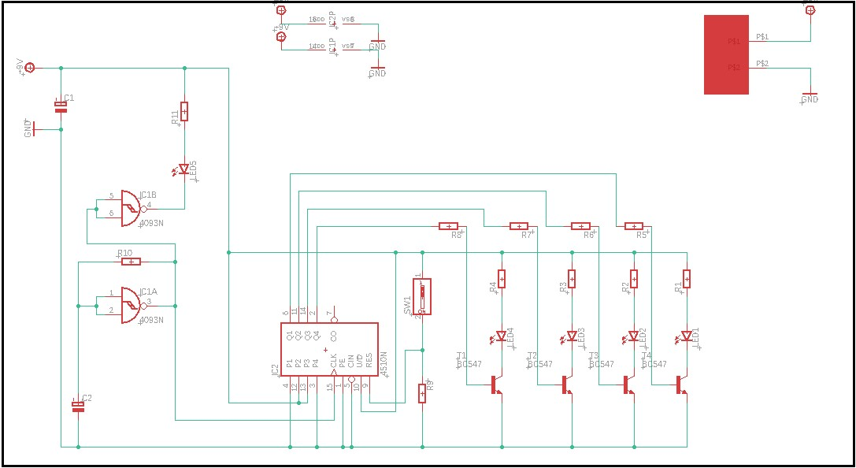

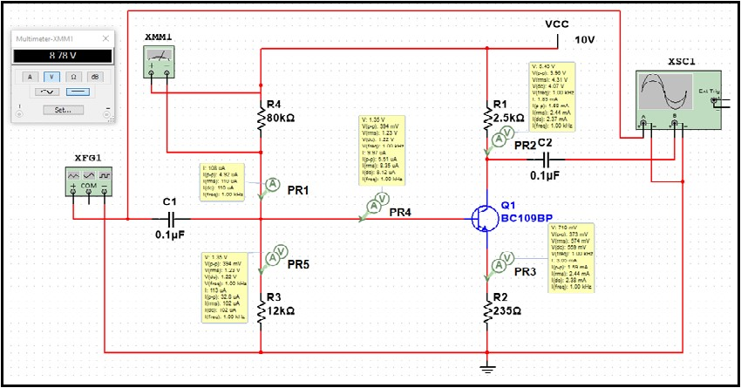

|  |
| --- |
| **Design requirements** |
| Competitors shall be able to:   * design small modifications to electronic basic electronics blocks * draw a developed circuit using E-CAD program * design a Printed Circuit Board using E-CAD program * assemble circuits and a Printed Circuit Board and develop into a prototype * display working simulation before production |

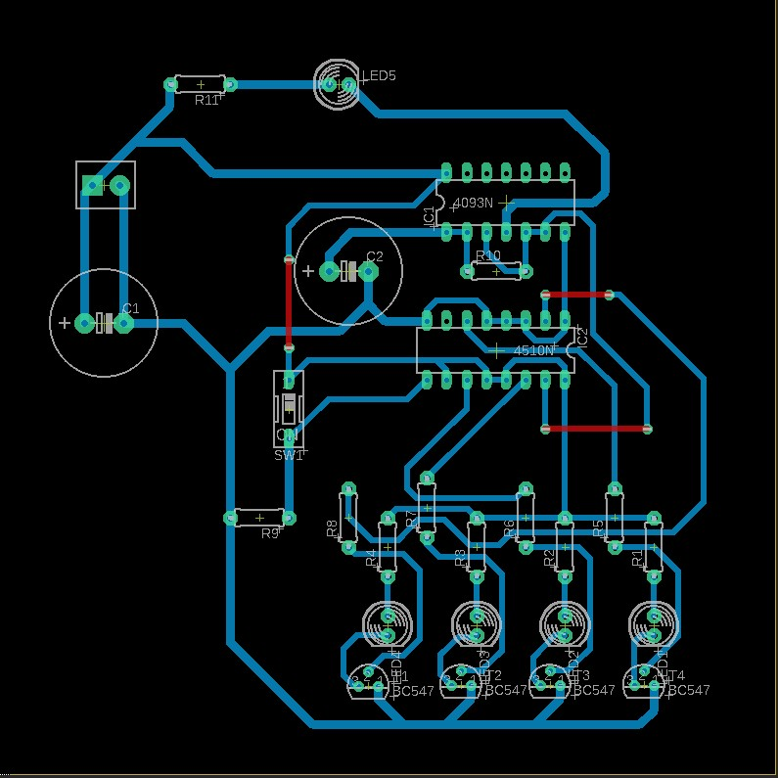

The above images show the full production phase. The first image is the LT Spice example of a simple single stage amplifier competitors will need to get familiar with the software which is open source. The second schematic/circuit design using AutoDesk Fusion. The third image shows a circuit fully simulating using Multisim, allowing the competitor to complete the final production stage. The final image then shows the circuit board neatly laid out following the design rules and ready to be milled.

# Marking Scheme

The marking scheme is designed to fairly compare every competitor’s work. Marking is split between measurement and judgement aspects. The marking scheme for the Hardware design considers elements such as design rules, functionality, PCB and soldering quality and the use of the E-CAD software packages. The tasks are broken down to four tasks with weighting applied. Each of the four tasks are worth 25 marks again giving a total of 100 marks. Marking is both measurement and judgment see detail below.

## Measurement

There are a number of design rules which can be used to determine measurement marks. The value of a given dimension is decided by its tolerance, which is split into:

* board dimension (0% tolerance, exact size to be entered)
* net line size (minimum of 0.2mm, maximum of 0.5mm) • power line size (minimum of 0.5mm, maximum of 1.0mm)
* clear difference in size between Net lines and Power lines.

All projects will be supplied with a mark summary form. The mark summary form will show only the number of marks assigned to each aspect, not the breakdown of marks (e.g., Hardware design will tally a total of 30 marks).

All marks for measurement criteria are “all or nothing”, e.g., if the board dimensions are 160mm x 120mm and they fall outside of these parameters, then they are awarded zero marks for that aspect. If the board is to the correct size, then the competitor would be awarded full marks.

# Judgement

Judgement marks are more subjective, for aspects such as:

* neat design with correctly aligned IC’s and components
* quality of finished PCB
* assembled PCB
* functionality
* voltage/current measurements
* correctly labelled waveforms

Judges will work to a judgement handbook with examples of each criterion. Each judge will reveal a value from zero to three, and an average will be taken. For example, if all judges assess the soldering quality as a two overall, the competitor will receive 66% of the possible marks. Judgement marking accounts for only 10% of the overall score.

Soldering joints should look like the image below to align with the IPC standard.

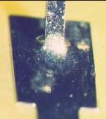

The soldering joints meet the IPC standards as they meet the following criteria:

* solder fillet appears generally smooth and exhibits good wetting of the solder to the parts being joined
* outline of the part is easily determined
* solder at the part being joined creates a feathered edge
* fillet is concave in shape

This competitor would be awarded full marks.

The following images show what you should avoid doing when soldering

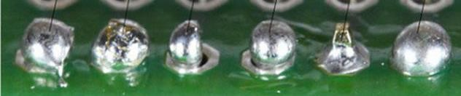

This time the soldering does not meet the IPC standards. This is because of the following points:

* solder fillet does not appear smooth, good wetting of solder to the lead is **not** evident.
* less than 50% pad coverage
* solder splashes evident and shorting visible
* cold joints
* insufficient wetting
* too much solder

This competitor would likely receive zero marks.

**What does excellence look like in Industrial Electronics?**

1. A strong skill set in ALL CORE ELECTRONIC DISCIPLINES.
2. Excellent innovative skill set.
3. Excellent ability to realise electronic designs.
4. A strong mind set with attention to detail.
5. Ability to work accurately at a fast pace.

“Excellence in electronics is the ability to bring innovative ideas to life to improve the world around us”.

# Equipment

During training and delivery of the National Finals, lots of tooling and equipment will be provided by WorldSkills UK and various competition sponsors. All provided equipment to produce the test project is specified here:

|  |
| --- |
| **Tools/Equipment** |
| Oscilloscope |
| Function generator |
| Power supply |
| Bench Multimeter |
| Soldering iron and fume extraction (including different tips) |
| BNC cables |
| Red/black banana leads |
| Tweezers |
| Wire strippers, snips and long nosed pliers |
| Screwdrivers |
| Digital magnification scopes |
| PC’s capable of running all necessary software |
| Bench lamps |
| Anti-static wrist bands |
| Solder Wick/De soldering stations |
| LPKF milling machine |

## Training

There is training available throughout each stage of the journey this is in the form of remote master classes culminating in mind set training with WorldSkills UK and a weeks dedicated technical training at the industrial electronics squad training centre.

**Stage - 1 Pre-Entry Stage:**

Using the on-line resources to check soldering skill level use the you tube link with your college training provider to run a soldering training event:

<https://youtu.be/3-1x-tlg-mk>

**Stage 2 – Entry Stage Training:**

Use the Autodesk Fusion Training package document linked in appendix

**Stage 3 - National Qualifier Stage:**

Use past examples linked in appendix

**Stage - 4 WorldSkills UK National Final:**

Use training plan outline in appendix

# Self-directed training

All competitors will need to practice to make it to the National Finals. Dedication is key to confident performance in a competition. To help with this, WorldSkills UK has handy guides on best soldering practices, beginners guides on how to use Autodesk Fusion, fault finding methods and sample codes that can be used to develop an understanding and how to interpret the code.

As part of the invitation to compete at the National Finals, competitors will be invited to a development training event, this will either be physical or online. This is an excellent opportunity for all competitors to boost their confidence using the equipment in a safe environment, while replicating the competition project and expectations. This training will cover:

* an introduction to Autodesk Fusion (Both schematic and board design)
* correct soldering technique up to IPC 610 standard
* a number of fault-finding techniques
* increasing the student’s ability to read and interpret schematics
* mind-set training
* competition craft

Companies may send representatives to visit the training at any point.

# National Finals

## What to expect

The National Finals are held in Regions for 2023/2024 they were held in greater Manchester. For 2025/26 the National Finals are being held across Wales. Specific skills clusters will be held in specialist venues. The competitor can expect a high level of technical tasks and technical equipment.

Competitors will be provided with accommodation near the venue with all costs covered for the accommodation and food.

The competition stand will be prepared with all the equipment necessary to compete. Each competitor will have a computer they can password protect, as well as a USB to back up files. Below is a typical timetable for national finals week:









13

# Beyond the National Finals

Looking beyond the National Finals, there are a host of opportunities for competitors. Age-eligible competitors who show the highest skills, passion, and drive to compete will be invited to train for the EuroSkills and WorldSkills international competitions.

Those who are not eligible for international competitions may join the Champions programme, which allows continued involvement, including the opportunity to work with WorldSkills UK and visit schools, colleges, and events to inspire the next generations.

Alternatively, if training is of interest to you, you could consider supporting WorldSkills UK with organising and training, and even helping to run the National Finals.

**Get inspired and you could become part of Team UK!**



Autodesk Fusion Training Videos

Available upon request from

[Steve.williams@gcs.ac.uk](mailto:Steve.williams@gcs.ac.uk)

Learning Lab link

<https://www.worldskillsuk.org/learning-lab/>