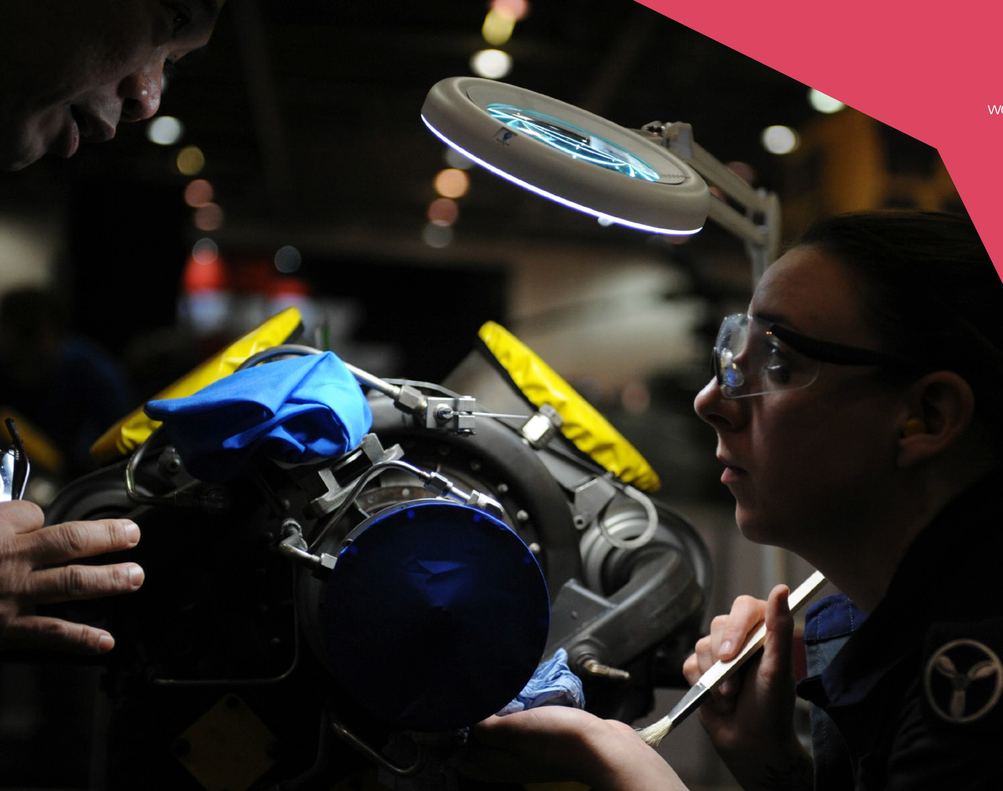

Additive Manufacturing Technical handbook

2025

**Table of Contents**



Sponsors 1

WorldSkills UK 2

Sector Overview 2

Career Pathway 3

Competition Cycle 4

Competition Overview 4

Entry Criteria 4

Competition specific rules 4

Pre-competition Activity 4

Digital Badges 5

Entry Stage 5

National Qualifier 5

National Final 6

Judges Top Tips 6

## - 01 -



# WorldSkills UK

WorldSkills UK is an independent charity and a partnership between employers, education and governments. Together, they are raising standards in apprenticeships and technical education to enable more young people get the best start in work and life. They are leading the charge to ensure that all young people have equal access to high quality apprenticeships and technical education, by:

* inspiring young people through their careers advice resources, to choose excellence through apprenticeships and technical education as a prestigious career route on their path to reaching their potential, whatever their background.
* developing excellence in young people by testing and assessing their skills and knowledge against their peers through their national and international competitions programmes, improving their confidence and potential.
* innovating to mainstream global excellence to help improve the standard of teaching, training and assessment through international benchmarking to help young people, employers and the UK economy succeed.

They are also part of WorldSkills, a global movement supported by over 80 member countries, which celebrates young people achieving world-class standards in the biennial ‘skills Olympics.

This link can be used to access more information about WorldSkills UK and the work it undertakes:

# Sector Overview

One of the newest and fastest-growing branches of engineering, Additive Manufacturing is more commonly known as 3D printing.

Traditional manufacturing methods, such as milling and turning, cut away material to create the desired end product. In Additive Manufacturing, layers are added in succession to achieve the same result.

Additive Manufacturing can be a more agile way to create strong and complex objects, such as prototypes, for industry and designers, and with less waste.

Working in Addictive Manufacturing requires a new approach to design and manufacturing. This includes a thorough understanding of the equipment for 3D printing and scanning, and the characteristics of the materials used, along with applied mathematics, geometry, and Computer Aided Design and Engineering (CAD and CAE). An understanding and imagination for the potential future uses of this technology is essential.

## - 02 -

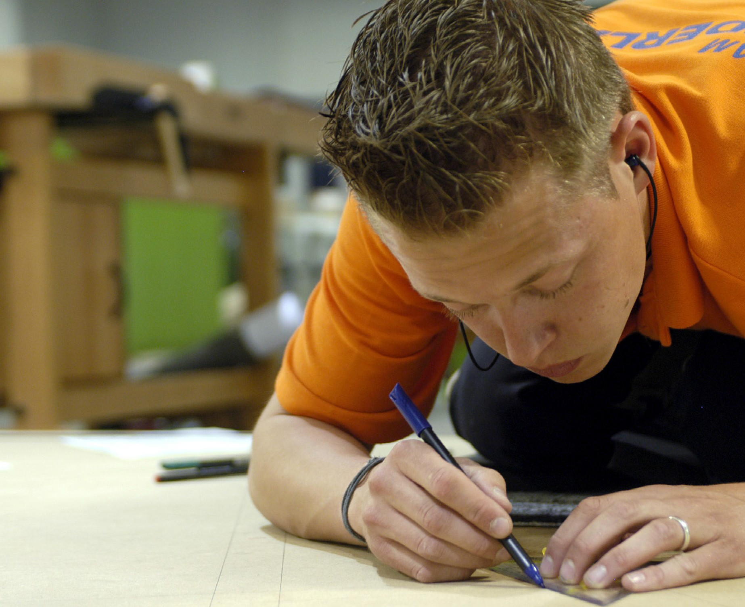

# Career Pathway

Additive Manufacturing is used by Designers, Engineers and Technicians to create parts, develop ideas and produce designs and models, including product concepts, Jigs and Fixtures, and end user parts. Individuals looking to work in Additive manufacturing will need to know about the different types of Additive Manufacturing technologies available, will need to be able to use a CAD design software, will need to be able to work with and capture part geometries from a scanner, as well as being able to prepare, print and post process a 3D model.

The individual will need to be capable in doing mathematical calculations in their day- to-day tasks, have the ability to use a computer and main software packages. Have excellent design skills knowledge while working well with others and using initiative.

## - 03 -



# Competition Cycle

### Date Stage

March Registration April -May Entry stage

May - June National Qualifier

July Announcement finalist

October Bootcamp November National Finals

# Competition Overview

This competition assesses the skills and abilities of competitors entering the field of Additive manufacturing

This competition consists of:

* An Entry stage, a remote assessment in which you must complete work in your own time and submit this for judging; (This will depend on the number of entries in a specific year)
* A national qualifying heat, which will be Remote for 2025 cycle
* You must attend and complete a series of tasks on a specific day, within a given timescale;
* A UK national final, taking place over 3 days in November as part of WorldSkills National Finals.
* Selection for International

**Core competencies** Competitors taking part in this competition should be able to demonstrate the following competencies:

### The skills you need to demonstrate:

* Numerical skills
* Communication skills
* Technical knowledge and expertise
* Methodical
* Accuracy
* Attention to detail
* Problem solving
* Team working

### The knowledge you need to demonstrate:

* Knowledge of additive manufacturing technologies
* Knowledge of Computer Aided Design (CAD)
* Reverse Engineering
* Obtaining Scan data

### The behaviours you need to demonstrate:

* excellence
* diversity
* fairness
* innovation
* integrity
* transparency

## - 04 -

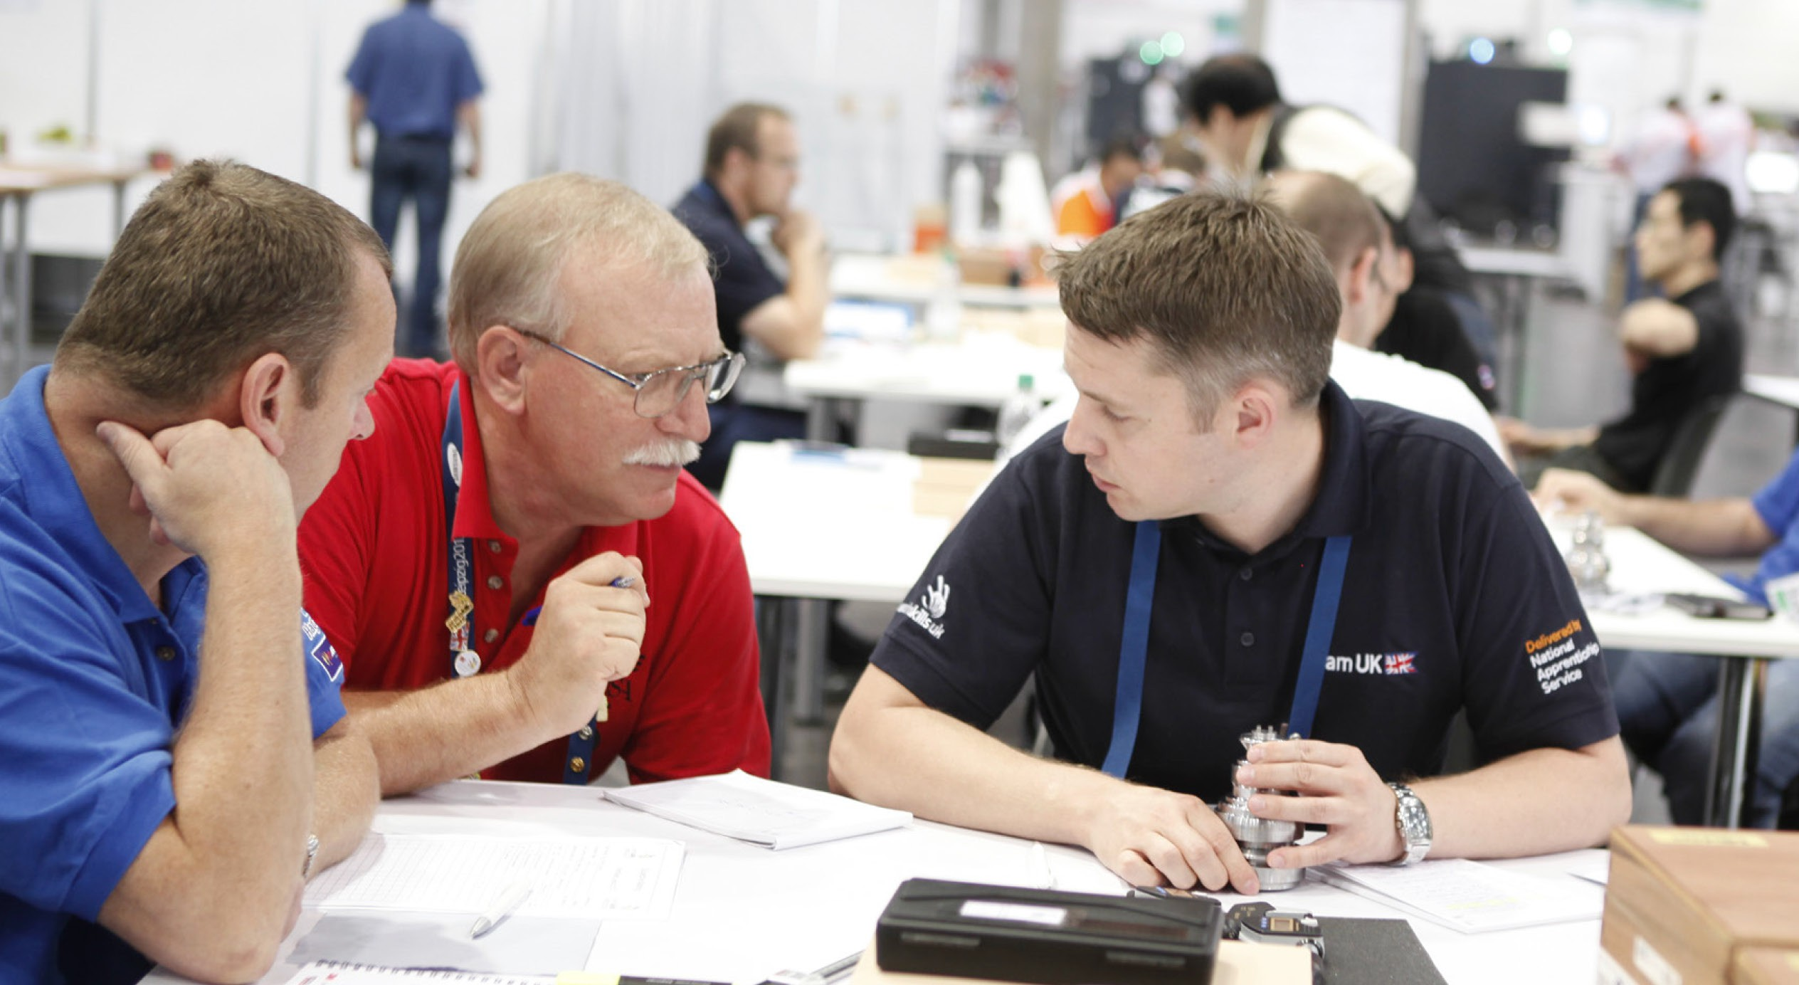



* Be able to use a CAD platform for the modelling of 3D parts and the reverse engineering of a part from scan data or a provided part.
* Be able to use a scanner to obtain part geometry.
* current internationally recognized standards (ISO)
* standards currently used and recognized by industry
* The preparing of models and setting up for printing on Material Extrusion and Vat Polymerisation technologies.
* Post processing of completed prints.

# Entry Criteria

* This is an individual competition.
* There is no limit to the number of competitors permitted to enter this competition per organisation.
* The competition is intended for those studying, training and/or working towards a relevant programme of study in 3D Computer Aided Design and Additive. Manufacturing at Level 3 or beyond.
* Anyone studying in a Sixth Form, Further Education setting, Higher Education setting, or are studying Post-16 Apprenticeships at a Level 3 or above can enter.
* This is an open competition and no industry experience is needed; competitors should have no more than five years’ experience, inclusive of training in a mechanical engineering working environment.

# Competition specific rules

TBC

- 05 -

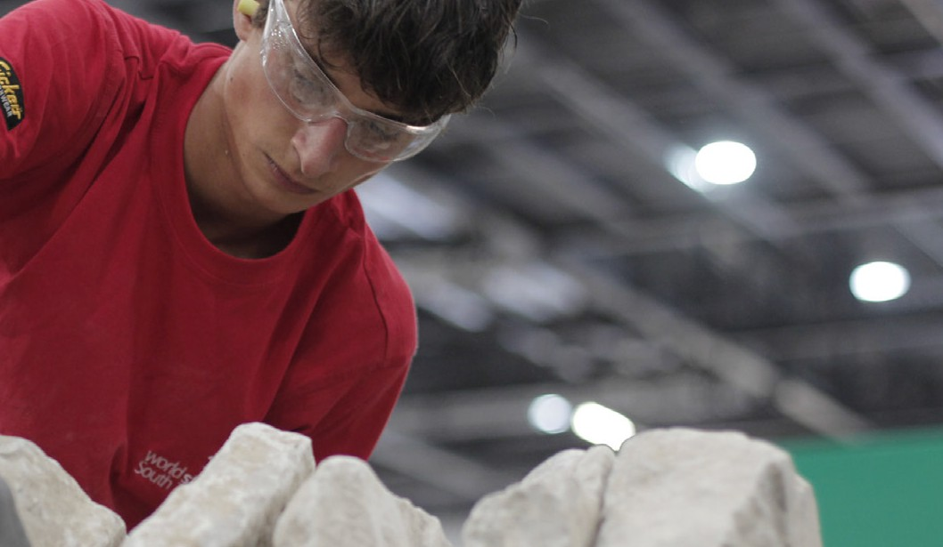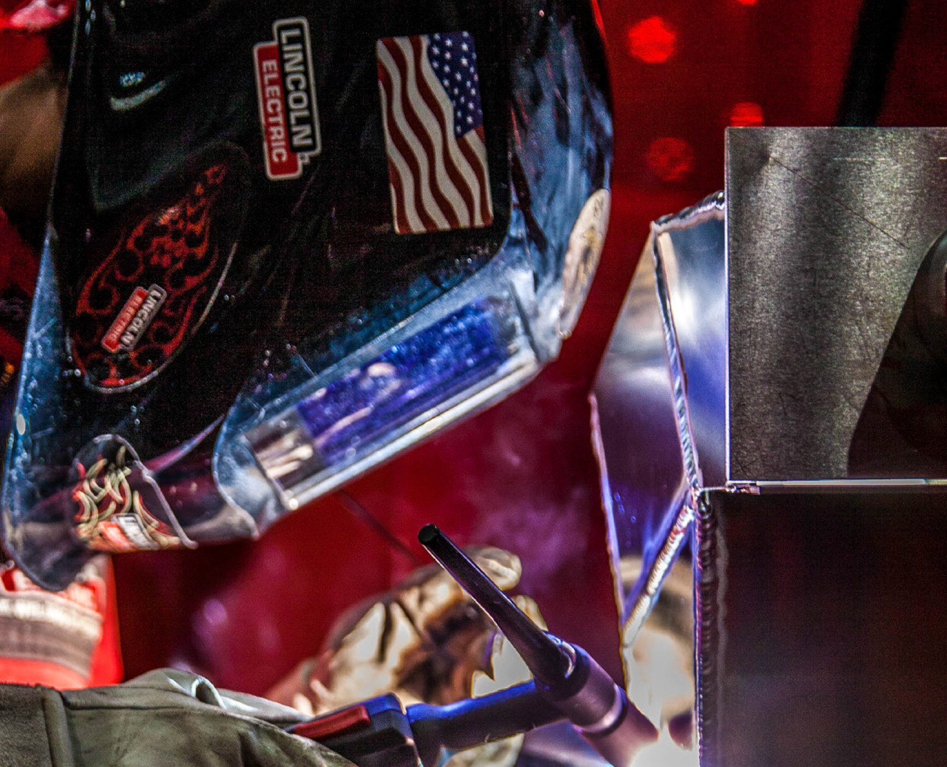



# Pre-competition Activity

Before registering to enter students and apprentices to take part in a WorldSkills UK Competition, it can be helpful to enable them to practice, test and challenge their technical and mental skills by getting involved in the pre-competition activity {add Link}, available on the bottom of the WorldSkills UK webpage. As well, the following activities could be used to support prospective competitors to get a feel for what will be expected of them in a WorldSkills UK Competition, whilst still in an environment with which they are familiar:

* on and off the job training and work experience
* WorldSkills UK or other externally run competitions
* internal competitions e.g. internal to an employer, specially designed competitions - using WSUK competition briefs
* local competitions e.g. in colleges and training providers.

# Digital Badges

As recognition of the participation and achievement of learners who take part in the competition you will be awarded a Digital Badge from WorldSkills UK. This credential has been awarded to those who have participated in our competition- based training programme. In taking part in this programme there has been a commitment to developing technical, employability and personal skills to a high standard using benchmarked assessments, leading to higher skills development. At each stage of the competition activity there has been personal and professional growth as well as developing skills, knowledge and behaviours in

vocational and technical education.

The digital badges are sent via Credly to your email and can be shared on social media platforms and in your email signature. For a short outline of the value of Digital Badges, look at our short video at [https://www.worldskillsuk.org/digital-credentials/](http://www.worldskillsuk.org/digital-credentials/) (45 secs).



- 06 -



# Entry Stage

The Entry Stage of the competition will be an online task aimed at challenging and assessing your knowledge of general and some specific topics of Additive manufacturing.

The tasks will consist of general knowledge questions on Additive Manufacturing and some basic use of a Computer Aided Design (CAD) Package to test your basic design skills.

There is a 1 hr allowance for the entry task from start to finish, you may continue to answer the questions after the hour, the time to complete the tasks will be used to rank the competitors if they achieve the same score.

The task will be completed through google forms, with each answer being multiple choice. Once started the timer will start to submission of the form.

On completion of the task, the form will Automark the answers.

When the entry online task has been completed you will be notified to let you know if you have scored high enough to go through to the National Qualifiers.

# National Qualifier

### National Qualifier – sample competition task

The following is an example of a sample task that may be asked at a National Qualifier. You may be asked to complete a number of tasks that equate to 5-6 hrs of competition time.

### National Qualifier Additive manufacturing

The Reverse engineering and printing of a part using Fused Filament Fabrication

technology

### Task:

Reverse engineer a provided part and then print on a Fused Filament Fabrication 3D printer

Time: 3.0 hours (time does not include printing time)

### Given:

Test part to reproduce 150mm Vernier gauge 30mm Steel Rule

### Task:

1. Measure and create a 3D model of a given part
2. Export the file and import into the required slicing software
3. Prepare the part for 3D printing using the chosen slicing software
4. Create an orthographic projection drawing of the part showing the main dimensions used to create the part.



Save all files as instructed Use of computer

Use of the computer is allowed from the beginning of the competition time. Output:

Software Modelled Part.

Notes:

Some marks are to be taken from digital files and the remaining from your printed part and your safe use of the 3D printing equipment.

Marking

There are a mixture of Objective and subjective Marking and broken down as follows:

|  |  |
| --- | --- |
| **Sample Aspect** | **Sample Mark** |
| Part Modelling | 30.00 |
| Orthographic drawing | 10.00 |
| Part printing setup | 10.00 |
| Correct inputting of results | 5 |
| Total Marks | 55 |
|  |  |

# National Final

The Additive Manufacturing national final usually takes place over two days of the competition.

2 x One day tasks (approx. six hours each day) – Additive Manufacturing:

The challenges will be divided into a couple of tasks during the day some examples are as follows:

* + Obtain broken part data using a scanner
  + Recreate a parametric part design from scanned data
  + repair broken element of the scanned part file
  + export the new file to the printer slicing software
  + set up and use FFF 3D printing technology to produce the new part

## - 08 -

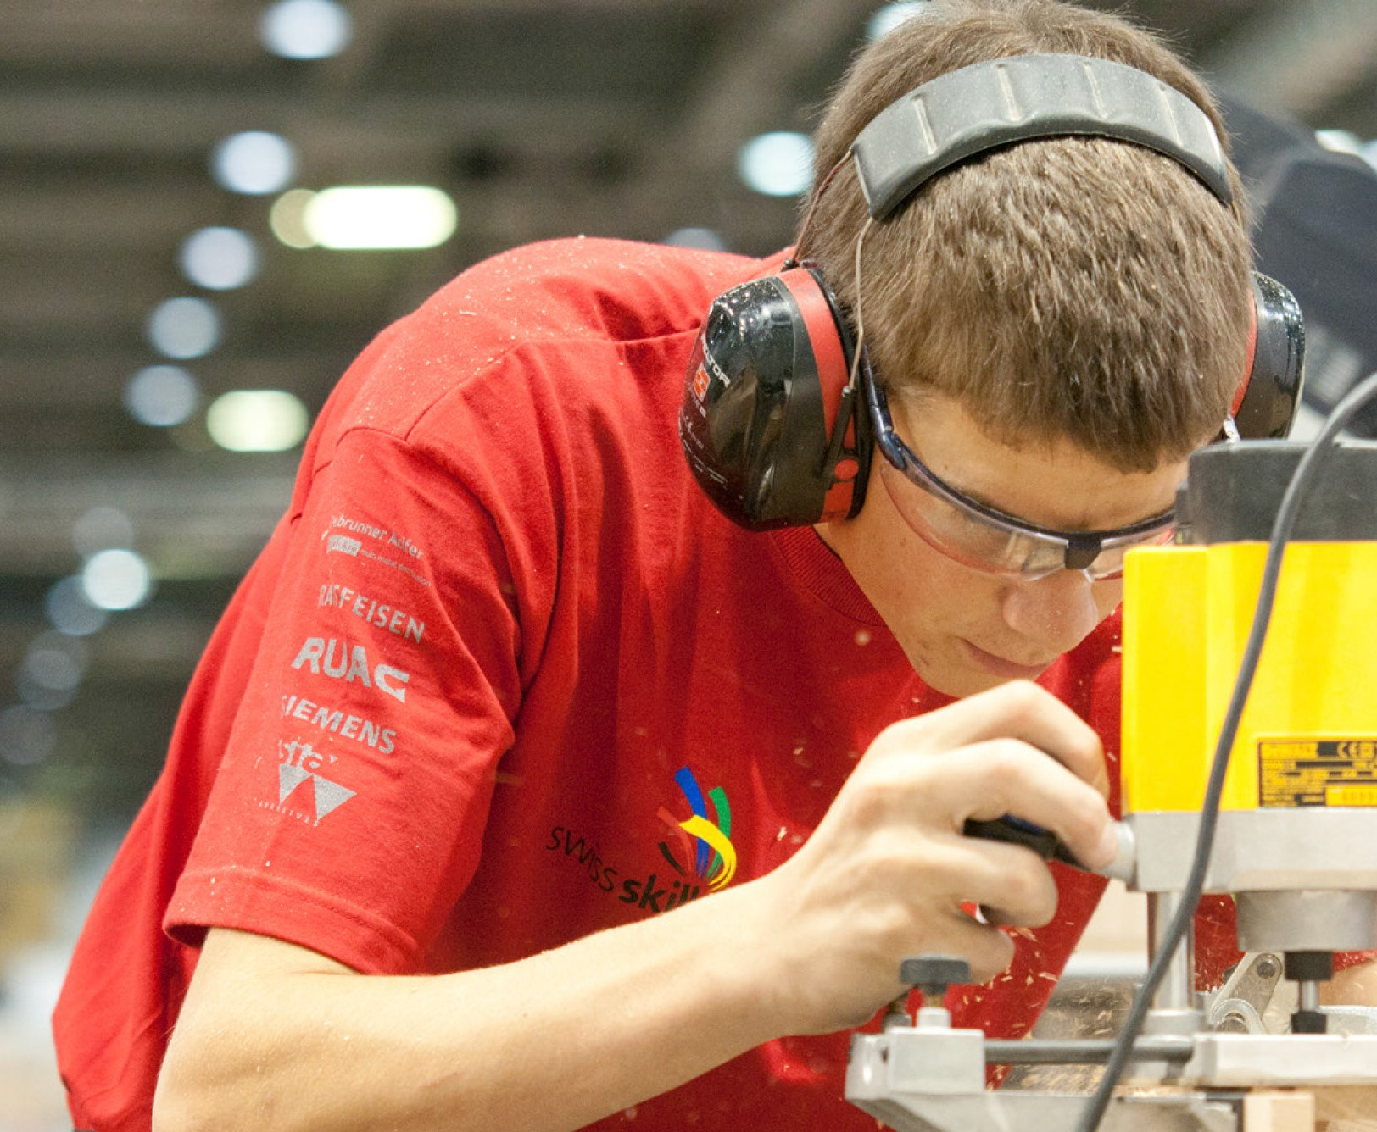



International Competitions

Looking beyond the National finals, there are a host of opportunities for competitors.

Age-eligible competitors who show the highest level of skills, passion, and drive to compete may be invited to train for the EuroSkills and WorldSkills international competitions. Those who are not eligible for international competitions may join the Champions programme, which allows continued involvement, including the opportunity to work with WorldSkills UK and visit schools, colleges, and events to inspire the next generations.

Information on the most recent International competition test project can be found here

- https://worldskills.org/internal/competition-documentation/special-edition-2022/test- projects/

# Judges Top Tips

Using the learning Lab, review and practice as much as you can

Remember accuracy is important and marks can be lost if you do not read the brief correctly

## - 09 -







**3DGBIRE** Units 44 & 45, Chorley North Industrial Estate, Chorley, Lancashire PR6 7BX

**T:** 01257 228 411 **E:** [enquiries@3dgbire.com](mailto:enquiries@3dgbire.com)

@3dgbire

[www.3dgbire.com](http://www.3dgbire.com/)

3dgbire