**AIRCRAFT MAINTENANCE**

**PRE-COMPETITION TEST PROJECT**



FOR ANY QUERIES REGARDING THE PRE-COMPETITION TEST PROJECT PLEASE CONTACT

Jamie Mapp-Jones, Jamie.mapp-jones@cambria.ac.uk

Jimmy Callaghan, wsukaircraft@hotmail.com

**AIRCRAFT MAINTENANCE PRE-COMPETITION EXERCISE**.

**SHEET METAL: LIGHT ALLOY PLATE & RIVETING EXERCISE**

OBJECTIVE - To read and interpret the engineering drawings provided and then manufacture the item to the specifications provided.

TASK TIME – No Formal time allocated but as a guide the task should take no more that 2 hours to complete.

MARKING – Basic marking guide is supplied. Standard used for Worldskills competition is IAW AC 43

**HEALTH & SAFETY**

It is the individual’s responsibility to take reasonable care of themselves and others whilst at work. This includes the correct wearing of appropriate Personal Protective Equipment (PPE), clothing and footwear for the activity being undertaken. Local risk assessment should be followed.

**INSTRUCTIONS**

The drawing is blank to allow for the trainer to set different scenarios. Metal thickness, size and style of rivets, Radius of the corners can all be changed to enable more than one practice drawing.

As a guide metal is of standard 2024-T3 and a thickness normally between 0.0032” – 0.0040” or 1mm – 1.6mm

Rivets are normally SP 71-xx or SP80-xx. Any style of aircraft rivet can be used. Rivets should be formed using pneumatic reaction. The riveting aspect will be carried out entirely by the competitor at the competition.

This task will be timed and as a guide 90 – 120 Minutes should be allowed to complete the task. Task should be completed with a tolerance of +/- 0.02”.

All materials and equipment must be marked out/used in the most economical method.

Marks will be awarded for the following:

* Attire and attitude to Safety
* Item manufacture
* Assembly
* Tolerance
* Workshop Practices

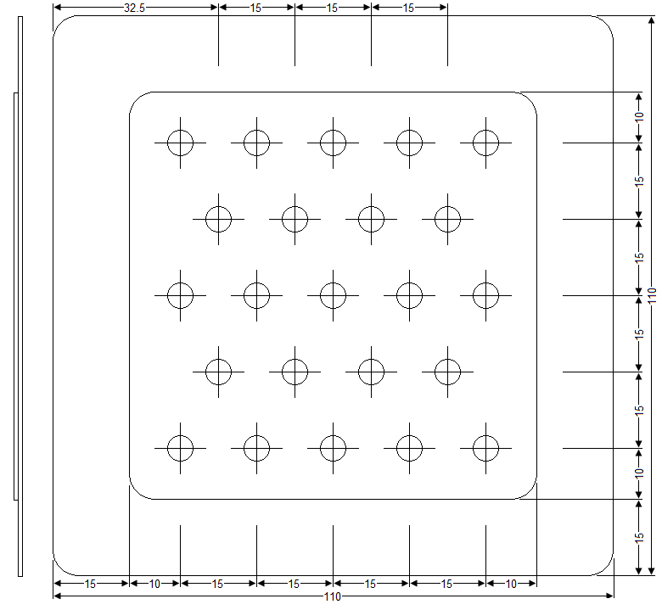

|  |  |  |  |  |
| --- | --- | --- | --- | --- |
| **Rivet Table** | | | | |
| CODE | Part No | Makers Head | Formed Tail | Number Of |
|  |  |  |  |  |
|  |  |  |  |
|  |  |  |  |
|  |  |  |  |
|  |  |  |  |  |
|  |  |  |  |
|  |  |  |  |
|  |  |  |  |
|  |  |  |  |  |
|  |  |  |  |
|  |  |  |  |
|  |  |  |  |
|  |  |  |  |  |
|  |  |  |  |
|  |  |  |  |
|  |  |  |  |

**Notes**

All radius to be ___________________ mm

Material to be ______________________

Rivet Selection IAW with Rivet Table above. All rivets should be formed IAW the AC 43

|  |  |  |  |  |  |  |  |
| --- | --- | --- | --- | --- | --- | --- | --- |
|  |  | Blank drawing allowing multiple changes to allow development of the competitor | National Finals Practice Riveting Exercise | Scale |  | Drawing Number |  |
|  |  | Tolerance |  | Drawn by |  |
|  |  | Finish |  | Date |  |