

Aircraft Maintenance Competition

***Technical Handbook***

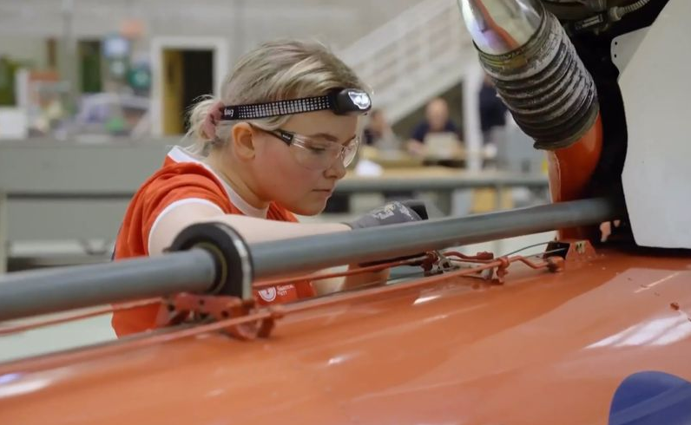

James Callaghan Lead Judge

Aircraft Maintenance

Tel: 07771801379

**E** [wsukaircraft@hotmail.com](mailto:wsukaircraft@hotmail.com)

Jamie Mapp-Jones

Competition Organising Partner

Coleg Cambria Aircraft Maintenance

Tel 07564850514

**E** [competitions@cambria.ac.uk](mailto:competitions@cambria.ac.uk)

Contents

## Page

Competition Sponsors 3

Abstract 4

Coleg Cambria overview 5

Role overview 6

Demonstrable skills 6

Job roles and careers advice 7

Information and competition entry overview 9

Competition structure 10

Competition specification 12

Core Competencies 13

General competitor instructions 17

Judges’ top tips 18

Complaints 20

Health and Safety 20

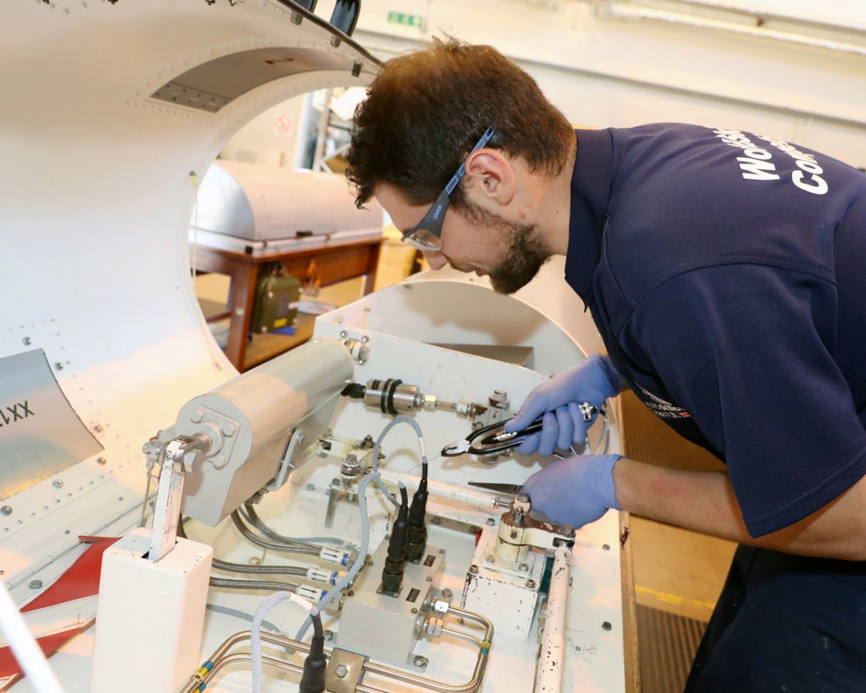

# Competition Sponsors

##### We would like to thank all our amazing sponsors that have assisted in making this competition possible:

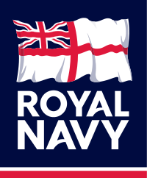

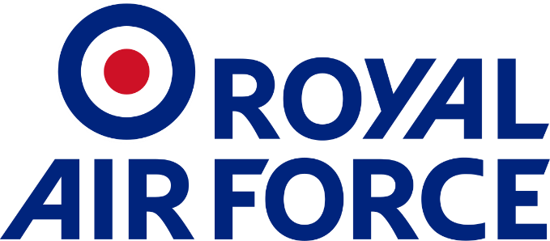

# Abstract

WorldSkills UK is an annual skills competition designed to promote standards and skills across the aero industry, developing competence into excellence.

The competition sees talented aircraft engineers test their expertise on a series of challenging practical tests in a bid to be named WorldSkills UK National Champion.

WorldSkills UK can bring invaluable benefits to students, colleges, and employers.

Competitors can gain recognition for exceptional skills, injecting dynamism, and excitement into training.

Employers can enhance their business reputation and improve the skills of their workforce.

The aim of this technical manual is to help competitors prepare for the Aircraft Maintenance competition from registration, through entry to qualifying and culmination at national level.

The guide contains general advice, technical tips and an in-depth overview of the competition structure and its content.

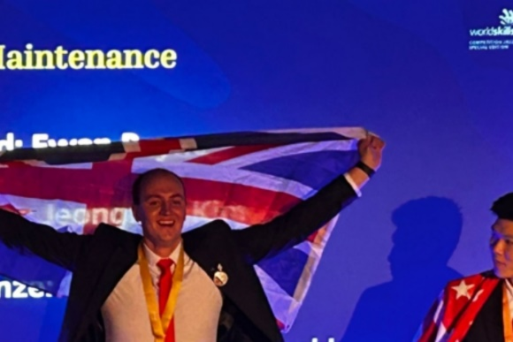

**Ewan Payne – WorldSkills International - Aircraft Maintenance Gold Medal Winner – Cardiff 2022**

**Haydn Jakes – WorldSkills International - Aircraft Maintenance Gold Medal Winner – Kazan 2019**



**Rosie Boddy – WorldSkills International - Aircraft Maintenance – Skills Champion – Lyon 2024**

# Coleg Cambria overview

We were founded back in 2013, and since then we’ve rapidly established ourselves as a leading UK education provider. We’re one of the largest colleges in both Wales the UK, with approximately 7,000 full-time students, 20,000 part-time learners and many international links.

Across our five sites, we offer a vast array of full-time and part-time courses including A Levels, GCSEs, BTECs, Welsh for Adults, and Higher Education. The college also works in partnership with over 1000 employers locally and nationally to help you gain apprenticeship and traineeship opportunities.

Coleg Cambria’s Institute of Technology Department in Deeside is the home of Aeronautical Engineering. Across Aeronautical Engineering alone, there is approximately 500 learners both full-time and day-release, working with companies all over North Wales and the North West of England. The Aeronautical workshops are equipped with two full-functioning Jet Provost Aircraft, a full equipped A318 Wing, A Rolls-Royce Conway Gas Turbine Engine, and work benches to accommodate 160 learners.

Coleg Cambria has supported WorldSkills UK Aircraft Maintenance for many years, however is really please to continue this support as the Competition Organising Partner for 2024. We really look forward to inspiring the next generation of Aircraft Engineers through this next competition cycle and beyond.



# Role Overview

Aircraft Maintenance Fitters/Technicians work on maintaining aircraft of all types from small aeroplanes to airliners, jet fighters and helicopters, and more recently UAV’s.

They are expected to carry out approved maintenance processes to maintain the airworthiness of the aircraft including inspection, servicing, modifying, troubleshooting, removal, installation, rigging, testing, and repairing.

Key attributes required by all aircraft maintenance technicians wherever they work are efficient work organisation, self-management, communication, interpersonal skills and problem-solving.

They must have the ability to work safely and rigorously adhere to civil or military regulations, manufacturer’s instructions, and organisational requirements. These universal traits are the benchmark of an outstanding aircraft maintenance technician.

It’s a responsible job as the aircraft maintenance technician is one of the last lines of defence to ensure the safety of the aircraft before flight, checking carefully and meticulously first time, every time.



# Demonstrable Skills

Teamwork Adaptability to change

Verbal communication Initiative

Working with technology Self-motivation

Problem solving Attention to detail

Observation Researching

Plan development Time management A genuine interest in, and passion for, engineering.

**Job role and careers advice**

To work on aircraft, you will need specific qualifications and certification, just as pilots are trained and then licensed to fly, aircraft maintenance engineers and fitters are trained and licensed to maintain the aircraft to an industry standard whether civilian or military based,

###### Travel

Aviation is a global industry and as such engineers and mechanics often have to work abroad to support airline operations at overseas airports. Financial models require aircraft to be operating at maximum profitability so an aircraft on the ground (AOG) situation requires rapid support. Military operations require working abroad, under possible hostile environments.



###### Hours

Aviation requires around the clock operations which is reflected in the need for a varied shift pattern workforce.

###### Environment

Tasks range from an indoor maintenance to flight line ramp operations sometimes at extreme temperatures and if military-roled under harsh physical locations with minimal comforts.

###### Salary

Salary is based on multiple factors.

Experience

Level of licence held

Number of aircraft types authorised to maintain Mobility

The starting salary for both civilian and military maintenance engineer averages £20k a year.

An experienced Aircraft Engineer with 10 plus years’ experience having attained the expected specialist qualifications can expect an average total salary of £40k.

#### Career’s advice

Most popular route is through an apprenticeship usually with a blended approach of on-the- job placement training alongside classroom based theoretical and system understandings.

This can be through a learning provider, further education institute, an aircraft operating concern with an in-house training facility or the military route.

[www.careersinaerospace.com](https://gbr01.safelinks.protection.outlook.com/?url=http%3A%2F%2Fwww.careersinaerospace.com%2F&data=04%7C01%7Coknight%40worldskillsuk.org%7C90dcbdfea11c4384b48e08d9dcedef49%7C8167e3da8c51471c9f34326988053d0a%7C0%7C0%7C637783736747080703%7CUnknown%7CTWFpbGZsb3d8eyJWIjoiMC4wLjAwMDAiLCJQIjoiV2luMzIiLCJBTiI6Ik1haWwiLCJXVCI6Mn0%3D%7C3000&sdata=09G6soJxk09WxIuuLI%2FIGuGcml0BdwIG5t2VCIKg%2Fcc%3D&reserved=0) has a lot of useful guidance for young people who want to embark on a career in the aerospace industry, including apprentices

Other enquiries can be advanced through following links;

<https://www.gov.uk/become-apprentice> <https://nationalcareers.service.gov.uk/>

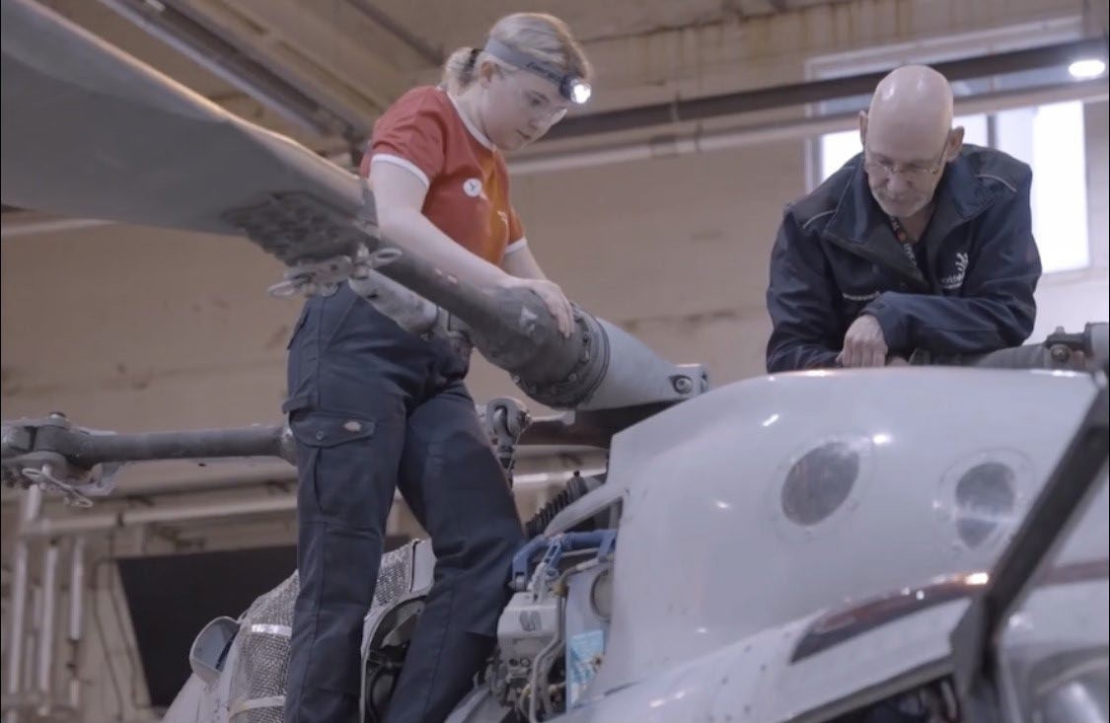

# Information and competition entry overview

#### WorldSkills UK information and Resources

WorldSkills UK has a wealth of information, guidance and resources on its website aimed at helping learners, educators, and employers.

[WorldSkills UK - Home Page](https://www.worldskillsuk.org/) [Skills Development Hub](https://www.worldskillsuk.org/skills/skills-development-hub/) [Careers Advice Toolkit](https://www.worldskillsuk.org/educator-resources/careers-advice-toolkit/) [Centre of Excellence](https://www.worldskillsuk.org/educator-resources/centre-of-excellence/)

#### WorldSkills UK Registration

For general information and resources on the WorldSkills UK 2025competition cycle including how to register, competition rules and the steps to competing, visit the following link; <https://www.worldskillsuk.org/skills/national-competitions/>

Further information relevant to pre-registration preparation can be found at; [Competition Development Programme](https://www.worldskillsuk.org/skills/competition-development-programme/)

For the Aircraft Maintenance landing page visit <https://www.worldskillsuk.org/competitions/>

#### Competition Entry Criteria

This is an individual competition

There is no age limit for Regional or National Competitions

The competition is intended for those studying, training and/or working in the aircraft maintenance industry. As such, competitors must be familiar with the core competencies listed in this handbook and either meet or at least be working towards one of the following criteria;

Studying or enrolled on a level three programme Achieved a level three qualification in the last 12 months Gained a EASA Part 66 Qualification.

Up to level three for England, Northern Ireland, and Wales, Up to level six for Scotland

Or up to five years’ experience in a working environment).

There are no restrictions on what organisation may enter a competitor and they may enter learners/employees from learning institutes (colleges, universities, schools) or business of any size.

# Competition Structure

#### Registration

Once you have completed your registration (and accepted all terms and conditions) you will receive email conformation, and someone from Coleg Cambria Competitions Team will be in touch to arrange a time and date to email a link to complete the Entrytest online

Prospective students should try to familiarise themselves with working under competition style activities, for example have a fellow student judge a completed work task during a timed practical session at college/training provider.

#### Entry Stage

The entry test consists of multiple choice type questions. It is to be completed within 1 hour. It will be timed. This also MUST be completed INDIVIDUALLY and not as a group.

It covers a range of relevant topics and is aimed at challenging and assessing your knowledge of general and specific topics of aircraft maintenance.

When all registered entrants have completed the entry test, you will be notified if you have scored high enough to progress to the National Qualifying round.

#### National Qualifiers

Ensure you are ready to compete in your National Qualifier by reading and understanding the project brief, core competencies. This outlines the tasks you will be expected to carry out.

Ask your lecturer/employer for help in any areas where you feel you may have any knowledge gaps and work to improve/gain the necessary skills.

The National Qualifier will take place at Coleg Cambria College, Connah’s Quay, Deeside, CH5 4BR. Competition dates to be released in due course, but an expectation will be June 2025

Competition consists of three stances each one hour in duration. A competitor will be allocated a time and date and complete all tasks within a single AM or PM. Unsuitability of assigned time/date are to be discussed with the Coleg Cambria Competitions Team.

#### WorldSkills UK Pre-National training

As part of the invitation to compete at the National Finals, WorldSkills UK Aircraft Maintenance will host an online seminar to discuss stance, and what additional training competitors can do to help them prepare for the Finals. Further details and date are to be arranged after the qualifying heats.

#### WorldSkills UK National Final

The 8 highest scoring competitors across the National Qualifier will be invited to complete at the finals.

Competition consists of eight stances of varied duration totalling 18 hours over 2 ½ days.

Ensure you are ready to compete in your WorldSkills UK finals by reading and understanding the project brief, core competencies. This outlines the type of tasks you will be expected to carry out.

Ask your lecturer/employer for help in any areas where you feel you may have any knowledge gaps and work to improve/gain the necessary skills.

#### WorldSkills UK International Competitions

Beyond the national finals, there are a host of opportunities for competitors.

Age-eligible competitors who show the highest skills, passion, and drive from the national finals may be given the opportunity to compete to train for the EuroSkills and WorldSkills international competitions.

Those who are not eligible for international competitions may join the Champions programme, which allows continued involvement, including the opportunity to work with WorldSkills UK and visit schools, colleges, and events to inspire the next generation.

Alternatively, if training is of interest to you, you could consider supporting WorldSkills UK with organising and training, and even helping to be part of the National finals.

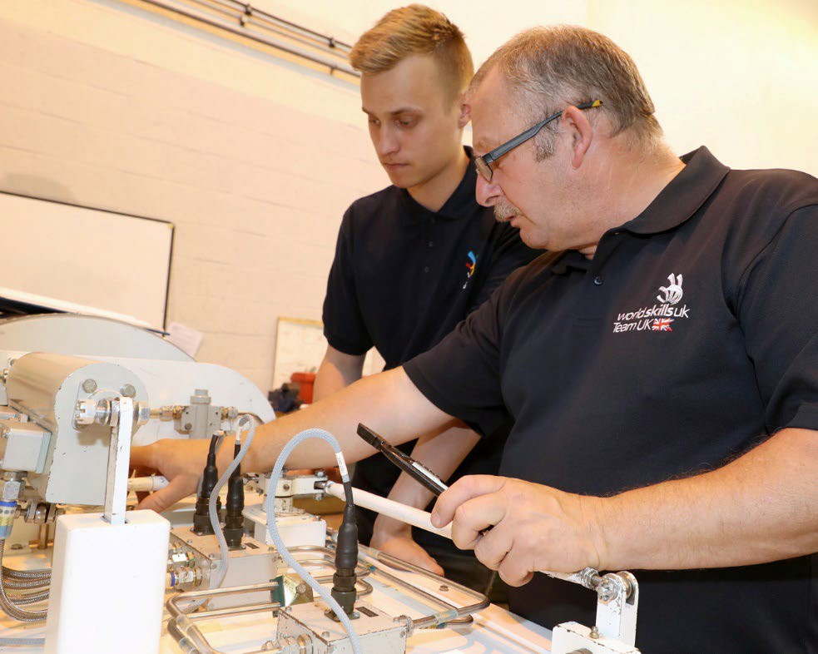

# Competition Specification

The competition has been designed to reflect the role of an Aircraft Mechanical Technician and the standards that are expected within the aeronautical industry.

At the Qualifying and National competition, competitors will undertake the following taskings:

Aircraft knowledge

Airworthiness check of an aircraft and/or individual component with possible associated defect rectification

Design, build and test a hydraulic circuit Engine borescope

Flying control rigging Sheet Metal repair

Component removal, inspect and refit Composite repair

Avionic / Electrical loom repair / diagnosis

#### Marking Allocation

The following is the marking criteria for the Qualifying competition:

|  |  |  |
| --- | --- | --- |
| **Criteria** | **Task** | **Mark** |
| **A** | Sheet Metal | **33.33%** |
| **B** | Component Inspection | **33.33%** |
| **C** | Flying Control Wear Check | **33.33%** |
|  | **Total Marks** | **100%** |
| The following is the marking criteria for the National Final: | |
| **Criteria** | **Task** | **Mark** |
| **A** | Aircraft Airworthiness Check | **12%** |
| **B** | Hydraulic Circuit Design and Build | **14%** |
| **C** | Mechanical Rigging & Control | **12%** |
| **D** | Engine Borescope | **8%** |
| **E** | Sheet Metal | **20%** |
| **F** | PFCU removal | **12%** |
| **G** | Composite | **14%** |
| **H** | Avionic/Electrical Loom Build | **8%** |
|  | **Total Marks** | **100%** |
|  | |  |

# Core Competencies

The following table lists the competitions core competencies and the expected standards within these from the WorldSkills UK national qualifiers through to the UK National Final.

|  |  |  |  |
| --- | --- | --- | --- |
| **Core Competencies and standards for WSUK UK Skills Competition activities** | | **Qualifying** | **UK Final** |
| **Working Environment** | | | |
| **Competency** | Knowledge and understanding of the working environment including:  Comprehension and compliance with industry standards/laws relating to safety and hygiene  Compliance with use of appropriate personal protective equipment for the working environment (PPE)  Requirement for a workplan Industry standard manuals  Precautions for safe use of tooling as required, including (but not limited too) - hand, power, cutting, electrical, wiring, pneumatic, calibrated and precision tools i.a.w normal and safe operations  FOD and the implications within the aviation industry  Cost and logistic resupply implications when using consumable materials | **Y** | **Y** |
| **Standard** | Competitors shall be able to:  Comply with Health and Safety regulations & documentation Identify and use the appropriate personal protective equipment Work carefully within their work/competition environment  Plan and organise work and resources, demonstrating effective time development  Use a variety of tools (as required on both Mechanical and Avionic slanted taskings) in accordance with normal and safe operations  Conduct pre-use and calibration torque checks on equipment as required Undertake continual awareness of FOD and the need to minimise  Use consumable materials economically | **Y** | **Y** |
| **Aircraft Airworthiness check** | | | |
| **Competency** | Knowledge and understanding of:  Working on aircraft  Following process driven instructions Common fault parameters and recognition  Interpret and act upon pilot divulged information to aid fault rectification | **Y** | **Y** |
| **Standard** | Competitors shall be able to:  Safely navigate around, over and under the aircraft in accordance with judge's direction given at aircraft familiarisation  Conduct an airworthiness inspection on a generic aircraft and/or specific components to determine serviceability status and if safe for further flight or additional inspections required  Identify and correctly document fault symptoms on industry standard paperwork to reflect serviceability status | **Y** | **Y** |

|  |  |  |  |
| --- | --- | --- | --- |
|  | Interpret and troubleshoot pilot information to guide fault rectification Complete first line depth maintenance on defects found during inspections  Accurately and efficiently troubleshoot the causes of unserviceability's, clearly record defects, and required rectification actions |  |  |
| **Hydraulic circuit design and build** | | | |
| **Competency** | Knowledge and understanding of:  System design requirements BS2917 and ISO symbology Fundamental hydraulic principles  Function of the major system components Importance of contamination management  Setting up procedures relating to hydraulic components  Safe working practices associated with application of hydraulic power | **N** | **Y** |
| **Standard** | Competitors shall be able to:  Interpret written system parameters into basic block build  Select and install components as prescribed by the circuit diagram and system requirements Construct simple hydraulic circuits to demonstrate Flow, Pressure and Direction  Test and functionally prove the performance of system involving the use of basic diagnostics Trouble shoot and overcome development issues post and during testing phases  Work with live hydraulics and applying safe working practices | **N** | **Y** |
| **Mechanical rigging and control** | | | |
| **Competency** | Knowledge and understanding of:  Working on aircraft  Following process driven instructions Component removal  Method of ensuring system operability is sufficiently restricted and the requirement for personnel safety whilst undertaking maintenance  Cable damage criteria Cable tension principles  Torque settings and measuring  Types of locking devices required during normal maintenance Types of serviceability inspections methods and criteria | **N** | **Y** |
| **Standard** | Competitors shall be able to:  Safely navigate around, over and under the aircraft in accordance with judge's direction given at aircraft familiarisation  Understand and follow process driven instructions  Ensure aircraft placed in safe scenario to allow personnel safe to interrupt and conduct system maintenance  Component removal including item/system/aircraft safeguarding from environmental and personnel induced damage during system disassembly and reassembly  Perform multiple locking methods including wire locking, split pins, tab washers Set flight control travel limits within range stops  Complete torque checks, conversion between units of measurements, torque meter settings and interpretation | **N** | **Y** |

|  |  |  |  |
| --- | --- | --- | --- |
|  | Complete visual and detailed cable examination to assess serviceability status  Rig, tension and functionally test flight systems to manufacturers parameters and recognise indication of malfunction or incorrect rigging, abnormalities, or adjustment  Accurately and efficiently troubleshoot the causes of unserviceability's, clearly record defects, and required rectification actions |  |  |
| **Engine Boroscope** | | | |
| **Competency** | Knowledge and understanding of:  Boroscope methodology  Types of distress commonly found within the combustion chamber. Compressor, combustor chamber & turbine distress limits.  Applying borescope inspection techniques to safely perform required inspections without damage to engine components  Identifying and correctly assessing and reporting/recording defect indications | **N** | **Y** |
| **Standard** | Competitors shall be able to:  Gain access to borescope portholes through equipment removal, as required  Use handheld borescope equipment in accordance with manufactures instructions Manipulate borescope into areas to visualise distress without causing further damage Accurately measure features, position, magnitude, dimensions, and defect types Generate borescope reports | **N** | **Y** |
| **Composite** | | | |
| **Competency** | Knowledge and understanding of: Measuring, cutting and fabrication Repair processes  Patch design Ply orientation  Aerodynamic requirements Curing methods  Setting up vacuum bags  Calculating Resin Ratios | **N** | **Y** |
| **Standard** | Competitors shall be able to:  Transpose data, dimensions, and information from technical drawings to materials Trim material to required measurements and tolerances  Demonstrate vacuum bagging  Design and manufacture a suitable repair insert and overlay patches Complete a hand lay-up | **N** | **Y** |
| **Sheet metal** | | | |
| **Competency** | Knowledge and understanding of:  Precautions for the safe use of mechanical and hand operated equipment Types of various technical drawings  Measuring, cutting and fabrication Drilling techniques and sizing  Finishing techniques with files, sanding, and deburring Aeronautical sheet metal industry standards and practices  Assembly technique for multiple sheet metal plate using multitude array of fasteners | **Y** | **Y** |

|  |  |  |  |
| --- | --- | --- | --- |
| **Standard** | Competitors shall be able to:  Interpret drawings and extract information as required Transpose dimensions from technical drawings to material Trim materials to required measurements and tolerances Removal of metal with varying levels of access  Drill and countersink holes to different sizes  Apply appropriate finishing techniques to faces, edges and holes Perform in accordance with AC43-13  Install variety of rivets, solid and blind (countersink and snap) to assemble the repair | **Y** | **Y** |
| **Component removal** | | | |
| **Competency** | Knowledge and understanding of:  Follow process driven instructions Component removal techniques Torque settings and measuring Types of locking devices required  Types of serviceability inspection methods and criteria | **Y** | **Y** |
| **Standard** | Competitors shall be able to:  Understand and follow process driven instructions  Component removal including item/system/aircraft safeguarding from environmental and personnel induced damage during system disassembly and reassembly Safeguarding items removed to ensure rebuild completed correctly  Complete torque checks, conversion between units of measurement, torque-meter setting and interpretation  Perform multiple locking methods including wire-locking, split pins, tab washers Complete visual and detailed examinations to assess serviceability status | **Y** | **Y** |
| **Avionic/Electrical Loom Build** | | | |
| **Competency** | Knowledge and understanding of: Follow process driven instructions recognition of electrical components Standard wiring practices manual  Manufacturing of aircraft electrical looms and terminations Correct tooling  Follow process driven instructions | **N** | **Y** |
| **Standard** | Competitors shall be able to:  Correctly carry out process driven SST.  Multimeter (Fluke 112) Pre-use checks and operation Follow a standard wiring diagram  Correct selection of components from stock  Sound understanding of the theory and operation of the circuit Correctly carry out an SST to ensure serviceability of the aircraft system | **N** | **Y** |

# General Competitor Instructions

It is the competitor’s responsibility to arrive at the event each day, late arrivals risk exclusion or reduced timings.

If travelling long distances to the competition discuss with Coleg Cambria Competitions Team

A hands-off, walk around will take place prior to competition commencement of any stances to allow familiarisation with equipment due to be used. Judges will be onsite to answer generic questions accordingly. No practicing of the task will be entertained.

Unless directed otherwise the timing for the task will commence immediately after the judges Health & Safety brief. Any additional time for familiarisation will be indicated prior to the task bespoke brief starting.

Ensure that you have read and fully understood the task objective, including the time allocated for the task and all supporting resource material provided within the Competitor Task Sheet. When you are content with what is required you should alert the judge and then initiate your work.

All materials and equipment must be accurately checked by the competitor upon commencing the competition and marked out/used in the most economical method. Marks will be deducted for inaccuracies beyond tolerances as indicated on the drawing and the marking schedule.

Specifications, drawings, technical guidance, consumables, and all tooling will be provided prior to commencement.

On completion all tools/equipment to be returned to their correct stowage, area cleaned and presented to the examiner. Marks will be lost for misplaced, lost, or spoiled materials and equipment if as a direct resultant of competitor action.

Should you sustain an injury which requires first aid treatment then you are to bring it immediately to the attention of the task judge who will determine the course of action required. Whilst a course of action and subsequent consequential actions are complied with, the event clock will be stopped. The clock will be restarted upon subsequent event recommencement.

Competitors may leave the area for comfort and non-essential breaks, but the tasking clock will not be stopped.

Judges may be required to carry out stage checks as deemed necessary. When required the clock will be stopped and not restarted until completion of the stage check and the competitor is able to resume the competition.

Competitors are actively encouraged to wear branded corporate clothing promoting their college/employer.

# Judges Top Tips

The following tips are neither exhaustive nor prescriptive and not a ‘magic’ formula to success. However, these are tips based on being involved with competitions for many years and they should assist you in future competition participation.

###### Preparation and Practice

A successful competitor needs to be calm, confident, and self-assured when competing. Prepare by practising your skills and techniques to ensure you achieve the required standards/results

###### Pressure

Undoubtedly you will be nervous and stressed.

However manageable stress gives increased energy and raised performance potential. The key is managing the level and not allowing induced pressure to overwhelm you.

###### Understanding the task

Listen to/read the Judge’s brief and ask questions if unsure.

Note that depending on the nature of the question asked the judge may decide that guidance is not appropriate in the interest of the competition.

Read the competitors’ brief at least twice - all task information is in the brief.

Take a deep breath and start the task. You are against the clock, so work with focus.

###### Standards

Remember tolerances are the limitations on full marks being awarded. Once achieved move on.

Think cleanliness, ensure the work is clean enough to ensure the judge can mark. If a Stage Check is mandated ensure it is completed – marks will be lost for non- compliance.

###### Time Management

Learn to manage your time effectively when completing tasks by working smart not fast. Practice working to time constraints under pressure to perfect your timings.

Section the task into stages and allocate timing blocks accordingly.

When sections are completed revisit the time allocation and readjust as required.

###### Task Completion

Remember, it is a competition and everything you do within the task is marked and therefore either worth points or subject to negative marking in the event of unsatisfactory completion.

Finish the task – you can’t obtain marks if you don’t complete the task.

###### Holistic view

Keep yourself fit.

Have a positive and confident mental attitude

Drink water not energy drinks – they give a short performance energy burst but concentrations will drop dramatically.

Eat well – bananas are a good source of slow, lasting energy release. Get decent sleep hours.

Be wary of alcohol.

###### All going wrong

Take a moment, step back and think. If necessary, re-read the brief.

Refocus, deep breath and go again.

After completion if the task hasn’t gone as well as planned, do not dwell, move on, and start the next time afresh. The competition is designed to test you so don’t feel bad.

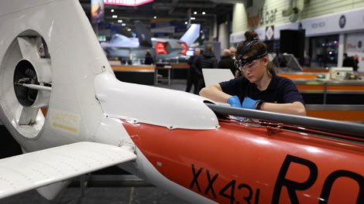

###### Final Considerations

Everything you do is marked so always think excellence.

Aircraft technicians always think FOD so ensure you maintain a tidy work area. Ensure time is allocated to ensuring the area is cleaned upon task completion. Tools and equipment’s should be returned to the correct stowage’s.

Using calibrated hand tools - think calibration checks.

Using POL - think COSHH, Risk Assessments, Safety data sheets Think Safe - think PPE

And above all - enjoy the experience, no matter how far you make within the competition. Remember you’ve earnt your place here, whether it be by employer/college recommendation or excellence at a qualifying competition.

# Complaints

A copy of the WorldSkills UK Complaints Procedure will be communicated to all competitors prior to commencement.

A copy will be available throughout the competition.

# Health and Safety

Competitors must provide their own safety footwear.

Generic and bespoke Health & Safety brief will be conducted immediately prior to the task commencing.

It is the individual’s responsibility to take reasonable care of themselves and others whilst at work. This includes the correct wearing of appropriate clothing and footwear for the activity being undertaken.

Any specialised Personal Protective Equipment required for an activity will be made available by the competition host.

Judges are to provide direction on any actions that are in contravention of the Health & Safety regulations and where appropriate they may deduct marks for such non-compliances.

Continual disregard for Health & Safety by a competitor will result in the task being terminated prematurely. A competitor will be warned if his continuation of Health and Safety disregard is considered of a severity worthy of expulsion. Lead judge decision will be final.

### The best thing about my skill is the satisfaction I get from keeping aircraft safe.

### Skills have changed my life because of opportunities and experiences that I have had so early in my career.

### You should consider a skill as it is a very rewarding career path with many opportunities that you could never imagine existing!

#### Jarrod Wood,

#### WorldSkills International - Aircraft Maintenance Abu Dhabi 2017

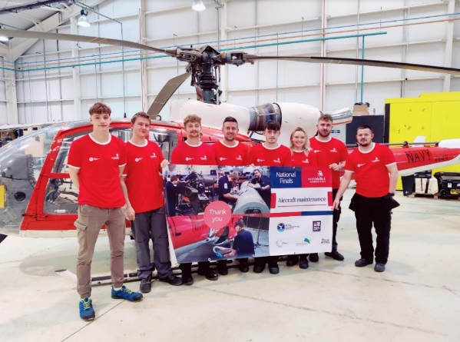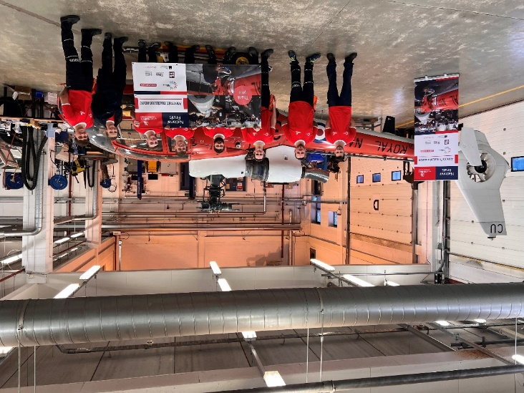

**WSUK National Competition Finals – Wigan and Leigh College (Manchester) 2023**

**WSUK National Competition Finals – ICAT Cardiff 2022**

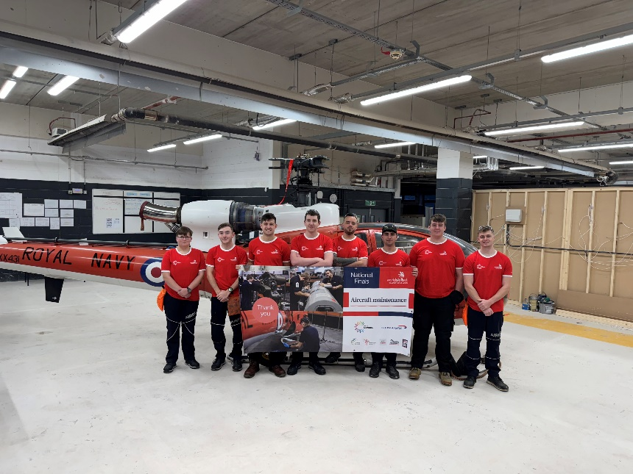

**WSUK National Competition Finals – Wigan and Leigh 2024**

**Further sources of information and websites**

**WorldSkills UK**

Email: [enquiries@worldskillsuk.org](mailto:enquiries@worldskillsuk.org) Web: [www.worldskillsuk.org](http://www.worldskillsuk.org/) Tel: 0800 612 0742