## horizontal line

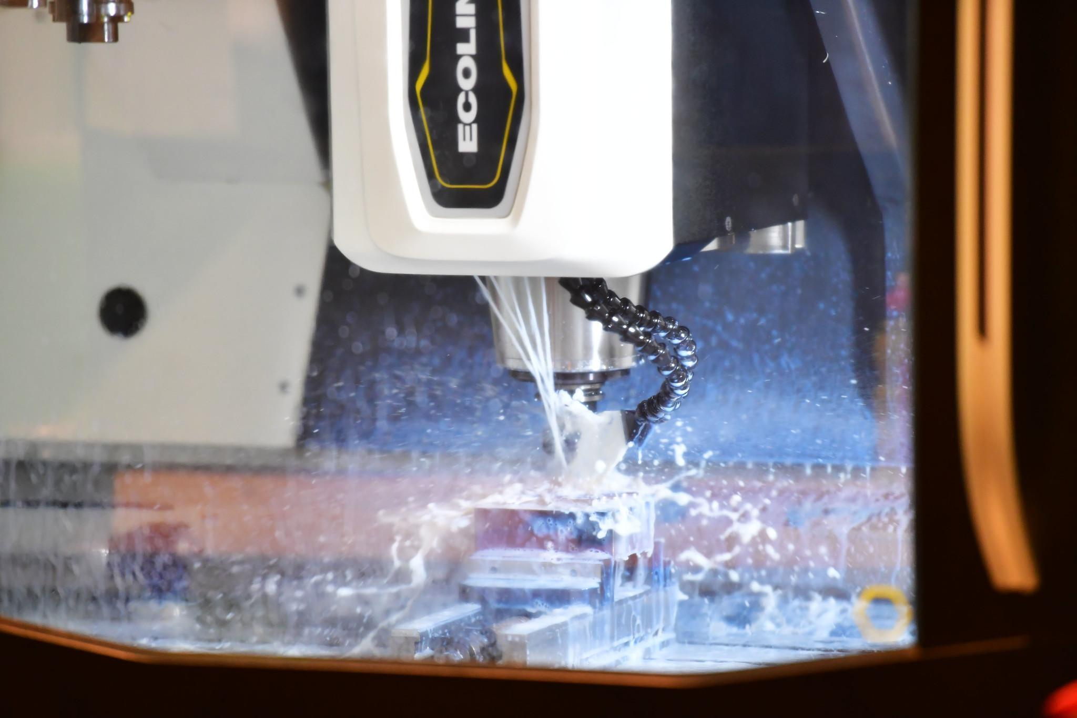

CNC Milling

Technical Description 2025

**Enquiries:**

**Competition Organising Partner:**

# Introduction

WorldSkills UK is an annual skills competition designed to promote standards and skills across a wide range of industries, developing competence into excellence.

The CNC Milling competition sees talented engineers test their expertise on a series of challenging practical tests in a bid to be named WorldSkills UK National Champion.

WorldSkills UK can bring invaluable benefits to students, colleges, and employers.

Competitors can gain recognition for exceptional skills, injecting dynamism, and excitement into training.

Employers can enhance their business reputation and improve the skills of their workforce.

The aim of this technical manual is to help competitors prepare for the CNC Milling competition from registration, through passive to qualifying and culmination at the national level.

The guide contains general advice, technical tips and an in-depth overview of the competition structure and its content.

CNC Milling is a significant sector within the engineering industry, encompassing a wide range of skills, standards, and ideas. This guide will provide you with a clear path to follow, from initial registration to the National finals and beyond.

**Role Overview**

The CNC machinist / Technician role can cover a wide range of skills such as machine setting and operating, CNC programming and editing and the use of CAD/CAM software to generate efficient machining strategies that can be output as CNC programs.

They are expected to safely prove out CNC programs while ensuring that the production process is also optimised. Completed components must be checked and inspected against tight tolerances and quality standards

Key attributes required by all CNC technicians wherever they work are efficient work organisation, self-management, communication, interpersonal skills and problem-solving.

They must have the ability to work safely and rigorously adhere to regulations, manufacturer’s instructions, and organisational requirements. These universal traits are the benchmark of an outstanding CNC technician.

**Resources**

For information and resources, including how to register, competition rules, and the steps to competing, visit:

[Mastercam home learning edition](https://signup.mastercam.com/demo-hle)

[Autodesk Fusion 360 Download](https://www.autodesk.com/education/edu-software/overview?sorting=featured&filters=individual)

[Competition Page](https://www.worldskillsuk.org/competitions/cnc-milling/)

[WorldSkills competition Rules](https://www.worldskillsuk.org/wp-content/uploads/2022/03/CNC-Milling-QA5.-Competition-Overview-doc-for-mail-merge-2.pdf)

[Careers Page](https://www.worldskillsuk.org/careers/how-to-become-a-cnc-miller/)

# Core competencies

Projects will be designed to test competitor's technical ability to;

* Follow relevant safety practises
* Read engineering drawings
* Understand tolerances
* Create wireframe geometry
* Create and modify solid models
* Program CNC toolpaths from solid models and wireframe
* Produce CNC programs
* Set a machine vice
* Set tool information on machine
* Calculate speeds and feeds
* Run CNC programs safely
* Accurately measure and adjust tool information
* Compete under time pressure

## 

**Competition Structure**

**Registration**

Once you have completed your registration (and accepted all terms and conditions) you will receive an email confirmation and further information on how to complete the entry stage.

Prospective students should try to familiarise themselves with working under competition-style activities, for example, have a fellow student judge a completed work task during a timed practical session at a college/training provider.

**Entry Stage**

The entry test consists of multiple-choice type questions.

It covers a range of relevant topics and is aimed at challenging and assessing your knowledge of general and specific topics of CNC machining and Engineering

When all registered entrants have completed the entry stage test, you will be notified if you have scored high enough to progress to the National Qualifying round.

**National Qualifiers**

Ensure you are ready to compete in your National Qualifier by reading and understanding the project brief, and core competencies. This outlines the tasks you will be expected to carry out.

Ask your lecturer/employer for help in any areas where you feel you may have any knowledge gaps and work to improve/gain the necessary skills.

The Qualifying task will be to program and produce a component to the correct quality standards on a CNC Milling machine within a specified time limit. A 2D engineering drawing will be provided.

Any CAD/CAM system may be used to create the program. The finished test project component must be sent for judging with a copy of the CAD/CAM file and output CNC code.

The test project should be sent to:

**Lee Pratt**

**UWTSD**

**IQ Building**

**Swansea**

**SA1 8EW**

**WorldSkills UK Pre-National training**

At the WorldSkills UK National competition competitors must use CAD/CAM software

to produce CNC programs, you will have a choice of two industry standard systems:

MasterCAM

Autodesk Fusion 360

As part of the invitation to compete at the National Finals, you will have the chance to join free training sessions on your chosen software, run by our sponsors, MasterCAM UK and Autodesk.

**WorldSkills UK National Final**

The highest scoring competitors across the National Qualifier will be invited to compete at the finals.

The competition task will be to program and produce a component to the correct quality standards on a CNC Milling machine within a specified time limit. A 2D engineering drawing will be provided and in some cases a 3D CAD model

Ensure you are ready to compete in your WorldSkills UK Live final by reading and understanding the project brief, core competencies. This outlines the type of tasks you will be expected to carry out.

Ask your lecturer/employer for help in any areas where you feel you may have any knowledge gaps and work to improve/gain the necessary skills.

## 

## **Self-directed training**

All competitors will need to practice to make it to the National finals. Dedication is key to confident performance in a competition.

Free training will be provided on your chosen CAM system, either MasterCAM or Fusion 360.

# Project overview

While the project drawings and models can vary greatly within CNC milling, we have reduced the number of features to test core skills while keeping cost manageable for organisers and entrants. So only the following features will be included

|  |  |
| --- | --- |
| Included features | Optional features |
| -Profile contours  -Pockets  -Slots, open or closed  -Drilled holes  -Chamfers  -Radii | -Reamed holes  -Tapped holes  -Bosses  -Bores  -Engraving |

## 

## 

## Project example: National qualifiers 2022

|  |  |
| --- | --- |
| Design specification | |
| Material | Aluminium 100x100x50mm |
| Time | 7h |
| Additional data | * 2D drawing with 3D shaded view; all dimensions included * Work on 2 or 3 faces * Minimum size for a finished part is not smaller than 50x50x30mm * Will be possible with minimal tooling 6mm and 12mm end mills with 9.8mm drilling |

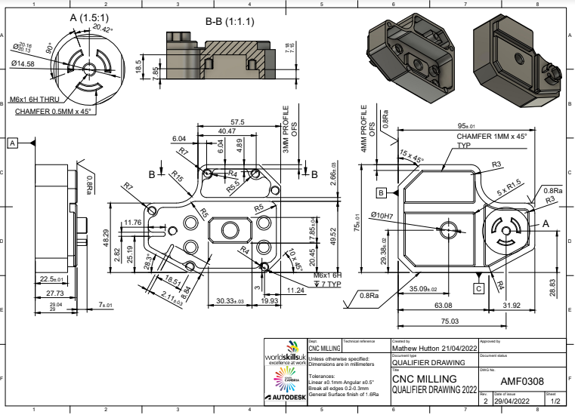

## 

## Project example: National finals 2022

|  |  |
| --- | --- |
| Design specification | |
| Material | Aluminium 100x150x50mm |
| Time | 7h (3h programming / 4h machining) |
| Additional data | * 2D drawing with 3D shaded view; critical dimensions only * 3D step file * Work on 2 or 3 faces * Minimum size for a finished part is not smaller than 30x30x10mm * Will use any combination of tooling from the equipment list |

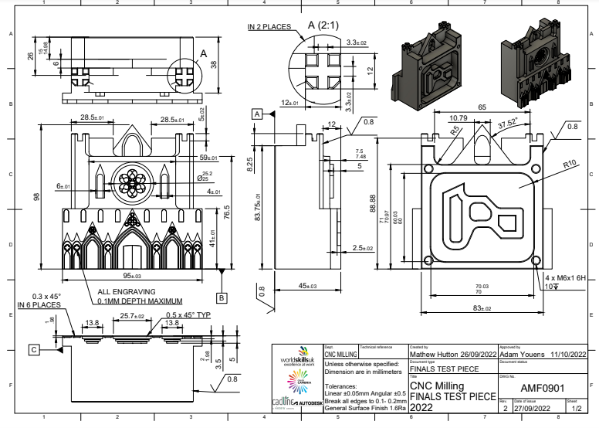

# Marking scheme

The marking scheme is designed to fairly compare every competitor’s work. Marking is split between measurement and judgement aspects.

## Measurement

Any dimension on the drawing can be a measurement mark. The value of a given dimension is decided by its tolerance, which are split into:

* Main dimensions (±0.005mm to ±0.02mm)
* Secondary dimensions (±0.04mm)
* General tolerance (±0.1mm)
* Surface finish (0.8Ra to 1.6Ra)

All projects will be supplied with a mark summary form. The mark summary form will show only the number of marks assigned to each aspect, not the breakdown of marks (e.g., main dimensions: 40 marks maximum).

All marks for measurement criteria are “all or nothing”, e.g., if a dimension is specified at 40±0.04, full marks will be awarded from 39.960mm to 40.040mm. Anything outside of this will be awarded zero marks.

## Judgement

Judgement marks are more subjective, for aspects such as:

* False cuts (collisions)
* Vibration
* Scratches
* Machine deburring
* Hand deburring

Judges will work to a judgement handbook with examples of each criterion. Each judge will reveal a value from zero to three, and an average will be taken. For example, if all judges assess the machine deburring as a two overall, the competitor will receive 66% of the possible marks. Judgement marking accounts for only 10% of the overall score.

Edges should be broken on machine where possible:

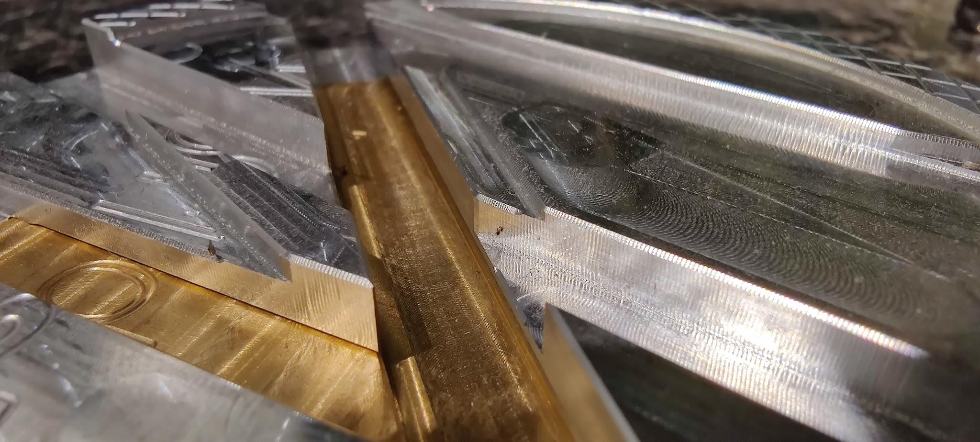

Avoid the following:

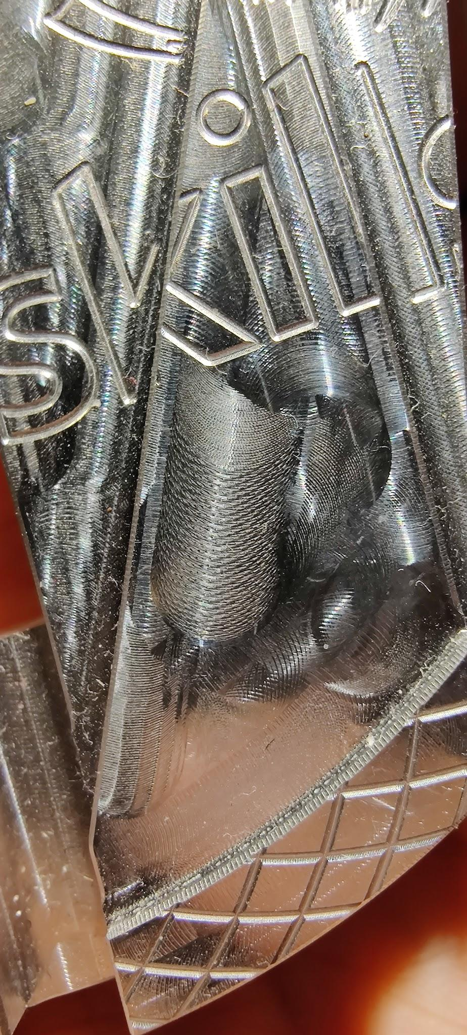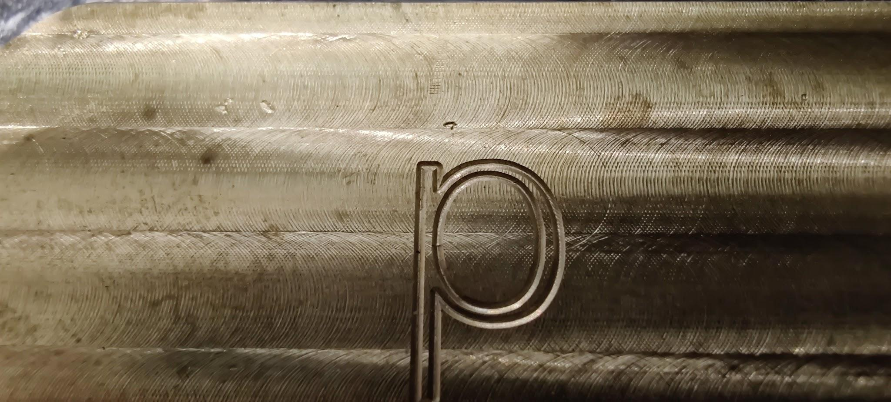

# Equipment

During delivery of the National finals, tooling and equipment will be provided by WorldSkills UK and various competition sponsors.

***Qualifying Tooling:***

Typical Tooling need to complete the qualifying round would be:

Ø10mm Endmill

Ø6mm Endmill

Chamfer cutter

Drills and taps (M6 typical)

## Software

|  |  |
| --- | --- |
| CAD/CAM  [Mastercam home learning edition](https://signup.mastercam.com/demo-hle) | [Autodesk Fusion 360 Download](https://www.autodesk.com/education/edu-software/overview?sorting=featured&filters=individual) |

# Training

## Self-directed training

All competitors will need to practice to make it to the National finals. Dedication is key to confident performance in a competition.

**National finals**

## What to expect

Employers can enter the competition floor with the permission of the competition manager; they can take sponsorship photos or gain a better understanding of the competition itself. Competitors are expected to wear the appropriate H&S equipment (e.g., safety boots, glasses) as well as a company work top and trousers while competing.

The competition stand will be prepared with all the equipment necessary to compete. Each competitor will have a computer they can password protect, as well as a USB to back up files. There will be one set of measuring equipment and cutting tools per machine, which will be checked and cleaned between each competitor’s shift.

An example timetable:

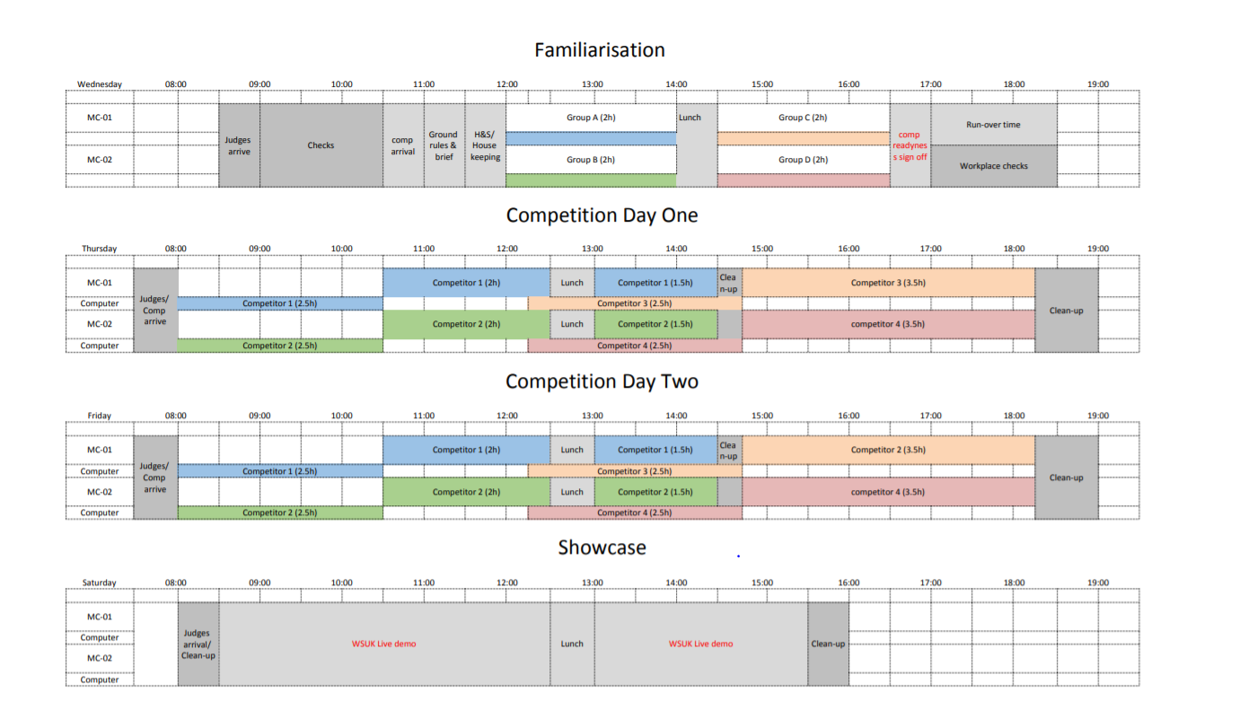

# 

# Beyond the National finals

Looking beyond the National finals, there are a host of opportunities for competitors. Age-eligible competitors who show the highest skills, passion, and drive to compete will be invited to train for the EuroSkills and WorldSkills international competitions.

Those who are not eligible for international competitions may join the Champions programme, which allows continued involvement, including the opportunity to work with WorldSkills UK and visit schools, colleges, and events to inspire the next generations.

Alternatively, if training is of interest to you, you could consider supporting WorldSkills UK with organising and training, and even helping to run the National finals.

Get inspired and become a part of Team UK today!

