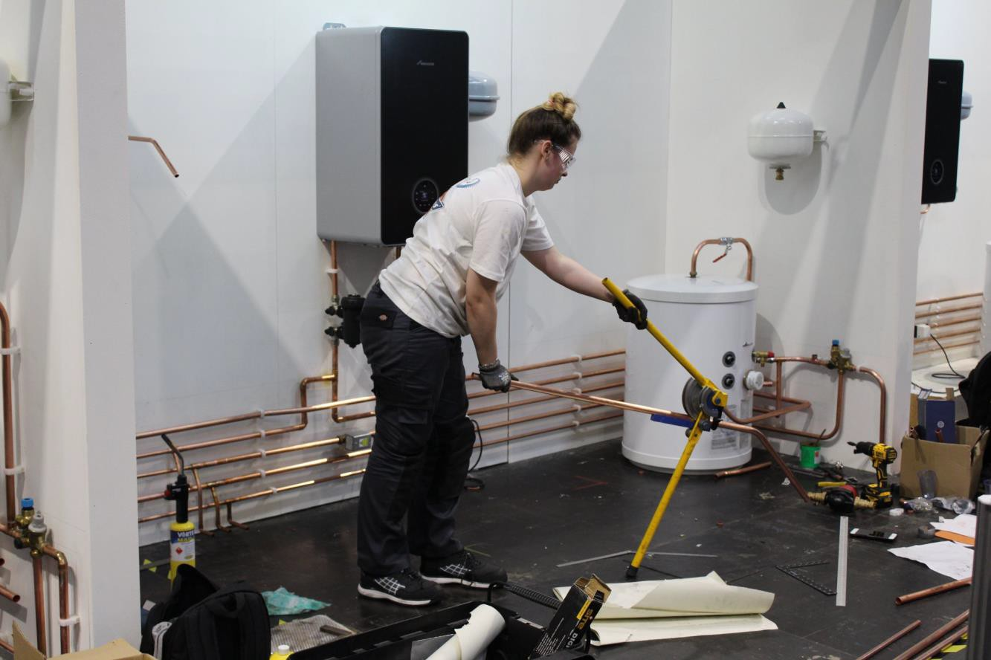

**Plumbing and Heating**

**Technical Handbook**

**Paul Dodds MBE**

**BPEC - SkillPLUMB - Competitions Lead Judge**

[plumberskills@gmail.com](mailto:plumberskills@gmail.com)

We thank all the amazing sponsors that make this competition possible:

# **Occupation Overview**

Plumbing and Domestic Heating Technicians plan, select, install, service, commission, and maintain all aspects of plumbing and heating systems. Plumbing and domestic heating technicians can find themselves working inside or outside a property. Customer service skills and being tidy and respectful are important qualities as they can often find themselves working in customers’ homes as well as on building sites.

As a competent Plumbing and Heating Technician, the installation of plumbing and heating systems includes accurate measuring, marking, cutting, bending, and jointing metallic and non-metallic pipework. Appliances and equipment can include gas, oil, and solid fuel boilers as well as pumps, heat emitters, bathroom furniture or controls as part of a cold water, hot water, and central heating or above-ground drainage and rainwater systems. Plumbing and Domestic Heating Technicians are at the forefront of installing new and exciting environmental technologies like heat pumps, solar thermal systems, biomass boilers, and water recycling systems. It is important for a plumbing and heating technician to be able to work independently or as a team and use their knowledge and skills to ensure that both the system and appliances are appropriately selected and correctly installed, often without any supervision, and done so in a safe, efficient and economical manner to minimise waste.

[Reference © Institute for Apprenticeships and Technical Education / Plumbing and domestic heating technician]

Whether the Plumbing and Heating technician is working alone or in a team, the individual takes on a high level of personal responsibility and autonomy. From working to provide a safe and reliable plumbing and heating service, in accordance with relevant standards, through to diagnosing malfunctions, and commissioning plumbing and heating systems and components, precision, accuracy, and attention to detail at every step in the process matters and mistakes are largely irreversible, costly, and potentially life-threatening.

With the international mobility of people, the Plumbing and Heating technician faces rapidly expanding opportunities and challenges. For the talented Plumber, there are many commercial and international opportunities; however, they carry with them the need to understand and work with diverse needs, cultures, and trends. The diversity of skills associated with Plumbing and Heating is therefore likely to expand.

[Reference ©WorldSkills International TD15 v8.0 WSC2021 Technical Description]

# **Competition Overview**

WorldSkills UK is an annual skills competition designed to promote standards and skills across the plumbing industry, developing competence into excellence. The competition sees talented young plumbers test their expertise on a series of challenging practical tests in a bid to be named the WorldSkills UK National champion.

WorldSkills UK can bring invaluable benefits to students, colleges, and employers. Competitors can gain recognition for exceptional skills, injecting dynamism and excitement into training. Employers can enhance their business reputation and improve the skills of their workforce.

This guide will provide you with a clear path to follow, from initial registration to the National Finals and beyond.

# **Resources**

For information and resources, including how to register, competition rules, and the steps to competing, visit:

<https://www.worldskillsuk.org/skills/national-competitions/>

For competition-specific information relating to Plumbing the WorldSkills UK and BPEC, websites have a lot of information about competitions past and present to help you in getting ready for competition, including a video of a past National competition.

<https://www.worldskillsuk.org/competitions/plumbing/>

<https://bpec.org.uk/the-bpec-charity/activities/skillplumb/>

# 

# **Project specifications**

Projects will be designed to test competitor’s technical ability to:

* Read drawings
* Interpret Instructions
* Communication Skills
* Work Safely
* Measure
* Prepare work area
* Setting out for installation of pipes and components
* Install Pipes and Components using industry practices
* Test completed work for leaks

# Entry Stage Project overview

SkillPLUMB is open to apprentices and Level 2 or 3 plumbing students (year two or above students are ideal, aged16+). **Please note: the maximum number of competitors that could progress from the entry stage to the qualifier stage from one (local) organisation is three.**

This stage consists of a small piece to be completed in your training workshop under the supervision of a plumbing tutor to observe the process. The task must be completed as detailed in the specification that is sent with the drawings to the competitor. The tutor marking the task must have completed the training provided by BPEC in the standardisation of assessment. The tutor is not to give technical advice as to how the task is to be completed but can clarify the drawing or information provided by SkillPLUMB, without leading the competitor to a solution on completion of the task. This is a skill that will be tested in the completion of the task, the ability of the competitor to find solutions to a problem.

The task will be completed in 2hrs. The task will be very similar to a plumbing qualification task offering stretch and challenge at level 2 using copper pipe and end feed soldered joints. The task will require testing and the test is to be completed within the allocated time.

Upon completion, the task will then be marked by your tutor to standards set in this technical handbook and the marking sheet provided based on the standardisation training. The marks recorded are then sent to SkillPLUMB. Analysis of these marks, photo evidence, and compliance with the specification will lead to the selection of approx. 72 competitors nationally who will progress to the National Qualifier Stage.

# **National Qualifier Project overview**

All competitions have features included in the task that are essential processes, these are listed below. If you want your work to stand out and demonstrate a higher level of skill that will have an impact on visitors, employers etc. the ‘optional features’ are good skills to have and in today’s work environment, customers’ expectations are also high. Keeping to ‘optional features’ will lead to future work through recommendations.

|  |  |
| --- | --- |
| **Included features** | **Optional features** |
| * Interpret drawings read drawings carefully to ensure that the work is produced as per drawing and in the correct position etc. * Work safely, keeping work area tidy and wearing PPE as per specification. * Organise workstation – the ability to organise tools and equipment to provide space for work and enable an efficient system of work. * Fix pipe supports to structure as per specification. * Fix copper pipe to walls and bend the tube to various angles as specified. * Prepare pipe for joints & solder fittings using industry processes. * On completion test installation for leaks. * Tasks are challenging and require good time management for completion within time allocated. | * Keep walls clean (no dirty finger marks on walls etc.). * No undue pencil marks (when marking out for clips etc. keep pencil marks behind clips or components). * Clean pipe work with a damp cloth after soldering to remove all traces of flux. |

# **Project example: National Qualifiers**

Details of a past competition is detailed below, with a very simple specification. The task relates to core competencies in bending and jointing pipe and provides stretch to the curriculum with multiple bends and a timescale that requires the competitor to be organised in their planning etc. to complete in the available time.

It is important to remember you are competing against a standard and not the competitor next to you as you will need to be in the Top 8 scoring competitors across all the UK qualifying heats to get to the next stage, the National Finals

|  |  |
| --- | --- |
| **Design specification** | |
| Material | 15mm & 22mm Copper Pipe |
| Time | 3.5hrs |
| Additional data | * Pipework exercise to simulate part of a Domestic Heating System. * All soldering to be completed using Lead Free solder. * All preparation for bending to be done in competition time (No Templates). * All testing to be completed in competition time (competitor may test prior to asking for official test). |

Example of a previous Qualifier Stage task

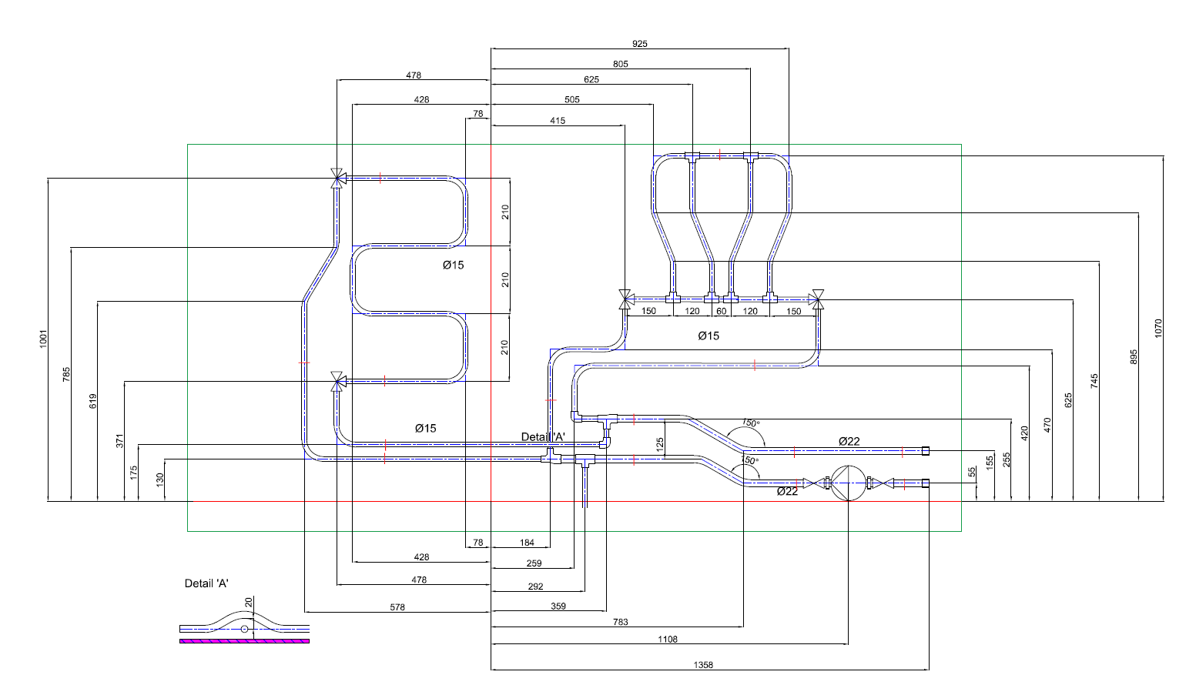

# **Digital Badges**

As recognition of the participation and achievement of learners who take part in the competition, you will be awarded a Digital Badge from WorldSkills UK. This credential has been awarded to those who have participated in our competition-based training programme. In taking part in this programme there has been a commitment to developing technical, employability, and personal skills to a high standard using benchmarked assessments, leading to higher skills development. At each stage of the competition activity, there has been personal and professional growth as well as the developing of skills, knowledge, and behaviours in vocational and technical education.

The digital badges are sent via Credly to your email and can be shared on social media platforms and in your email signature. For a short outline of the value of Digital Badges, look at our short video at <https://www.worldskillsuk.org/digital-credentials/> (45 secs).

# **Project example: National Finals**

The National Final is a step up from the qualifier and is over four days. One day for arrival and briefings, Two days of competition and 1 day which is a fun day presenting your work, and explaining this to visitors and an awards ceremony to celebrate all the finalists achievements. The quantity and quality of work is also a step up from the qualifier as design is included in the task that needs to be communicated by the production of drawings prior to installation and then to complete the design as per your drawing.

|  |  |
| --- | --- |
| **Design specification** | |
| Material | Heating components (Boiler, Pump, and associated equipment) Hot Water Components (Unvented Hot Water Storage System) 15mm and 22mm Copper Pipe |
| Time | 16 Hrs over 2 days |
| Additional data | Time Management to complete 2 Modules and meet deadlines (competition is over 2 days, so on day 1 approx.50% is completed and ready for assessment and on day 2 the remainder needs to be completed. It is clearly identified on the drawings issued what is to be completed on each day).  Interpret Drawings – the ability to accurately relate a drawing to a real task and specification. Thus, ensuring that the planned activity matches the installation that is produced.  Working Safely – involves the ability to keep a safe working environment by keeping the area free from trip hazards etc.. Working to risk assessments and instructions given on methods of work etc..  Communication Skills – required for communication with judges, for questions, materials and requesting testing of work.  Measuring Skills - used to position components and pipe as per specification.  Design part of the pipework installation and produce drawings of the design in 2D or 3D (isometric). To include sufficient detail so a third party could follow the drawing.  Prepare work area for installation (organising tools, materials etc. and positioning datum lines).  Install components as per drawing.  Bending copper pipe to various angles.  Solder copper pipe fittings using lead-free solder.  Testing of installation in time at 1bar for 2mins using air. |

# **Marking Scheme**

The marking scheme is designed to fairly compare every competitor’s work against the specification for the task and the standards defined and assess the quality of work produced by competitors. Marking is split between measurement and judgment aspects these are explained below.

# **Measurement**

Measurement is objective in that, it is either the physical measurement of a dimension or an angle. It can also be a yes/no scenario, such as was all PPE worn correctly, another example is, was the work area kept free of hazards, and finally are the walls free from burn marks.

Any dimension on the drawing can be a measurement mark. The value of a given dimension is decided by its tolerance, which is split into:

* Dimensions (±2mm ).
* Angles (±1o using a digital angle finder).
* Plumb and Level (±0.5o using a digital level).
* Clean and Tidy work area – yes/no.
* No Burn marks on the walls – yes/no.
* Additional screw holes – yes/no.
* Testing with Air (1bar – 2 minutes).

When the assessor tests, there are to be no leaks detected to pass. The competitor may check their own work and rectify leaks prior to asking for an assessed test.

All to be completed in competition time.

All projects will be supplied with a mark summary form. The mark summary form will show only the number of marks assigned to each aspect, not the breakdown of marks (e.g., Dimensions: 40 marks maximum).

All marks for measurement criteria are “all or nothing”, e.g., if a dimension is specified at 40mm ±2mm, full marks will be awarded from 38mm to 42mm. Anything outside of this will be awarded zero marks.

# **Judgement**

Judgement marks are more subjective. However, to ensure standardisation of assessment clear objective criteria is required of what each mark will be awarded for.

Judgement is used for aspects such as:

* Soldering

Judges will work to the specifications detailed below with examples of each criterion. Each judge will reveal a value from zero to three, and an average will be taken. For example, if all judges assess the soldering as a two overall, the competitor will receive 66% of the possible marks.

# **Copper Pipe Joint Quality**

Soldering of copper pipe is a common process in plumbing systems and a process that takes time to master. If your soldering is to stand out against other people’s work the tips below should help. You can then compare your soldering to the standards required in the competition detailed below. If these standards are adopted in your daily working life by achieving a high score you will see that the quality of your work will improve, and that customer satisfaction will increase. All soldering is to be completed with pipe in-situ (mounted on the vertical wall and in the pipe clips).

The Soldering tips are:

* + Ensure you have cleaned the fitting and the pipe for best results, even when using self- cleaning flux.
  + Do not over-do the flux – it will not improve quality and will lead to solder runs.
  + Ensure that the flame is not too fierce to burn the fitting and the wall.
  + Heat the pipe outside the fitting to get some heat in to the pipe, before putting heat on the fitting.
  + Ensure 1 small touchpoint when applying solder. Lead-Free Solder only.
  + Do not wipe solder whilst it is still molten with a cloth or brush, as this will lose marks.
  + Wipe pipe and fitting with a damp cloth after soldering to remove excess flux.
  + Do not polish the joints with abrasive cloths etc.

The criterion for the quality of soldering is detailed below with photographic examples:

|  |  |  |
| --- | --- | --- |
| **Judgment**  **score 0-3** | **Photos for standardisation** | **Description for**  **Standardisation** |
| 0 |  | * **All flux after the soldering process needs to be removed with a damp/wet cloth.**  If there are any traces of Flux on pipe or fitting = 0 * **Solder needs to be clearly visible all the way around the fitting and loaded to edge of fitting.**  If solder is not clearly visible and not fully loaded as top photo = 0 * If too much solder is applied and running down pipe as bottom photo = 0 * **Cleaning of pipe is only permitted with a damp/wet cloth with no detergent.** It is not allowed to clean away the additional solder or any drops of solder! by wiping when the solder is molten. = 0 * Cleaning of pipe/ fitting with abrasive = 0 |
| 1  Bronze |  | * **If any of the criteria for 0 was scored at 0 do not continue to this assessment criterion.** * **When soldering fittings the ideal is to have only one small touch point and let capillary action complete the soldering process.**  If pipe Ø15-22mm has more than 2 start points visible or going around the fitting with the solder when soldering as in top and centre photo = 1 * **Solder needs to be clearly visible all the way around the fitting and loaded to the edge of the fitting, ensuring excessive solder is not applied.**  If there is a small drop of solder as shown in the bottom photo and is on the Pipe and/or Fitting. = 1 |
| 2  Silver |  | * **If any of the criteria for 1 was scored at 1 do not continue to this assessment criterion.** * **When soldering fittings the ideal is to have only one small touch point and let capillary action complete the soldering process.**  If pipe Ø15-22mm pipe has not more than 2 start points visible and is not wide with the solder when soldering = 2   (Attention: The flat start point can be on both at the pipe and the fitting! This is not a fault.) |
| 3  Gold |  | **● If any of the criteria for 2 was scored at 2 do not continue to this assessment criterion.**  ● **When soldering fittings the ideal is to have only one small touch point and let capillary action complete the soldering process.**  Solder must be loaded as centre photo  If pipe Ø15-22mm only 1 start touch point is visible as shown in bottom photo = 3  (Attention: The flat start point can be on both at the pipe and the fitting! This is not a fault.)  It is important that a score of 3 is only given if none of the previous faults are found. |

# **Sample Mark Allocation**

The table below shows the 7 headings used in a previous competition and marks that are awarded in each section.

Each section then will have assessment points, so for example for dimensions, which carries 30 marks the judges may well have between 20 and 50 measurements to check.

The scores then for each section are used at each stage to determine the best competitor. The scores are also used to provide constructive feedback to enable you to determine a plan of action with your tutor for training to improve your performance at the next stage of competition or in your everyday working life.

|  |  |
| --- | --- |
| **Summary** | **Max Mark Available** |
| Task layout and pipework soundness Completed in time and test complete with no leaks | 10 |
| Dimensions +/-2mm | 27 |
| Joint Quality  Judgement 0-3 | 15 |
| Bend Angles +/- 1o | 10 |
| Plumb & Level +/- 0.5o | 8 |
| Material Usage & overall presentation No additional materials such as pipe/fittings  No Burn marks on walls  No additional holes on wall surface | 9 |
| Health & Safety  Clean and Tidy work area no debris on floor etc. and safe working environment.  PPE to be worn as specified. | 8 |
| Air Source Heat Pump  Knowledge of Air Source Heat Pump components and their function, including common faults | 13 |
| Cumulative Result | 100 |

# **Equipment**

During the competition at the National Qualifier and National Finals, a limited number of tools and equipment will be required to complete the task. To maintain standards of fairness for all competitors, it is essential that every competitor has access to the same tools. This will be checked by judges prior to the competition rounds taking place. The tools listed below will be required to perform the tasks at both National Qualifier and National Final Stage, no other tools are permitted. Competitors are to provide their own tools for competition.

|  |
| --- |
| **TOOL** |
| 2 x Adjustable spanners to suit compression connections (15mm & 22mm) |
| Full set of Screwdrivers flat and cross head |
| Battery Drill driver with spare battery / charger with bits (No impact drivers) |
| Bradawl |
| 2 x adjustable Water pump pliers |
| Junior Hacksaw complete with spare blades |
| Tape measure (3m) |
| Steel rule 300mm / 600mm / 1000mm types |
| Digital Small inclinometer and Large (600mm) spirit levels |
| Protractor / Angle finder can be digital |
| Pencils, rubber, and pencil sharpener |
| Plain paper for drawing templates or roll of lining paper  (no pre-prepared templates) |
| Tube cutters (i.e., pipe slice) 15mm and 22mm |
| Tube reamer |
| Claw Hammer |
| Pipe bender mechanical 15mm – 22mm (portable hand scissor bender only) |
| Blow torch and cylinder |
| Soldering Mat |
| Cleaning pad, water-soluble flux, and Lead-Free solder suitable for potable water |
| PTFE tape |
| Tool Bag |

**Personal Protective Equipment (PPE)**

|  |
| --- |
| **PPE** |
| Goggles / safety glasses (clear) Mandatory to wear |
| Gloves |
| Safety boots / shoes |
| Work-wear trousers or overalls (No Shorts) |

**Training**

**Self-directed training**

Every competitor is encouraged to practice at work or in college, to ensure that they have the best chance of competing in the competition. To assist with any training needs that competitors might have, the BPEC website has information and In-House activities that are free and open to all. There is also information on mark sheets in order to assist competitors with preparing for the competition.

The link to these resources are

<https://bpec.org.uk/the-bpec-charity/activities/skillplumb/>

On the website there are guides to the competition and a document titled “Essential Plumbing Skills” which includes tips and training materials. Competitors can use these guides to build their own confidence and get ahead of the competition.

# **National Finals training**

As part of the invitation to compete at the National Final, SkillPLUMB provide an example of past competition at National Level to help develop competitors. This is an excellent opportunity for all competitors to boost their confidence using skills and equipment in a safe environment, while replicating the competition project and expectations.

In the past, our sponsors have provided manufacturer’s instructions etc. to help train competitors in the installation of components.

Online Training on equipment for competition.

BPEC provides finalists with a lot of information closer to the competition to help the development of competitors.

# **Judges top tips**

* Keep yourself fit.
* Have a ‘can do’ attitude – all competition tasks are possible.
* Reflect on your own performance, what’s good and what needs improving – write it down.
* Always read the specification thoroughly, make sure you understand what is required.
* Ask questions to clarify what is required.
* Concentrate on your own performance and not that of others – don’t look at others whilst competing.
* Prepare yourself for a change in plan – especially when you make an error. Park the problem, re-plan, and move on. Think: “I can still do it”.
* Prepare yourself for a noisy and distracting environment. Could you do plumbing in front of the crowd at Wembley on cup final day? At the National Final, there will be many people watching you during the competition – you need to be in the zone.
* Don’t drink energy drinks – they give a short energy burst then your performance and concentration will drop dramatically.
* Drink water to keep hydrated.
* Eat bananas rather than energy bars – they give a slow, lasting energy release rather than a quick boost.
* Set times for various stages of the task that are achievable as this will make you feel good as you check your progress.
* There are no daft questions! If something doesn’t make sense –ask.
* Don’t bring impact drivers, they are not permitted.
* Have spare batteries for any tools.
* Hand wipes are an easy way of keeping hand clean.
* If using digital levels make sure they are calibrated as per the manufacturer’s instructions prior to starting.
* Do not bring blackboard / whiteboard instruments as may not be accurate. Consider a digital angle finder.
* Do not be afraid to go back to tasks you did in your first few days and weeks of training but do them much better, than the first time.
* Listen to the advice of where to place datums and ensure they are accurate as judges will measure from these.
* Think about tooling – what do I need? Keep them close - don’t waste time walking around looking for things.
* Take care using a tape measure as the end that’s loose may well exceed the tolerance you’re working to.
* Flatten your solder, it will make you more in control of your soldering 15mm of solder for 15mm pipe, 22mm solder for 22mm pipe is about right for the finished product.

# **National Finals What to expect**

In previous years, the National finals are a large-scale event, organised by WorldSkillsUK. There are many skills in diverse sectors, so you have to be prepared to do a lot of walking at the event with some crowded areas, and your family, friends, and other visitors are welcome and view the intense competitions going on.

Employers are able to take photos or gain a better understanding of the competition itself by talking to the delivery team involved with the competition.

The competition stand will be prepared with all the equipment necessary to compete. Each competitor will have a dedicated workspace and will have a session to familiarise themselves with the surroundings and check materials for the task. Competitors are expected to wear the appropriate H&S equipment (e.g., safety boots, glasses) while competing and if supplied the organiser’s T-shirts.

Below is a picture to demonstrate what a workstation at the finals could look like, sourced from a WorldSkills Final that took place in a prior year.

An example timetable for the National Finals:

On the arrival day, competitors arrive with tools and are allocated a workstation. They also have a briefing to get to know each other and the judging team, with time for questions, etc...

The main competition is over two days with Module 1 completed day 1 and the following day complete Module 2.



# **Competition Resource Information**

# **Lead Sponsor**

**

# **Ideal Heating - Providing heating you can rely on**

Ideal Heating has been bringing warmth and comfort to domestic and commercial markets since 1906. Committed to a sustainable future and maintaining our core principles of quality. innovation and value, we supply market-leading boilers, heat pumps and heating controls to homes and businesses across the UK.

<https://idealheating.com/>

# **A yellow and grey logo Description automatically generatedLearning Material**

BPEC have free learning resources for plumbing including, books, videos and games that can be downloaded <https://bpec.org.uk/shop/free-learning-resources/>

* + Plumbing text book
  + Essential Plumbing Skills Manual
  + ACS Re-Assessment Poster
  + Legionella Risk Assessment Paperwork
  + Get Gas Safe
  + Water Regulations Video
  + Cut Your Carbon Game
  + Asbestos Awareness
  + Electrical Safety Awareness
  + The Dangers of Carbon Monoxide (CO)

# **Tools and Equipment**

**

# Ideal Heating was founded in 1906, meaning that we have over 100 years of providing the best quality boilers to our customers continually working to meet ever-changing domestic heating needs.

# Taking boilers from basements into kitchens in the 1920s, through to introducing pioneering high-efficiency technologies, we continually deliver reliable products designed with our customers in mind.

# Today, Ideal remains at the forefront of the domestic and commercial heating markets, leading the industry in setting new standards and challenging technological boundaries. Our company remains true to its founding principles of quality, innovation and value – building on its rich heritage as we look to the future.

# [**https://idealheating.com/**](https://idealheating.com/)

**

Good information for the specialist tooling for the plumbing industry <https://monument-tools.com/downloads/>

DeWalt are a leading provider of power tools used in the construction / plumbing industry. DeWalt tools are built to withstand the rigours of the construction site.  
<https://www.dewalt.co.uk/>

Information on the various grades of copper and different types of tube for different installations. Detail of manufacturing and characteristics of copper and why we choose copper.

<https://www.muellereurope.com/>

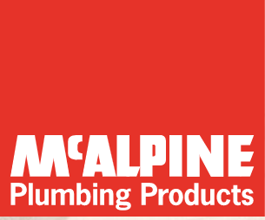

Provides information on installation detail and a range of products to solve plumbing problems

<https://mcalpineplumbing.com/help-support#installation-downloads>

# **Trade / Employer Organisations**

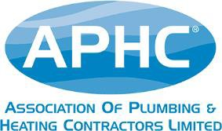There are a number of Trade and Employer associations for Plumbing with a wealth of information on the industry and the benefits of membership etc..

The Association of Plumbing and Heating Contractors (APHC)

<https://www.aphc.co.uk/>

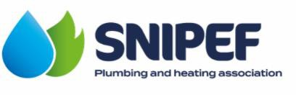

The Scottish and Northern Ireland Plumbing Employers’ Federation (SNIPEF)

<https://snipef.org/about-us/about-snipef/>

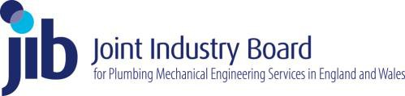

The Joint Industry Board of Plumbing Mechanical Engineering Services in England and Wales.

<https://www.jib-pmes.org/about-jib-pmes/>



The Chartered Institute of Plumbing and Heating Engineering (CIPHE)

The link below provides access to a wide range of plumbing websites that provide products and installation and support details.

https://www.ciphe.org.uk



WaterSafe is a free online directory and national accreditation body for competent and qualified plumbers, water supply pipe installers and other water services specialists in England, Scotland, Wales and Northern Ireland.

<https://www.watersafe.org.uk/>

# **Beyond the National Finals**

**Career path and progression**

You can develop your skills by taking further training in areas like heating, ventilation and air-conditioning, and renewable energy technologies like solar powered hot water and heat pumps.

You can also join the Gas Safe Register or get certified with the Oil Firing Technical Association (OFTEC). These would show you're qualified to work on gas or oil-fired appliances.

You could go on to study for a higher national diploma or degree and become an engineer. This could lead to career options in building services engineering, estimating and contract management.

Reference: [**https://nationalcareers.service.gov.uk/job-profiles/plumber**](https://nationalcareers.service.gov.uk/job-profiles/plumber)

# **Further Competitions and Opportunities**

Looking beyond the National finals, there are a host of opportunities for competitors. Age-eligible competitors who show the highest skills, passion, and drive to compete will be invited to train for the EuroSkills and WorldSkills international competitions.

Those who are not eligible for international competitions may join the Champions programme, which allows continued involvement, including the opportunity to work with WorldSkills UK and visit schools, colleges, and events to inspire the next generations.

Alternatively, if training is of interest to you, you could consider supporting WorldSkills UK with organising and training, and even helping to run the National Finals.

**Get inspired and you could become part of Team UK!**

