Laboratory Technician

Technical Handbook

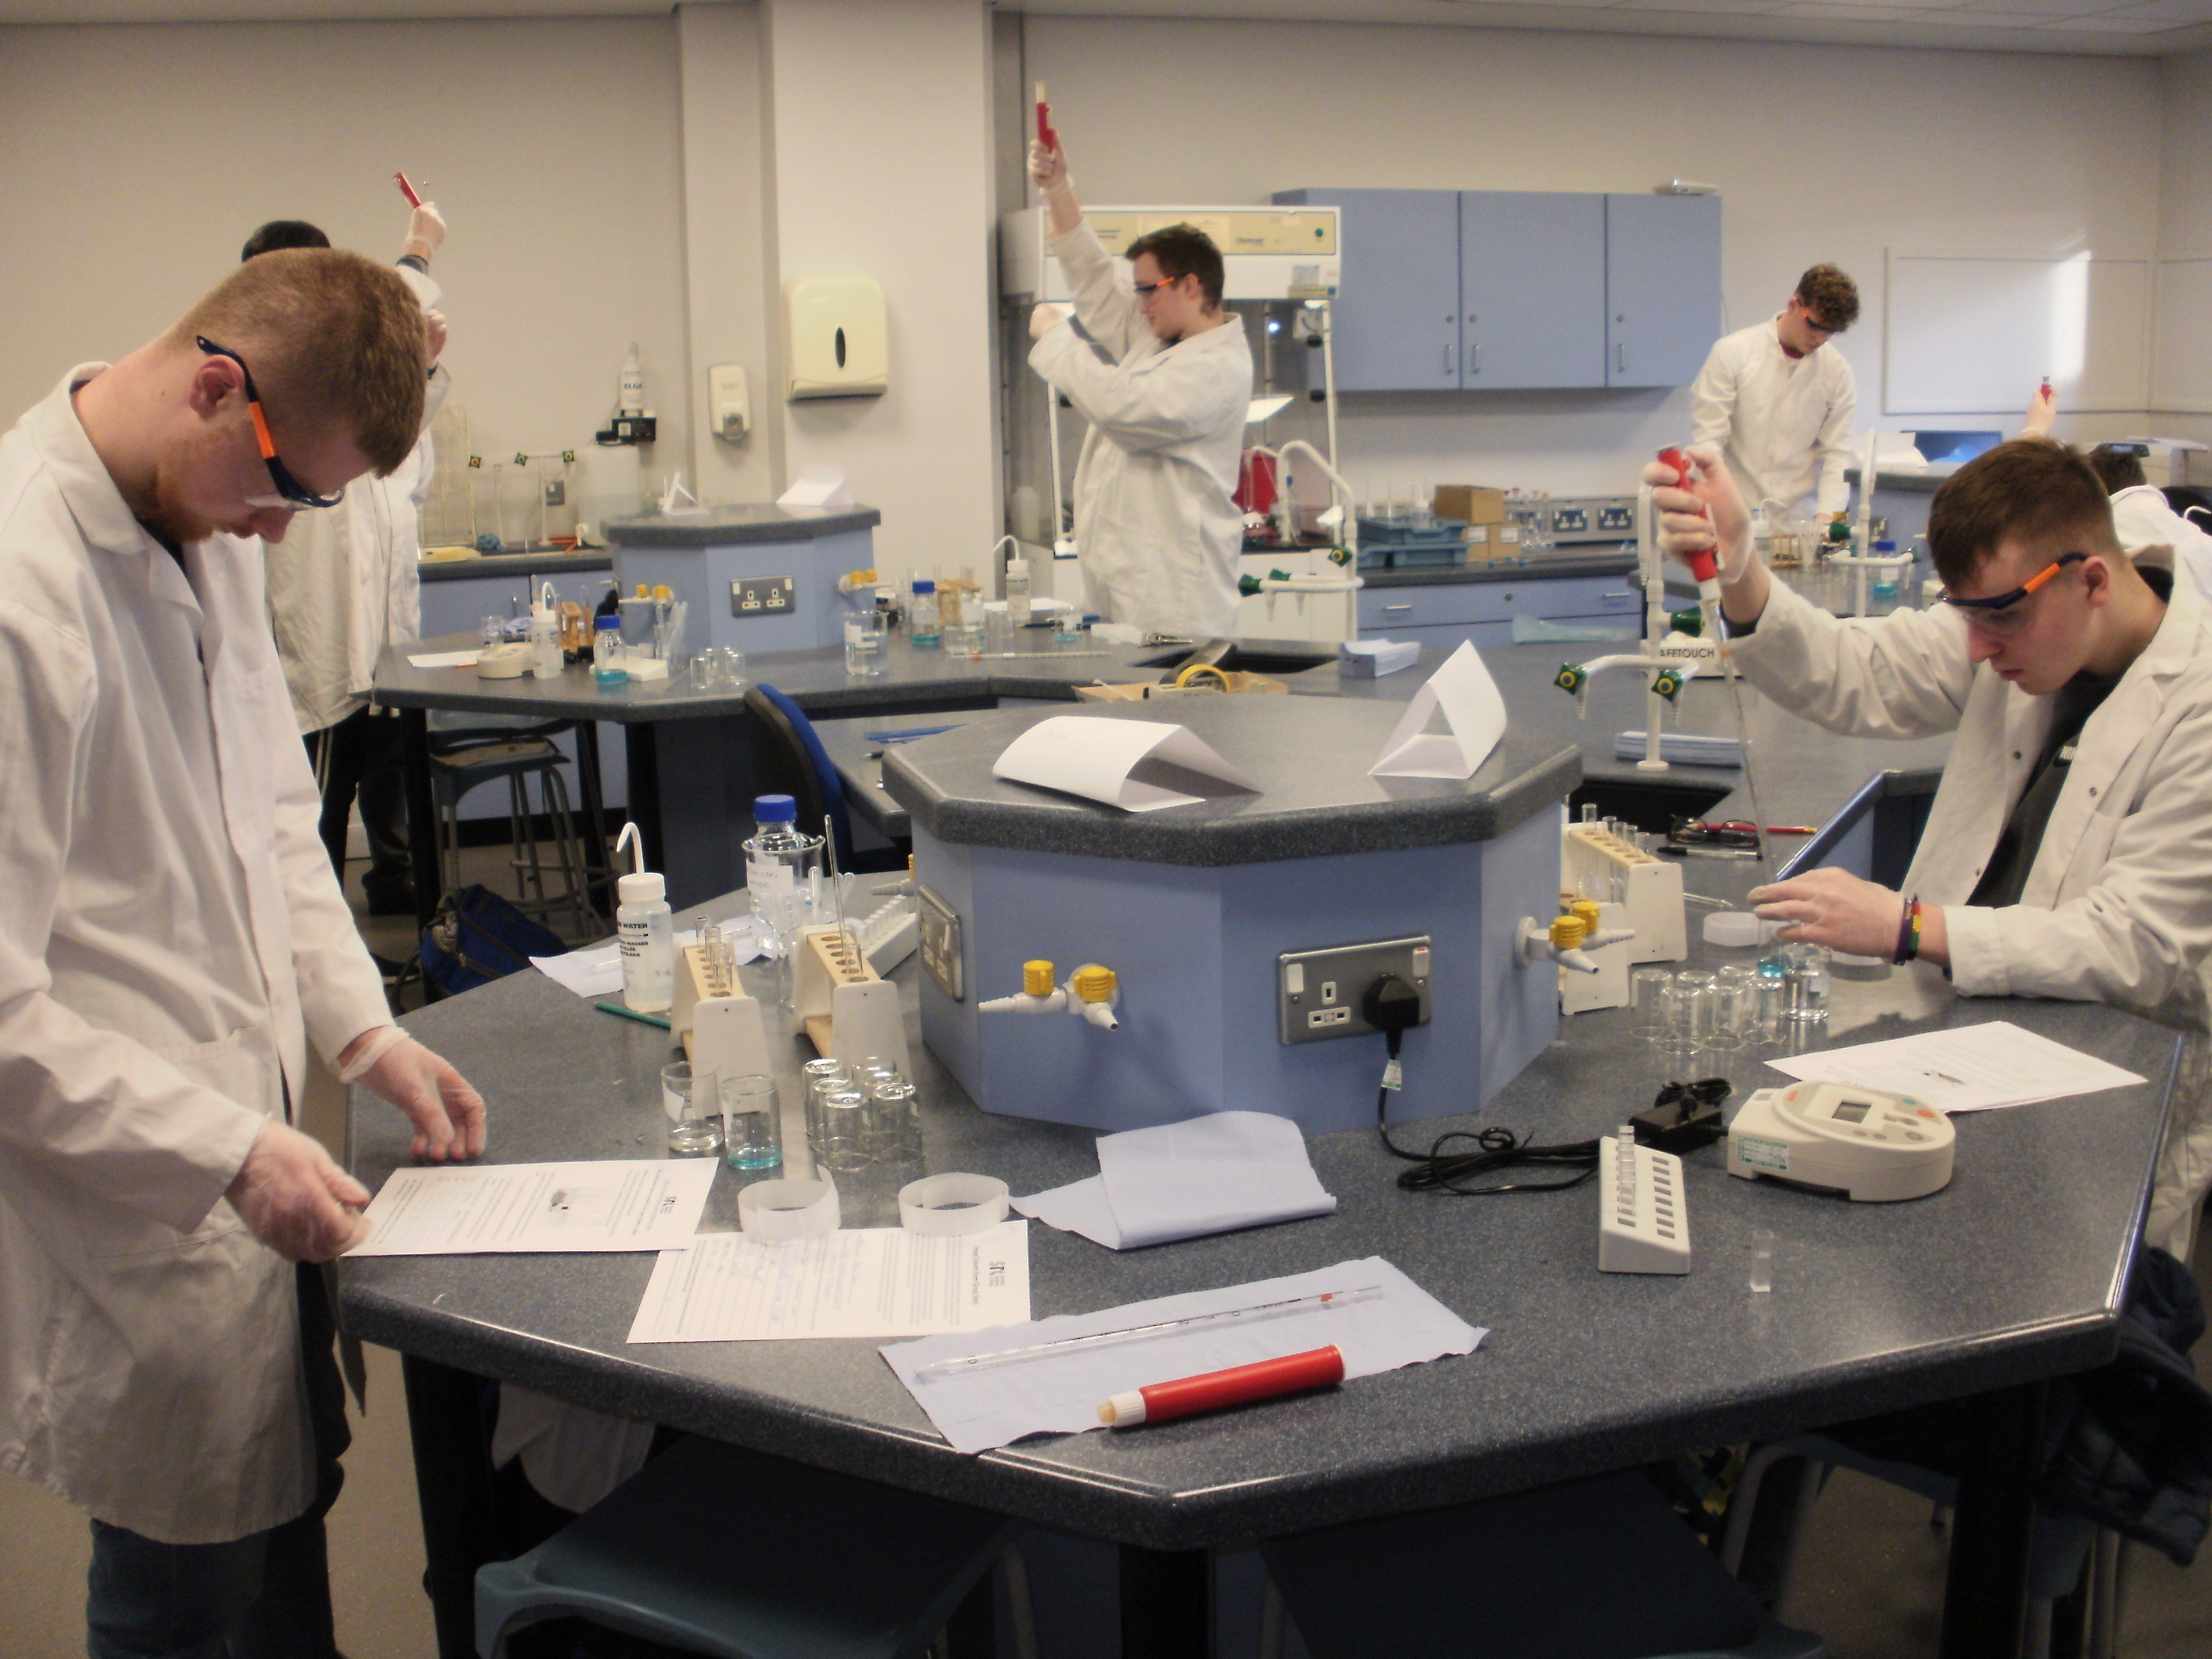

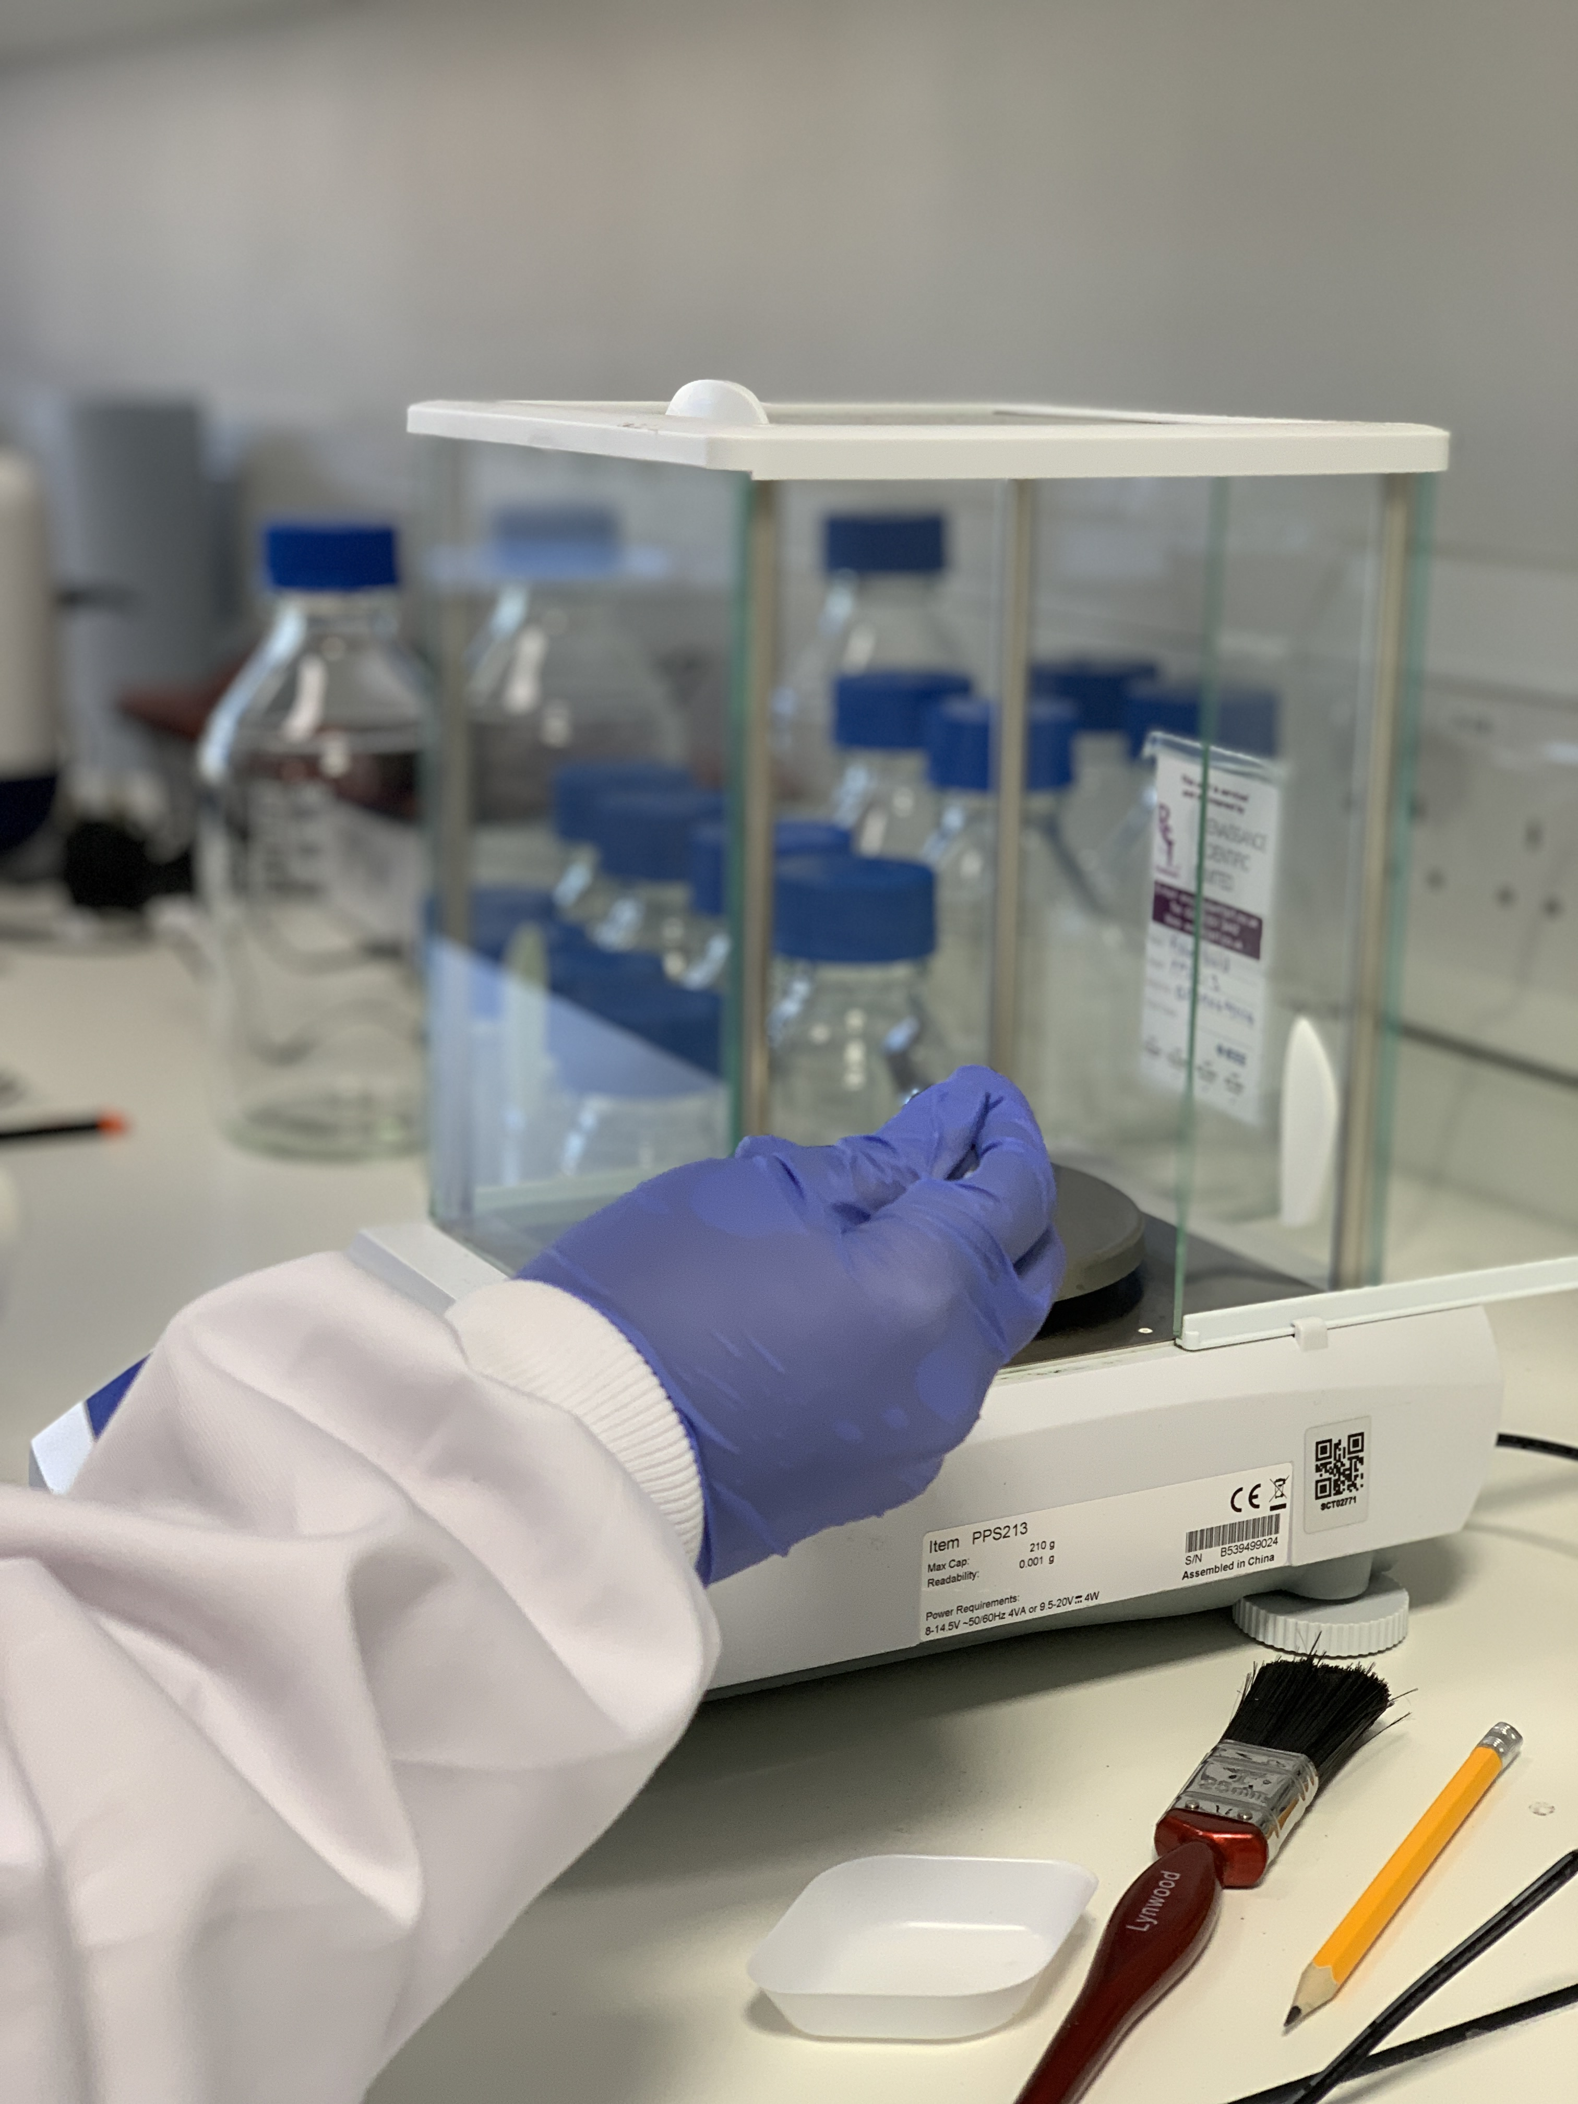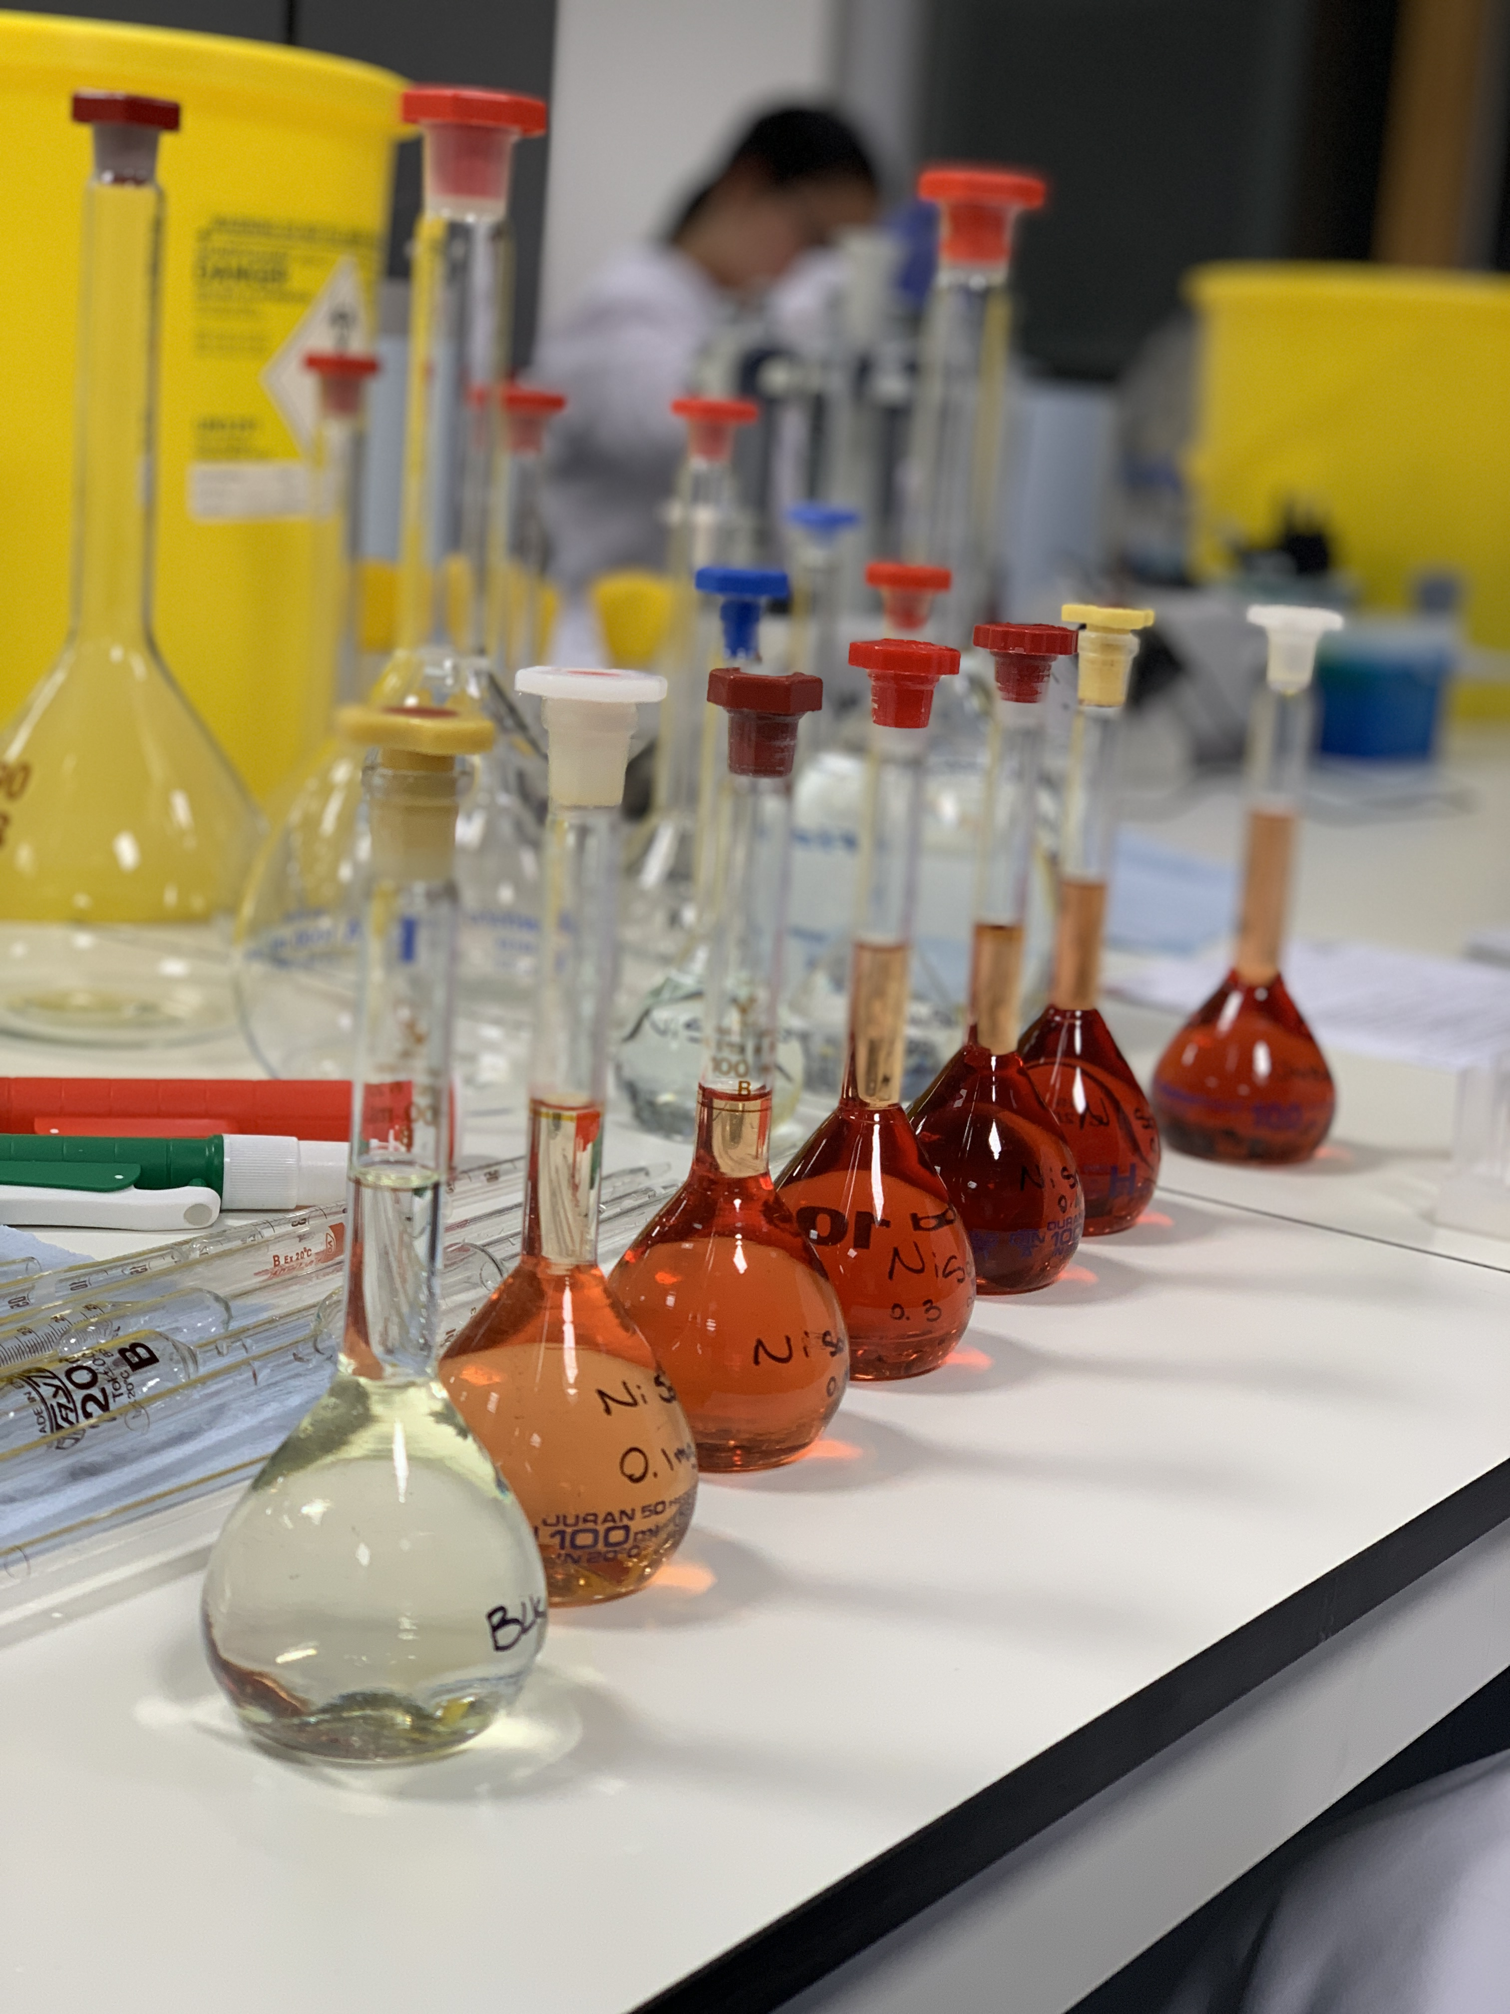

Overview
Roles and responsibilities of a laboratory technician

A laboratory technician’s role involves the support of scientific research, development, analysis, investigation and teaching. This is typically in the fields of physical, biological, chemical and life sciences and the role varies depending on the sector they are involved in.

They are relied on to ensure the smooth running of laboratories and facilitating a safe work environment for laboratory users by strictly adhering to health and safety procedures. Typically, day to day tasks can involve carrying out risk assessments, handling of hazardous chemicals and substances, preparation of samples, performing tests to produce precise and reliable data, assembling, maintaining and calibrating laboratory equipment, carrying out safety inductions and training researchers and junior colleagues on laboratory equipment and procedures.

Qualifications

Although degrees or HNC/HND are not essential, they may improve chances of employment in competitive sectors. Typical subject areas are:
- biology
- biomedical science
- biotechnology
- chemistry
- environmental science
- forensic science
- materials science/technology
- pharmacology
- physics.

There are other routes of entry through vocational courses and apprenticeships. NVQs in subjects such as laboratory sciences and laboratory and technical fields can also open doors for employment. Some entry level roles may only require GCSEs, A Levels or equivalent qualifications with on-the-job training provided.

Skills

A laboratory technician should demonstrate a combination of the following skills:

- A good level of numeracy, literacy, and written communication.
- Attention to detail and organisation.
- Ability to learn practical techniques and apply knowledge.
- Good hand-eye coordination.
- Be able to work autonomously and as part of a team.

Employers

There are many opportunities in both the public and private sectors, organisations include:

- Hospitals, research, and forensic institutions.
- Public health organisations and environment agencies.
- Companies in industry areas such as cosmetics, food manufacturing, textile, materials and oil.
- Pharmaceuticals and chemical industry.
- Educational institutions such as universities, colleges and schools.

Salary and work hours

Entry level salary, dependent on qualifications, can range between £15,000-£19,000. With some experience this can increase to £20,000-£25,000. Supervisory and management roles can expect salaries ranging £30,000-£40,000.

Typical work hours are 35-40 hours per week and shift work may require weekend and evening work.

Sources:

Institute for Apprenticeships and Technical Education (2022). Laboratory Technician. [online] Available at: https://www.instituteforapprenticeships.org/apprenticeship-standards/laboratory-technician-v1-2 [Accessed 22 Jan 2025].

National Careers Service (2022). Laboratory Technician. [online] Available at: https://nationalcareers.service.gov.uk/job-profiles/laboratory-technician [Accessed 22 Jan 2025].

Prospects (2025). Scientific Laboratory Technician. [online] Available at: https://www.prospects.ac.uk/job-profiles/scientific-laboratory-technician [Accessed 22 Jan 2025].

Competition Overview – WorldSkills UK Laboratory Technician 2025

About the Competition
This competition assesses the technical skills and key competences of highly motivated individuals studying or training towards working in a Science Laboratory.

The competitors entering this competition are expected to have a core set of technical skills and knowledge that they would like to demonstrate in a competitive environment and further develop through preparing for and participating in competitions.

This WorldSkills UK competition is managed by Middlesex University in collaboration with partner organisations that host regional qualifiers and support the delivery of the competition.

The competition consists of

- An Entry stage:

Online tasks which you can complete in your own time between a release and submission date. Detailed information on the task, how to access it and when to complete it will be sent to you after your registration is complete. It should take you approximately 2-3 hours to work through the materials and 30 minutes for the assessment. Deadline for completion is Sunday 6th March 2025.

- A National qualifier competition:

After completion of the entry stage task, you may be invited to attend a national qualifier on a specific date in May or June, a one-day event in your region where you will complete a series of laboratory-based tasks. Information on qualifier venues and dates will be communicated through the website and via email.

- The WorldSkills UK national final:

Takes place in November (25th-28th), the venue and further details will be confirmed via the website and email. If you qualify as one of the top eight competitors from across all the national qualifiers, you will be invited to the national final. Finalists and reserves will also be invited to participate in training activities to help prepare for the Final. At the finals you will complete a series of laboratory-based tasks over a period of three days. This typically includes a 2-3 hour familiarisation with the competition venue and equipment and competition tasks totalling 14-16 hours.

Further information, including pre-competition sample materials, are available on the WorldSkills UK website https://www.worldskillsuk.org/competitions/lab-technician

- Beyond the national final:

The WorldSkills UK Laboratory Technician national finals also forms part of the selection process for the WorldSkills International competition in Chemical Laboratory Technology.

Further details of the international competitions including eligibility criteria can be found on the WorldSkills International website.

Following the finals, you will be notified if you have met the criteria to be eligible for the international competition. Successful competitors will be invited to the training programme.

Those who are not eligible for international competitions may join the Skills Champions programme, which allows continued involvement, including the opportunity to work with WorldSkills UK and visit schools, colleges, and events to inspire the next generations.

Get inspired and become a part of Team UK today!

Core competencies
Competitors taking part in this competition should demonstrate their abilities in,

- Reading and application of technical documents such as instructions related to analysis or procedures, formulations, and specifications of substances, diagrams, and manuals for equipment.
- Handling of the laboratory devices, apparatus, and equipment to be used, safe handling of the chemicals used in laboratories, implementing safety data sheets and the measures and procedures to be derived from them.
- Accurate quantitative weighing and volumetric techniques to prepare solutions and dilutions including any required calculations.
- Preparation and processing of samples, as well as separation processes for mixtures of liquids and solids.
- Performance of cleaning and concentration processes such as centrifugation, distillation, extraction, evaporation, and crystallisation.
- Determination of physical parameters and matter constants such as, temperature, density, pH value, refractive index, melting point, and conductivity.
- Application of titrimetric and gravimetric methods.
- Application of instrumental and electroanalytical methods such as Spectrophotometry, Chromatography, Potentiometry, and Conductometry.
- Extraction, purification, and methods of quantitative and qualitative analysis of biological molecules, including electrophoresis.
- Logging, graphic evaluation and interpretation of results, and documentation by using IT and statistical methods.
- Performance of work taking into consideration relevant norms, as well as quality, safety, and environmental standards.
- Appropriate written and oral command of language, specialist terminology, and use of job-related foreign language.

Marking will consider a range of aspects regarding competitor performance whilst working on set tasks. The marks are mapped and weighted against the core competencies.
Table 1: Typical % weighting of core aspects within the marking criteria at different stages of the competition.

Core competence | Entry stage | Qualifier | UK Final
Work organisation and management | 10 | 12.5 | 15
Communication and interpersonal skills | 0 | 5 | 5
Techniques, procedures and methods | 40 | 37.5 | 35
Data processing and record keeping | 15 | 15 | 15
Analysis, interpretation and evaluation | 20 | 20 | 20
Problem solving through Scientific methods | 10 | 5 | 10
Trends in Applied Science | 5 | 5 | 5

Entry Criteria
This is an individual competition.

The skill set needed to meet the entry requirements are usually met by currently (at time of registration) studying the following in a relevant field:
- Apprenticeship Level 3 or 4
- HNC
- HW QF for England and Wales
- Educational or vocational qualification at level 3 (e.g. A-level, T-level)
- Foundation Degree or access to HE course at L3 or L4 (or SQF L7)
- First year in a BSc in Chemical or Biological Sciences

Competitors who do not fall in any of the categories above or are unsure about their eligibility may contact the competition organising partner for clarification, prior to registering.

Competitors should be familiar with most of the core competences listed. To be eligible, competitors must not have more than two years industry experience post certification or have achieved higher qualifications in a relevant field than the ones listed above (e.g. completed year 1 of a BSc) at time of registration.

Competitors should be aged 16 or over to take part in this competition. Safe-guarding measures will need to be put in place for any competitors under the age of 18 years prior to them attending any National Qualifiers, competitor training or the finals.
Reasonable adjustments and support can be provided for any additional needs a competitor might have. These need to be declared at registration.

There is no limit on competitor registrations per organisation. Spaces at regional qualifiers are limited and competitors will be selected and allocated to a qualifier after the entry stage has been submitted and marked. Location preferences made on the registration form will be considered.

Marking and Assessment
Each stage of the competition and each module will be assessed and marked independently of any other competition activity.

Once marks have been awarded by each of the judges, they will be averaged to obtain the final mark.

A panel of judges has been selected from a range of industries, colleges, and training provider representatives. The judges’ decisions will be moderated, and quality assured by WorldSkills UK before being confirmed.

Please note that competitors who achieve the highest marks across all national qualifiers will be invited to compete at the WorldSkills UK National Final. There is no automatic entrance to the UK Final for winners of the national qualifiers. The competition organisers (Middlesex University) will send feedback to all competitors participating in national qualifiers and inform finalists following moderation of marks and public announcements made by WorldSkills UK.

Test Project
The competition is modular, each module consists of a laboratory practical task that will be independently marked, and the overall competition mark will be collated from all modules.

Competitors will be provided with all materials, and written instructions for the experimental or analytical task. A verbal briefing will be given at the start of each task and staff are at hand to provide support during tasks, e.g. with handling of specialist equipment or providing additional material.

Competitors are expected to risk assess the activity and materials using safety data sheets prior to commencing any work, to communicate this in writing or verbally and reflect this by their actions.

Note taking, data analysis, reporting and evaluation of results form part of the assessment. However the focus lies on the practical skills and abilities to carry out experimental or analytical laboratory work independently, safely, and efficiently, demonstration good technical skills and competency in handling substances and equipment.

Materials and Equipment
You will be provided with PPE, equipment, and all materials needed to complete the tasks. You will also be provided with a notebook and essential stationary.

Computers, any specific software, and other IT will also be provided if necessary.

You may wish to bring the following items, although these will be provided:
- Your own (company branded) lab coat (must be clean!).
- Your own goggles (essential if you wear googles with eye corrections).
- A scientific calculator (not mobile phone app, no formulae etc. on the cover).
- Your own stationary.

Competitors will not be permitted to use the following during the competition:
- Mobile phones, smart watches or any other devices with internet access.
- Notes, books, manuals, etc.
- Headphones.

A detailed briefing will be given about permitted and prohibited items and activities prior to the competition commencing.

Safe storage space or lockers for personal items, coats, bags, etc. that are not permitted in the laboratory will be provided, however space may be limited.

If you have any allergies, e.g. to gloves, please advise the organisers well in advance so that they can arrange alternatives or grant permission for you to bring your own.

It is at the discretion of the laboratory manager and lead judge to disallow competitors from entering the laboratory or exclude them from the competition, for example for any serious breaches of laboratory safety or inadequate clothing (e.g. flip-flops), breaches of the rules or if there are health concerns.

If you require any support or adjustments, for example for special educational needs or disability, please note these during registration and contact the competition organiser prior to any stage of the competition. WSUK, Middlesex University and all organisations supporting this competition are committed to equity and inclusivity and will make any reasonable adjustments to the competition material and set-up that might be required to accommodate you. Any information disclosed by your will be treated with confidentiality and only shared where needed for the competition and with your agreement.

If you have any questions or concerns about provisions and requirements at an event please contact the competition organisers prior to attending via the contact details below.

Contact Details
Competition Organising Partner, Middlesex University, Faculty of Science and Technology, Department of Natural Sciences, Competitions@mdx.ac.uk

Dr Dirk Wildeboer (Lead contact), d.wildeboer@mdx.ac.uk;
Stephanie Bee (Office) S.Bee@mdx.ac.uk, 0208 4115161

For general enquires please contact the WorldSkills UK Contact Centre 0800 612 0742 opt.2, Enquiries@WorldSkillsUK.org.

Competition Rules
A completed registration is an indication that you have agreed to the following:

- WorldSkills UK Competition Rules
- WorldSkills UK Terms and Conditions

Please ensure that you are familiar with these documents ahead of any competition activity. Guidance will be provided throughout the process.

In addition to this, you are expected to follow any specific rules and instructions relating to the different stages of the competition, activities, and local rules. These will be communicated to you in advance or at a briefing prior to taking part in a competition stage.

